MDJ

The antibacterial effect of Ellagic acid on Lacto bacillus acidophilus in comparison to Chlorhexidine

Dr. Saadi Jawad Muslim ,B.D.S, MSc.

Abstract

Ellagic acid is a natural herb extract were prepared from flesh pomegranate extract. The preparation and experiments were done and conducted in a laboratory of chemistry department of Ministry of Science and Technology. Biological activity of Ellagic acid to ward pathogenic bacteria (Lactobacillus acidophilus) was studied. The purpose of this study was to evaluate the antibacterial effect of prepared Ellagic acid with different concentrations on growth of lacto bacillus acidophilus in comparison with Chlorhexidine gluconate 0.2% and deionized water. This in vitro bacteriological study was tested according to agar well diffusion technique. The results showed that a highly significant increase in mean values of Ellagic acid compared to Chlorhexidine and deionized water. The concentration, 5 mg/ml and10 mg/ml of Ellagic acid showed stronger effects in inhibition of lactobacillus acidophilus, than Chlorhexidine 0.2%. Ellagic acid 5and10mg/ml has the ability to interfere with the adherence of Lactobacilli in vitro.
Previous study showed that Ellagic acid had antibacterial effect on Streptococcus mutans , Ellagic acid could be used as antibacterial mouth washes to prevent dental caries.
Chlorhexidine.

Key words: Ellagic acid, Lactobacillus,

Introduction

Dental caries is the most common of all oral diseases, the main causes of dental caries was attributed to oral biofilm, also known as dental plaque, a film of microorganisms sticking to the tooth surface ⁽¹⁾. The mouth contains a wide variety of oral bacteria, but only a few septic species of bacteria are believed to cause dental caries: Streptococcus mutans and Lactobacilli among them. These organisms can produce high levels of lactic acid following fermentation of dietary sugars, and resistant to the adverse effects of low PH, properties essential for cariogenic bacteria ^{(2, 3)}. Acid production from fermentation of dietary carbohydrates by the plaque microorganism is considered as a key factor in caries initiation. Certain microorganisms are a cidogenic as the mutans Streptococci and Lactobacilli. They produce Saccharic acid. These organic acids such as lactic, propionic, and formic acid can dissolve the calcium and phosphate minerals of the tooth structure ⁽⁴⁾.Caries result from the destruction of the surface due to decrease in the PH by acid producing bacteria. It is the bacterial metabolic products that cause caries and not the bacteria themselves, they are not essential for initial caries development. Lactobacilli are important in the progression of caries which have been initiated by other acid producing bacteria such as Streptococcus mutans⁽⁵⁾.As the cementum of root surfaces is more easily demineralized than enamel surfaces, a wider variety of bacteria can cause root caries including Lacto bacillus acidophilus, Antinomies spp., and Streptococcus mutans⁽⁶⁾Lacto bacillus acidophilus is a gram-positive bacterium in the genus Lactobacillus. These microorganisms are characterized as being aero -tolerant facultative an aerobes which are rod-shaped, catalase-negative, motile, and non-Sporulation⁽⁷⁾ .These bacteria are often found in chains of varying lengths. Lactobacillus acidophilus undergo homofermatative metabolism, resulting in mainly lactic acid production from carbohydrate fermentation. Other species of Lactobacillus undergo hetrofermentative metabolism, in which they produce lactic plus ethanol, carbon dioxide, and acetatefrom carbohydrate fermentation {⁸⁾.Lactobacilus acidophilus is non-pathogenic to humans. Lactic acid producing bacteria such as Lactobacillus acidophilus are widely used in the food industry for the production of yogurt, cheese and other foods.⁽⁹⁾ Cariology is the study of dental caries, Depending on the of tooth destruction, various treatments can be used to restore teeth to proper form, function, and aesthetics, but there is no known method to regenerate large amounts of tooth structure instead, dental health organizations advocate preventive and prophylactic measures, such as regular oral hygiene and dietary modifications, to avoid dental caries ⁽¹⁰⁾. Ellagic acid contains a naturally occurring phenolic compound that has strong antioxidant properties, present in many plant foods. The phenolic acids and flavonoids are forminga polyphenolic compounds that widely spread in plants, they termed by anutraceuticals⁽¹¹⁾Ellagic acid has anti- proliferative activities include antibacterial and antiviral activity. ^{(12, 13)}
Previous studies on the biological activity of the Ellagic acid which prepared from white flesh pomegranate extract against the growth of Mutans streptococci had showed that Ellagic acid were able to inhibit the growth of mutans streptococci^{,(14)}
The aim of the present study was able to find connecting effect growth and adherence of Ellagic acid on Lactobacillus acidophilus.

Material and Methods

The present study involved preparation of Ellagic acid from pomegranate extract and in vitro experiments to evaluate the effects of Ellagic acid on the growth and adherence, of lacto bacillus acidophilus.

1. Preparation of Ellgic acid
Ellagic acid was prepared, purified and characterized in chemical department of Ministry of technology as follow:
100g fresh weight of white flesh pomegranate was ground and mixed using mechanical mixer to obtain soft slurry. A mixture of 200 ml triethylamine and 20% aqueous ethanol in a ratio 1:9 (V/V), was added to the formed slurry and mixed for 1 hour at 25Cº .The resulting mixture was allowed to stand for 24 hours and then filtered by vacuum .For optimal extraction., the process was repeated on the seed residue .Then the extracts were collected and stored at -20Cº.The filtrate was dried at room temperature to evaluate the extract. HPLC technique was used to determine the Ellagic acid content in the extract of Iraqi pomegranate, 0.1g of the extract was dissolved in 5 ml of 20% aqueous ethanol and tirethylamine mixture with ratio of (9:1). The solution completed to 10 ml with same solvents mixture in a volumetric flask. The resulted solution was diluted twice more. The analysis conditions were carried on reversed phase ODS-C18 (250 × 4.6mm I'd) column, mobile phase 0.03M phosphate buffer PH (7): methanol 70:30 (V/V), flow rate 1ml /min., temperature 35Cºand UV-VIS. detector at 256 nm.(Fukumoto et al,2002).⁽¹⁵⁾The prepared Ellagic acid was identified by HPLC analysis of both standard and prepared Ellagic acid was recorded their retention times at 4.21 and 4.25 min. respectively, and appeared that the purity of prepared Ellagic acid is 97% compared with standard compound^{.(15)}

2. Microorganisms and culture conditions:
The growth in the media, consist of Petone 10g/l,meat extract 10mg/l, yeast extract 5g/l, glucose 20gm/l,k2 hpo4 2gml , Tween 80 1ml,Sodium acetate hydrate5gm/l,Triammonium citrate , 0.2gm/l,Mnso4.4H2O 0.05 G/L,PH 6.O _+ 0.2 . The media was heated, with continuous shaking until reach clear dissolve solution, then the media has been clear and distributed in to conical flask, then in cubated and prepare part of powder capsulated lactobacillus, obtained from biotechnology department, college of science of AL-Nahrain University. After identification of this Lactobacilus acidophilus powder by morphological examination ,Biochemical test and culture test ,since diagnosed the class, order, family and genus of it according to their morphological characteristics according to description cited by Prakash, S. etal^{(16).}Then prepare 250 ml in room temperature in a cooler shaken incubator in 120 rPm velocity to about 24 hour ,the antimicrobial activity was achieved by plate agar method.⁽¹⁷⁾ . Microorganisms were cultured aerobically at 37C for 24 hours in nutrient agar medium. The plates containing agar medium were inoculated by microorganism suspensions, which are spreading on the surface. Each sample in mg/ml was placed in a hole (3mm depth,4mm diameter) made in the agar layer. Under the same conditions, Chlorhexidine gluconate 0.2% and deionized water was used as control positive and deionized water was used as control negative. The diameter of inhibition zones were measured using a ruler with an accuracy of 0.5mm. A control using only inoculation was also carried out .After that noticed the growth and inhibition of the ellagic acid in different concentrations, 0.625mg/ml,1.25mg/ml,2.5mg/ml, and 5mg/ml and10mg/ml. The applied statistical analyses were done the following mean value, standard deviation, T.test, Value and ANOVA F-test using SPSS version 15.as seen in table (3) and table(4)

3. Effects of adherence of lacto bacilli to tooth surface in vitro:
The prevention of adherence of Lactobacillus acidophilus to the teeth and stainless wire after the use of 5mg/ml, 10mg/ml concentrations of Ellagicacid, Chlohexidine 0.2% and de-ionized water compared to the control positive(broth and bacteria without agent) and control negative(broth and agent without bacteria) has been tested in vitro according to the method described by (El-samarrai,2001)⁽¹⁷⁾ as in figure(1).

Procedures:-
The following steps were done to evaluate the effect of Ellagic acid on the adherence of Lactobacilli acidophilus to the teeth and stainless wire as in figure (1)
1. Stain less steel wire (15cm in length) was thread in one end in the root of previously cleaned and polished sound first premolars. These all were sterilized by autoclave.
2. Teeth were immersed in 10 ml of the tested agents for two minutes except for control positive which is broth and bacteria without agents. The test agents include 5,10mg/ml Ellagic acid, Chlorhexidine gluconate0.2% and deionized water.
3. The wires and teeth were washed using sterile deionized water for one minute and left to dry for 5 minutes at room temperature.
4. The teeth were immersed in 10ml, Brain heart infusion broth containing5% sucrose (PH 7.0). The study and control tubes were inoculated with 2% of bacterial isolates. All the bottles were incubated aerobically at 37C for seven days.
5. A positive score (+) was given to the adherent microbial growth on wire, teeth and tube walls, indicating a non-effective treatment and vice versa.

Results

Effects of Ellagic acid on growth of Lacto bacilli acidophilus
in vitro
Sensitivities on Lactobacilli acidophilus to different concentrations of Ellagic acid in this study. The results showed that Ellagic acid were able to inhibit the growth of Lactobacilli acidophilus in comparison to the control as seen and table (2) and figure(2). The diameter of zones of inhibition of Lactobacilli were increased as the concentration of Ellagic acid increased and when reach 5mg/ml,10mg/ml , the zone of inhibition were much higher than Chlorhexidine 0.2%. Results of this study exhibit that increasing in the values of inhibition of Ellagic acid to viable count of lactobacilli acidophilus in vitro when increased the concentration of agent in comparison to Chlorhexidine gluconate 0.2% and deionized water and 5,10 mg/ ml concentration of Ellagic acid shows the highest values as seen in the figure (2)

The effects of Ellagic acid on the adherence of lacto bacilli
in vitro
The adherence ability of lactobacilli on the tooth surface and stain less -steel wire and the effects of Ellagic acid ,Chlorhexidine, and deionized water on it were tested in this study in vitro, compared to control positive and negative, the results showed that small amount of dental plaque were accumulated on the positive controlled teeth when immersed in 5mg/ml,10mg/ml and teeth in Chlorhexidine show no accumulation of dental plaque on them after seven days incubation aerobically on brain heart infusion broth + 5% sucrose as in Table (2) And figure (1)

Discussion

Sensitivities of lacto bacillus to different concentrations of Ellagic acid in vitro (agar well diffusion)
Sensitivities of lacto bacilli acidophilus to different concentrations of Ellagic acid by agar well diffusion method had been tested in this study .The results showed that Ellagic acid were able to inhibit the growth of lactobaciilus,, this finding were in coincidence with (Hwang, 2004⁽¹⁷⁾Scalbert, 1991^{;(18)}Sakanaka et al, 1996⁾⁽¹⁹⁾. We notice that the diameter of zone of inhibition ,Ellagic acid were increased as the concentration of Ellagic acid increased especially when reach 5mg/ml and10 mg/ml ,the zone of inhibition were much higher than Chlorhixidine with highly significant reduction (P<0.01) as seen in figure (2) and table(3) and table(4).. This fact was also found in case of inhibition of Ellagic acid to Streptococcus Mutans , we saw that the zone of inhibition increased compared to Chlorhixidine 0.2%.A .Muslim,S;2009 showed that fact, in which Ellagic acid concentration increased,, the diameter of zone of inhibition of mutan streptococci was increased and become higher than Chlorhixidine 0.2%.^{.(14)}This finding may be explained by the fact that, Ellagic acid that had antibacterial effects against lacto bacillus and inhibit its growth.
Previous studies showed that Ellagic acid may had the ability to interfere with metabolism, growth and/or enzymatic activity of the bacteria ^{( 12,13,21)}.On the other hand, Ellagic acid5mg/ml and 10mg/ml showed more effective in reduction of the viable counts of lacto bacillus than Chlorhixidine0.2% in vitro. The result showed that, highly significant reduction(p<0.01) in viable counts of Lactobacillus acidophilus in 5,10 mg/ml Ellagic acid compared to control as seen in table (3) and table(4).

The effects of Ellagic acid on the adherence of lacto bacilli acidophilus in vitro
An important cariogenic determinant of lacto bacillus the ability of adherence on the tooth surface.^{(12, 22);(23)}.
In this experiment, 5mg/ml and10mg/ml had been tested, it has the ability to interfere with adherence of lacto bacilli in vitro .The result showed that the dental plaque could be eliminated and the effects of Ellagic acid on caries prevention could be truly reflected .No Plaque formed on teeth immersed in Ellagic acid, with 5,10mg/ml concentration,Chlorhixidine0.2% and control negative teeth, so considered zero while very small amounts of dental plaque is formed on control positive teeth and teeth immersed in deionized water, dental plaque not seen by eyes but by using dental probe , this finding agree with Sakanaka et al , 1996^{,(12)} .
Previous study investigated the activities of Ellagic acid to the adherence of mutans streptococci that retard acid production.⁽¹⁴⁾

References

- Marsh,P.D."Microbiological aspects of the Chemical control aspects of the chemical control of plaque and gingivitis.J.DentalRes.1992; 71:1431-1438.
- Hardie JM,." The microbiology of dental caries" 1982. Dent Update 1982; 9 (4): 199-200,202-4,206-8.PMD6959931.
- Rogers AH (editor) "Molecular oral Microbiology, 2008.Caister, Academic press. ISBN, 978-1-9044 55-24-0.
- Featherston J.D. Prevention and reversal of dental caries, role of low level fluoride. Community Dental Epidemiol 1999;27:31-40
- Klinberg,, I; A mixed-bacteria ecological approach to understanding the role of oral bacteria in dental caries causation: an alternative to Streptococus mutans and specific plaque hypothesis. Critical Reviews in oral Biology &Medicine, 2002; 13(2):108-125.
- Douglass,JM;LI,Y; Tinanoff,N."Association ofmutans streptococci between caregivers and their children"Pediatric Dentistry 2008 .30(5):375-87.
- Curran, H.R..,Rogers,L.A.,Whittier,E.O.;The distinguishing characteristics of Lactobacillus Acidophillus,2006; JoutrnalBacteriolog , 25(6):595-621;1933.
- Altemann, Eric, etal, 2005 "Complete genome sequence of the probiotic lactic acid bacterium Lactobacillus NCFMPNAS Vol: 1`02, No.11. http//www.panas org/ content/102/11/3906.full.pdfthtml.
- HolzapfelWH.HabererP.GeisenR,etal; Taxonomy and important features of probiotic microorganisims in food and nutrition .AmJ.Clin. .N utr.2001;73(2) :365s-373s.
- ^{8ab}Oral Health Topics: Cleaning your teeth and gum. Hosted on the American Dental Association Website. Page accessed August 15, 2006.
- FShahidi and Minacs. Phenolic in food and nutraceuticals .CRC press, USA, 2003, PP.85.
- SanakaS,AizawaM,Kim M, Yammamoto.T. inhibilitory effects of polyphenols on growth and cellular adherence of an oral bacterium prophyromonasgingivivalis. BiotechnolBiochem .1996;745-746.
- Lesso JN,Bansode RR, Trappy, BawadiHA and TruaxR.Invitroantiproliferative activities of ellagic acids NutrBiochem .2004; 15 (11):672-678.
- Muslim. S. The antibacterial effects OF Ellagic acid on Mutansstreptoocci in comparison to chlorhexidine(invitro and invivo study), A thesis submitted to the collage of Dentistry Baghdad University, 2009.
- Fukamoto Y, Ashik and Yama Zaki, :Methol for producing ellagic acid, Jap. Patent, NO. 2002-25003.
- Prakash, S.etal."The Gut Microbiota and Human Health with Emphasis on the Use of Microen capsulated Bacterial cells" Journal of Biomedicine and Biotechnology(2011)..
- G.A.Washington. Laboratory procedures in clinical bmicrobiology Spring Verlog. NewYork.1981.
- EL-Samarrai S.Major and trace elements contents of permanent teeth and saliva, among a group of adolescents, in relation to dental caries,gingivitis and mutans streptococci (invivo and invitro study) .PhD. Thesis, College of dentistry, University of Baghdad, Iraq,2001.
- Hwang JM, Cho JS,KimTH,LeeYl"Ellagic acid prptects hepatocytes fom damage by inhibiting mitochondrial production of reactive oxygen species. Biomed. Phamacother .{Epub ahead of print} ,2009.
- Scalbert A. Antibacterial properties of tannins. Chemistry 1999, 1, 30: 3875-3883.
- Grag.W, and Gldine .M. Bioavailability, and bioafficay of polyphenols in human, AmJClinNutr.. 2005, 81(1)243-255.,
- Menaker,L. "The biologic basis of dental caries an oral text book, Ed. Harper and Raw.Newyork-1980.pp.210-255,207-312
- ThylstrupA.and.FejersTextbook of Clinical Cariology.2nded. Munksgaard.Copenhagen.1996:11-158.

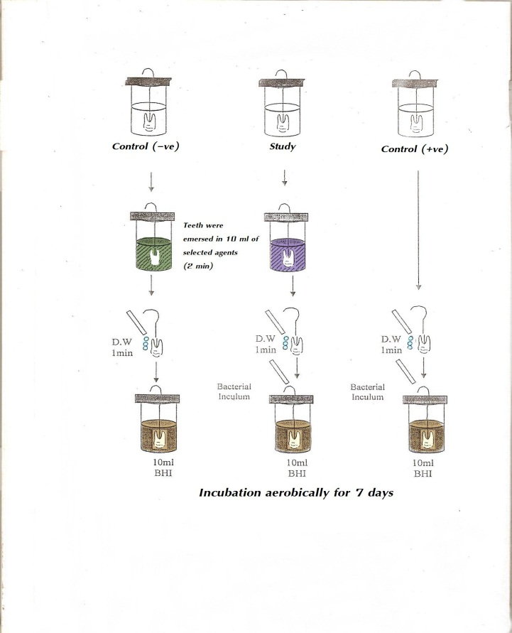
Figur (1 ) Eeffects of Different Concentrations of Ellagicacid on adherence of Lactobacillus acidophilus Invitro
Table (1) The effects of Ellagic acid 5 mg/ml, 10 mg/ml Ellagic , Chlorhexidine 0.2% and deionized water on adherence of lactobacillus acidophilus invitro

Adherance | Agent 2(minutes)
+ ve | Control Positive
- ve | Control negative
- ve | 5 mg/ml Ellagic
- ve | 10 mg/ml Ellagic
- ve | 0.2% CHX
+ ve | Deionized Water

Table (2) zone of inhibition in millimeter (mean and standard deviation SD) of Ellagic acid different concentrations, Chlorhexidine, deionized water

Deionized Water |  | 0.2% Chlorhexidine |  | Ellagic acid |  |  | Concentration  Mg/ml
SD | Mean | SD | Mean |  | SD | Mean
0.0 | 0.0 | 0.2432 | 12.16 |  | 0.131 | 6.52 | 0.625
0.0 | 0.0 | 0.2432 | 12.16 |  | 0.248 | 12.4 | 1.25
0.0 | 0.0 | 0.2432 | 12.16 |  | 0.311 | 15.5 | 2.50
0.0 | 0.0 | 0.2432 | 12.16 |  | 0.392 | 19.60 | 5.00
0.0 | 0.0 | 0.2432 | 12.16 |  | 0.398 | 19.90 | 10.0

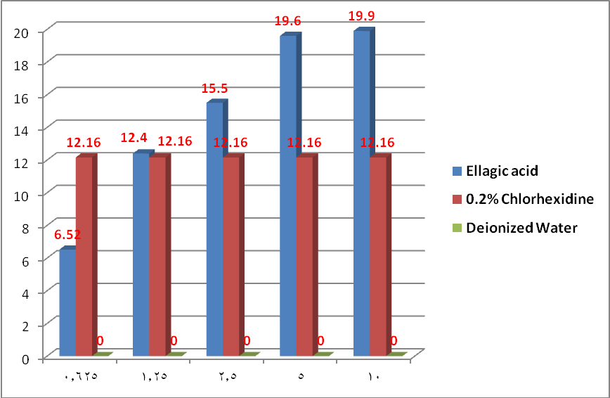
Figure (2) The effect of different concentration ofEllagic acid,Chlorhexidine 0.2% and Deionized water on growth of Lactobaclli in vitro

Table (3) Statically test between different concentrations of Ellagic acid

Description | P.Value | Ellagic acid  T-test | Concentration  Mg/ml
N.S | 0.093 | 0.103 | 0.625
S | 0.018 | 5.682 | 1.25
S | 0.016 | 7.329 | 2.50
H.S | 0.000 | 7.921 | 5.00
H.S | 0.0000 | 8283 | 10.0

Table (4) ANOVA between different Concentration of Ellagic acid

concentration  Mg/ml | Ellagic acid  ANOVA F-test | P.value
0.625 | 13.628 | P<0.01  HS
1.25 | 13.628 | P<0.01  HS
2.5 | 13.628 | P<0.01  HS
5.00 | 13.628 | P<0.01  HS
10.0 | 13.628 | P<0.01  HS

