MDJ

Comparative panoramic study of the elongated styloid process between male and female , their possible associations with age and Eagle’s syndrome symptoms in Iraqi dentulous subjects

Dr. Nuhad Al. Hassan. B.D.S. , M.Sc., Rad.

Abstract

Background : The stylohyoid process is a cylindrical bony structure surrounded by important anatomical structures including vessels and nerves. Calcification and elongation of the stylohyoid ligament complex over 30 mm may be associated with neck and facial pain, known as Eagle’s syndrome . The aims of the study were to compare the elongated styloid process between male and female , their possible relations with age and Eagle’s syndrome symptoms in Iraqi dentulous population using panoramic radiographs .
Materials and methods : Clinical and radiographical records of 70 patients (40 female and 30 male). The length of the styloid processes were assessed using panoramic radiographs . Measurements of the length of the styloid processes were made directly from its insertion site to the petrous part of the temporal bone to its tip.
Results : There was highly statistically significant difference between male and female for right side and left side of the styloid process length p-value <0.01. Chi-square between present of symptoms and styloid process length of age showed statistically non-significant difference.
Conclusion : Panoramic radiography is useful tool for detection of an elongated styloid process in patients with or without symptoms and can thus help avoid misinterpretation of the symptoms.

Keywords : Panoramic , styloid , Eagle’s syndrome , elongated .

Introduction

The styloid process (SP) , which arises embryonically from the Reichert cartilage of the second branchial arch, is a long and thin outgrowth at the base of the temporal bone , immediately in front of the stylomastoid foramen, posterior to the mastoid apex. It serves as a point of attachment for the stylomandibular ligament as well as the styloglossus , stylohyoid , and stylopharyngeus muscles. Elongation of it is a poorly understood process, commonly admitted theories about the actual cause of the elongation of the styloid process (SP) are defined as congenital elongation of the ( SP) , calcification of the stylohyoid ligament by an unknown process, and growth of osseous tissue where the stylohyoid ligament inserts ^{1,2} . The regional factors like dietary factors are also important for different patterns and types of styloid process elongation ³ . Panoramic radiograph is a routine exam in the dental and oral medicine practices , its great advantage is to allow practitioners to analyze components of the stomatognathic system in addition to other near structures ⁴ . Elongated styloid process (SP) gives a complex of symptoms described by Eagle in 1937, hence the condition is also known as Eagle’s syndrome ; symptoms are secondary to calcification of the stylohyoid ligament or to an elongated SP ^{2,5} . Normal length of styloid process was stated by Eagle as 2.5 cm ⁶ .There are authors that take normal values up to 3 cm for the SP length ^{7,8,9} . Eagle’s syndrome can occur unilaterally or bilaterally and frequently results in symptoms of dysphagia , recurrent throat pain and foreign object sensation , referred otalgia, headache , pain on rotation of the neck , dizziness , pain on extension of the tongue , pain on opening mouth , discomfort during chewing , change in voice , and a sensation of hyper salivation ¹⁰ . The symptoms can be confused with some other disorders including a wide variety of facial neuralgias, unerupted molars, temporomandibular joint disorders , tumor in the oropharynx and hypopharynx and irritation from the dental prosthesis these can be ruled out thorough clinical and radiological examination ¹¹ . In addition to careful clinical examination, the use of plain radiographs, orthopantomograms, or computed tomography (CT) scan allows accurate preoperative diagnosis of this syndrome. Surgical treatment positively resolves the symptoms ¹². The aims of the study were to compare the elongated styloid process between male and female, their possible relations with age and Eagle’s syndrome symptoms in Iraqi dentulous population using panoramic radiographs .
Materials and methods

Seventy dentulous patients (40 female , age ranged from 22 to 50 years ; 30 male , age ranged from 18 to 70 years) , all subjects were examined clinically and scanned using a panoramic machine (My ray CE 0051(V.B1 cocc A 14/C-IMOLA (BO)-Italy, X-ray source (85 kVp, 10 mA ) , exposure time(18 sec). The information's and history for all patients were recorded in special case sheets. The length of each SP was measured by using measuring tools from its insertion site to the petrous part of the temporal bone to its tip ^{2,13} . The length was recorded separately for each side since there were some differences between right and left sides . The collected data was analyzed using, statistical analysis software SPSS version 16 , t-test , Pearson’s correlation and Chi-square test were used to determine any significant differences between variables .

Results

In table (1) showed the mean of age ( 34.6 for female , 46.7 for male ) , SD, SE and number of female and male that present the symptoms . Figure (1) showed the mean of age for both gender .
Table (2) showed that the mean of elongated styloid process length for both right and left sides in male longer than female , figure (2) showed the means of elongated styloid process length for both male and female .
T-test between male and female by age showed statistically significant difference with (p-value = 0.002) , there was highly statistically significant difference between male and female for both right side and left side of the elongated styloid process in length (p-value <0.01), table (3) cleared that.
T-test cleared statistically non-significant difference for both age with right side of the elongated styloid process length ; and age with left side of the elongated styloid process length in female. T-test between right and left sides of the elongated styloid process length showed statistically non-significant difference in female.
T-test cleared statistically significant difference for both age with right side of the elongated styloid process length and age with left side of the elongated styloid process length in male with (p-value=0.002 ; p-value= 0.003) respectively. T-test between right and left sides of the elongated styloid process length showed statistically non-significant difference in male, table (4) explained these results.
Chi-square between present of symptoms and elongated styloid process length of age showed statistically non-significant difference, table (5) illustrated that.
The present of symptoms increased in older age groups in both female and male , as shown in tables (6) ; (7) . Figure (3) cleared that .
Pearson’s correlation showed moderate statistically significant correlation between age and present of symptoms in female , male and total (r=0.56 , r=0.48 , r=0.492 ) respectively, table (8) showed that .
Figures (4) , (5) and (6) cleared the value of the age effect on present of symptoms in female , male and total with ́β = (0.283) , (0.1541) and (0.165) respectively.

Discussion

It is important to be aware of presence of SP elongation for all health care professionals deal with the diagnosis and treatment of head and neck pain . Eagle’s syndrome (elongated styloid process syndrome) is a rare disease and 1.5–3.0% of adults have some of the complaints due to this pathology ¹⁴ . Eagle’s syndrome develops due to an elongation or deformation of the styloid process or ossification/calcification of the styloid process ^{9,14,15} . The pressure effect of the elongated styloid process may result in contraction of the surrounding soft tissues. It seems that the length is not enough to explain these complaints ¹⁶ . Thus, other morphological characteristics of the stylohyoid chain , such as the angle degree, are necessary to explain the causes ^{17,18} . In this study found that males had greater lengths of elongated styloid process than females and present of symptoms only in older age which is in agreement with findings of Balcioglu et al. in 2009 ¹⁹ during a study done using panoramic radiographs and they found that males had greater styloid process lengths than females and the symptomatic subjects were all older than 40 years . The differences in lengths between male and female patients is statistically significant and the observations of the very slow but significant increase of length with age in this study which is in conformity with the conclusions of Jung et al. in 2004 ²⁰ and MacDonald-Jankowski in 2001 ²¹ . More and Arsani ²² studied 500 digital panoramic radiographs of a population in the Gujarat region of Western India , in 2010 both these investigators favored the theory of ageing for styloid process elongation and had the same results of this study that the length of both styloids increased with age and males had longer styloids than females . The results of this study disagree with Lengele´ and Dhem in 1988 ²³ which found that “age is no factor influencing the length of the process” this difference may be due to the size of sample . Anbiaee and Javadzadeh ²⁴ used panoramic radiographs for the measurement of SP length and indicated that SP length was associated with increasing age . The result of this study agreed with a study done by Roopashri et al. ²⁵ revealed that as age increased elongation of styloid process increasd using panoramic radiograph of 107 subjects out of 300 patients who were aged between 10 and 70 years old . The findings of a study done by Shaik et al. ²⁶ who were observed that there was an increase in the length of the styloid process with an increase in the age, these findings were in consistent with the present study and studies conducted by various authors ^{27,28,29} . Clinical and radiographic records of 208 patients were evaluated retrospectively in study done by Öztunç et al. in 2014 ³⁰, radiological examinations including measurements of the structure, length, and medial angulations of SP were performed on CBCT images and they did not find a relationship between patient age and SP length in overall study population and the average length of SP between male and female patients was not significantly different in elongated group, indicating no relationship between gender and length of SP, the difference about this issue in different studies may be due to the race of the patients , study only patients suffering from orofacial pain , the size of sample and study both elongated and non-elongated styloid process while in this study only elongated and some patients suffering from present of symptoms using panoramic as diagnostic machine for measurement . The assessment of the length of SP might be effected by the magnification of the panoramic devices and by the angulations of the SP in 2D imaging technology. Moreover, symptoms also depend on the angulation of SP as well as length ¹³ . In this study measured only length without angle and this may be suggestion for further study that these parameters can only be measured by advanced imaging techniques exactly. When the angle of SP is narrow, it may be supposed to produce some complaints due to compression of adjacent structures. Öztunç et al. in 2014 ³⁰ and Nayak et al. in 2007 ³¹ , studies revealed that patients with elongated SP had significantly narrow angle . It was also observed that prevalence of subjective symptoms was significantly higher in the patient population with elongated SP. Bagga et al. in 2012 ³² showed during their study, the higher prevalence of elongated styloid could be attributed to the combination of factors including race, lifestyle, and dietary habits.

Conclusion

Panoramic radiography is useful tool for detection of an elongated styloid process in patients with or without symptoms and can thus help avoid misinterpretation of the symptoms . The assessment of the styloid process may be important factors to be taken into account not only from the viewpoint of styloid syndromes, but also in preoperatory planning and during surgery.

Acknowledgments:
The author wishes to thank Dr. Sabah Nima Ali (Assistant Professor in the college of dentistry – Baghdad University) for his help in the statistical analysis and Dr. Mais A. Mahdi ( ENT Board student ) for her help in this study .

References

- Camarda AJ. , Deschamps C. , Forest D. Stylohyoid chain ossification: a discussion of etiology. Oral Surg Oral Med Oral Pathol (1989) ; 67(5):515-20.
- Balbuena L. , Jr. , Hayes D. , Ramirez SG. , Johnson R. Eagle’s syndrome (elongated styloid process). South Med J (1997) ; 90: 331-334.
- Gokce C. , Sisman Y. , Ertas ET. , Akgunlu F. , Ozturk A. Prevalence of styloid process elongation on panoramic radiography in the Turkey population from cappadocia region. Eur J Dent (2008a) ; 2 : 18-22.
- Watanabe PCA. , Dias FC. , Issa JPM. , Monteiro SAC. , de Paula FJA. , Tiossi R. Elongated styloid process and atheroma in panoramic radiography and its relationship with systemic osteoporosis and osteopenia . Osteoporos Int (2010) ;21:831-836.
- Yuca K. , Avcu S. , Kiroglu AF. , Etlik O. , Cankaya H. , Kiris M. The detection of Eagle’s syndrome with three-dimensional multidetector computerized tomography (CT). Pak J Med Sci (2010) ; 26: 634-639.
- Kosar MI. , Atalar MH. , Sabanclogullari V. , Tetiker H. , Erdil FH. , Cimen M. Otag I. Evaluation of the length and angulation of the styloid process in the patient with prediagnosis of Eagle syndrome. Folia Morphol (2011) ;70: 295-299.
- Lorman JG. and Biggs JR. The Eagle syndrome. Am J Roentgenol (1983) ; 140: 881-882.
- Gokce C. , Sisman Y. , Sipahioglu M. Styloid process elongation or eagle’s syndrome: is there any role for ectopic calcification? Eur J Dentistry (2008b) ; 2: 224-228.
- Piagkou M. , Anagnostopoulou S. , Kouladouros K. , Piagkos G. Eagle’s syndrome: a review of the literature. Clin Anat (2009) ; 22: 545-558.
- Beder E. , Ozgursoy OB. , Ozgursoy SK. , Anadolu Y. Three-dimensional computed tomography and surgical treatment for Eagle's syndrome. ENT J (2006) ; 85: 443-445.
- Jain D. , Chuahan JS. , Jain S. , Goel G. Elongated Styloid Process : An Unusual Cause of Neck Pain and Difficulty in Swallowing .J OROFAC PAIN (2011) ;25 (3) : 269-271 .
- Fini G. , Gasparini G. , Filippini F. , Becelli R. , Marcotullio D. The long styloid process syndrome or Eagle's syndrome. J Craniomaxillofac Surg (2000) ; 28 (2) :123-7.
- Başekim CÇ. , Mutlu H. , Güngör A. , Silit E. , Pekkafali Z. , Kutlay M. , Çolak A. , Öztürk E. , Kizilkaya E. Evaluation of styloid process by three dimensional computed tomography. Eur Radiol (2005) ;15:134-139.
- Gervickas A. , Kubilius R. , Sabalys G. Clinic, diagnostics and treatment pecularities of Eagle’s syndrome. Stomatologija, Baltic Dental Maxillofacial J (2004) ; 6: 11-13.
- Orhan KS. , Guldiken Y. , Ural HI. , Cakmak A. Elongated styloid process (Eagle’s syndrome): literature review and a case report. Agri (2005) ;17: 23-25.
- Kim E. , Hansen K. , Frizzi J. Eagle syndrome: case report and review of the literature. Ear Nose Throat J (2008) ;87(11):631-3.
- Ramadan SU. , Gokharman D. , Tuncbilek I. , Kacar M. , Kosar P. , Kosar U. Assessment of the stylohoid chain by 3D-CT. Surg Radiol Anat (2007) ;29(7):583-8.
- Chuang WC. , Short JH. , McKinney AM. , Anker L. , Knoll B. , McKinney ZJ. Reversible left hemispheric ischemia secondary to carotid compression in Eagle syndrome: surgical and CT angiographic correlation. AJNR Am J Neuroradiol (2007) ;28(1):143-5.
- Balcioglu HA. , Kilic C. , Akyol M. , Ozan H. , Kokten G. Length of the styloid process and anatomical implications for Eagle’s syndrome . Folia Morphol (2009) ; 68(4) :265-270 .
- Jung T. , Tschernitschek H. , Hippen H. , Schneider B. and Borchers L. Elongated styloid process: when is it really elongated? Dentomaxillofacial Radiology ( 2004) ; 33 : 119-124 .
- MacDonald-Jankowski DS. Calcification of the styloid complex in Londoners and Hong Kong Chinese. Dentomaxillofac Radiol (2001) ; 30: 35-39.
- More CB. and Arsani MK. Evaluation of the styloid process by digital panoramic radiographs . Indian Journal of Radiology and Imaging (2010) ; 20(4) :261-265.
- Lengele´ BG. and Dhem AJ. Length of the styloid process of the temporal bone. Arch Otolaryngol Head Neck Surg (1988) ; 114: 1003-1006.
- Anbiaee N. and Javadzadeh A. : Elongated styloid process: is it a pathologic condition? Indian J Dent Res (2011) ;22:673–677.
- Roopashri G. , Vaishali MR. ,David MP. ,Baig M. , Shankar Y. Evaluation of Elongated Styloid Process on Digital Panoramic Radiographs . J Contemp Dent Pract (2012) ;13(5):618-622.
- Shaik MA. , N, Kaleem SM. , Wahab A. , Hameed S. Prevalence of elongated styloid process in Saudi population of Aseer region. Eur J Dent (2013);7:449-54.
- Scaf G. , Freitas DQ. , Loffredo Lde C. Diagnostic reproducibility of the elongated styloid process. J Appl Oral Sci (2003);11:120-4.
- Shah SP. , Praveen NB. , Syed V. , Subhashini AR. Elongated styloid process: A retrospective panoramic radiograph study. World J Dent (2012);3:316-9.
- Priyadarshini SR. , Desai VD. , Sharma R. , Gaurav I. Styloid Process Elongation – A Cross Sectional Study in North Western Part of India .International Journal of Scientific Study (2013);1(2):9-15.
- Öztunç H. , Evlice B. , Tatli U. , Evlice A. Cone-beam computed tomographic evaluation of styloid process: a retrospective study of 208 patients with orofacial pain. Head & Face Medicine (2014); 10:5 doi:10.1186/1746-160X-10-5 .
- Nayak DR. , Pujary K. , Aggarwal M. , Punnoose SE. , Chaly VA. Role of three-dimensional computed tomography reconstruction in the management of elongated styloid process: a preliminary study. J Laryngol Otol (2007) ;121:349-353.
- Bagga MB. , Kumar CA. , Yeluri G. Clinicoradiologic evaluation of styloid process calcification . Imaging Sci Dent ( 2012 ) ; 42 : 155-61.

Table (1) : Show the mean of age , SD , SE , and No. of symptoms in female , male and total .

No. of symptoms | SE | SD | Mean age
12 | 2.049 | 9.161 | 34.6 | Female
12 | 3.785 | 16.922 | 46.7 | Male
24 | 1.709 | 14.288 | 39.78 | Total

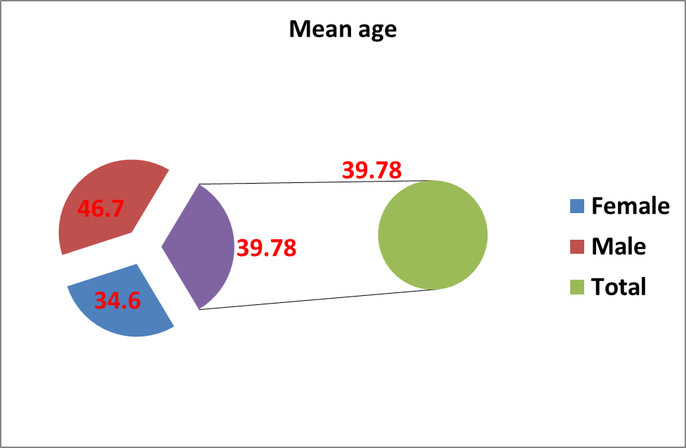

Figure (1) : 3-D Pie chart showed the mean age of female and male

Table (2): Descriptive of elongated styloid process length in both female and male
Male |  | Female
Left length | Right length | Left length | Right length
35.26 | 35.48 | 33.13 | 33.31 | Mean
1.764125 | 1.491216 | 1.971099 | 1.71057 | SD
0.394659 | 0.333605 | 0.440962 | 0.382678 | SE

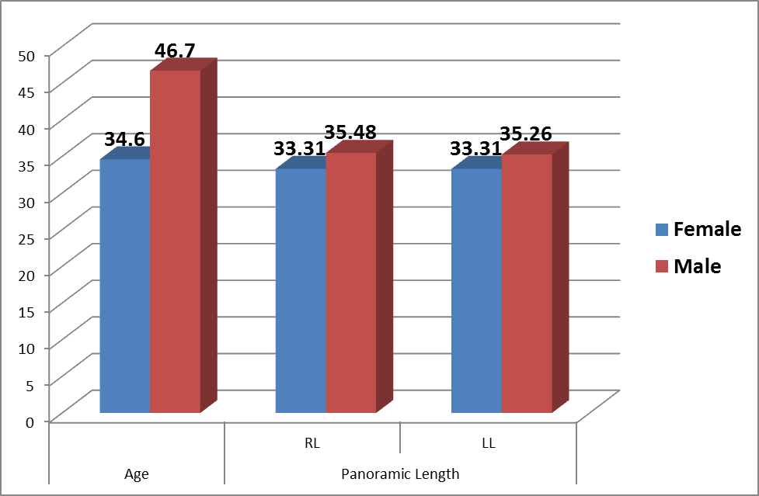
Figure (2) : The mean age of elongated styloid process length in female and male .

Table (3): T-test between male and female for age , length of right and left sides of elongated styloid process .

between male & female | T | p | Sig
age | 3.761 | 0.002 | S
Right length | 6.475 | P<0.01 | HS
Left length | 5.382 | P<0.01 | HS

Table (4) : T-test for age and length of right side, age and length of left side and between length of right and left sides of elongated styloid process in each gender.

 | Female |  |  | Male
 | T | p | Sig | t | p | Sig
Age & Right length | 0.969 | 0.339 | NS | 3.684 | 0.002 | S
Age & Left length | 1.114 | 0.272 | NS | 3.803 | 0.003 | S
Right & Left length | 1.364 | 0.181 | NS | 1.913 | 0.066 | NS

Table (5) : Chi-square for present of symptoms

Symptoms | Chi | p
Symptoms | 0.761 | 0.383 | NS
Non - signficant because they present in only old age .

Table (6) : Descriptive of symptoms by age groups in female and male .

 | Female | Symptoms | Male | Symptoms
<20 | 0 | 0 | 3 | 0
20-30 | 20 | 4 | 3 | 0
31-40 | 8 | 0 | 3 | 0
41-50 | 12 | 8 | 6 | 2
>50 | 0 | 0 | 15 | 10
Total | 40 | 12 | 30 | 12

Table (7) : Distribution of symptoms by age groups .

 | No. | % | S.y | %
<20 | 3 | 4.28571 | 0 | 0
20-30 | 23 | 32.8571 | 4 | 16.6667
31-40 | 11 | 15.7143 | 0 | 0
41-50 | 18 | 25.7143 | 10 | 41.6667
>50 | 15 | 21.4286 | 10 | 41.6667
Total | 70 | 100 | 24 | 100

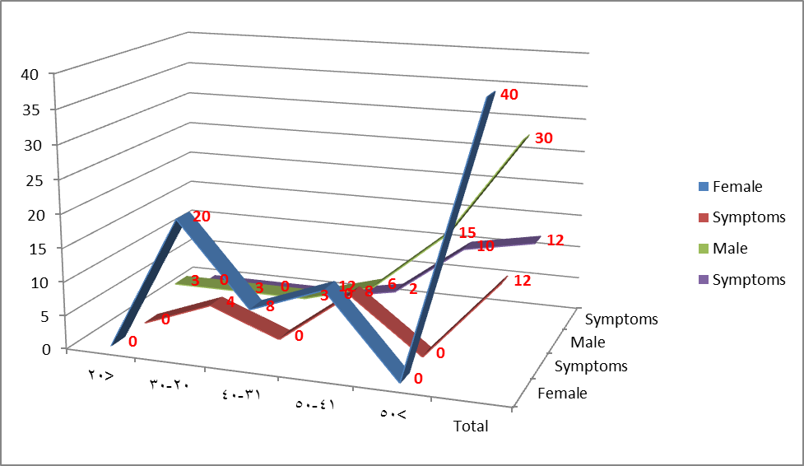

Figure (3) : Distribution of symptoms by age groups in female and male .

Table (8) : person’s correlation between age and present of symptoms in female , male and for total .

 |  | r | p
Female | Age & Symptoms | 0.56 | P<0.01
Male | Age & Symptoms | 0.489 | 0.007
Total | Age & Symptoms | 0.492 | P<0.01

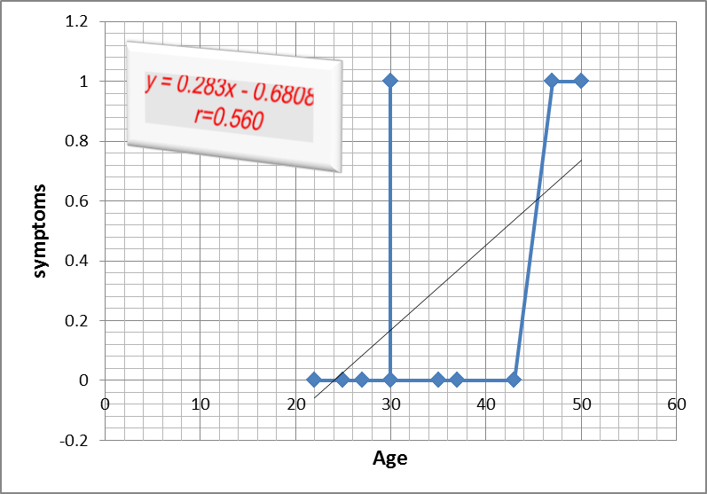

Figure (4) : Show person’s correlation r=0.560 between age with symptoms in female ; the effect of age with symptoms b=0.283

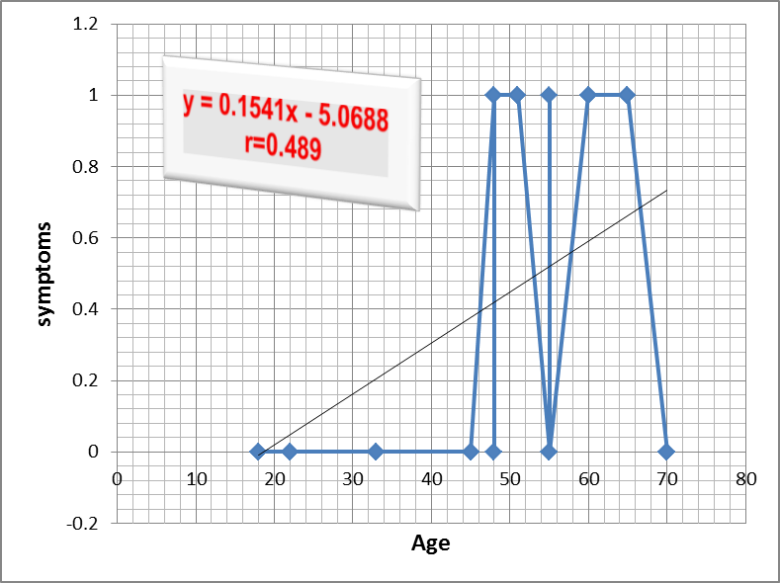

Figure (5) : Show person’s correlation r=0.489 between age with symptoms in male ; the effect of age with symptoms (b=0.154) .

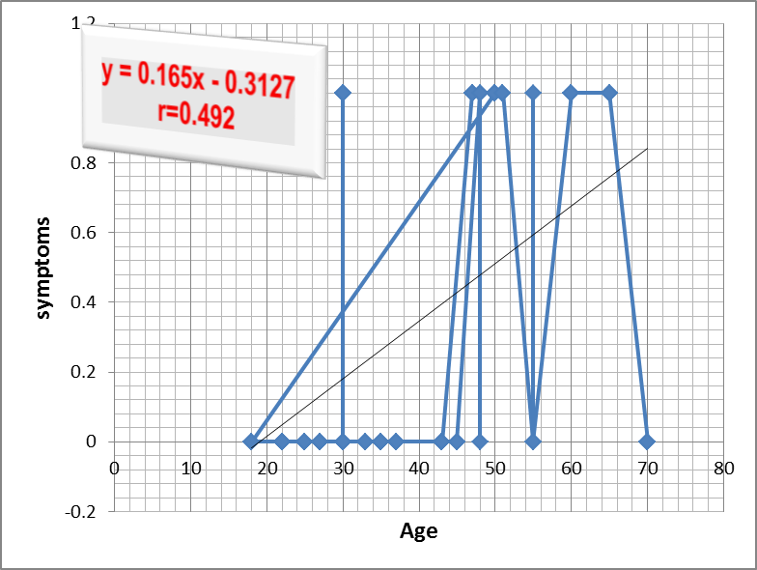

Figure (6) : Show person’s correlation r=0.492 between age with symptoms ; the effect of age with symptoms ( b=0. 165) .

