MDJ

Panoramic study of third molar eruption for chronologic age assessment in Iraqi population

Dr. Amal R.S. Mohammed, B.D.S., H.D.D., M.Sc. Rad.
Dr. Nuhad Al. Hassan, B.D.S., M.Sc. Rad.

Abstract

Background: Age estimation plays a great role in forensic investigations, orthodontic, surgical treatment planning and tooth transplantation. The teeth are considered a reliable indicator of age and provide a number of parameters for age prediction. The purpose of this study was to estimate the chronological age based on the stages of mandibular third-molar eruption following the four stages given by Olze et al.
Materials and methods: The sample consist of 150 Iraqi subjects have been chosen with known chronologic age (range: 6–26 years) and gender (70 males and 80 female), digital panoramic radiograph had been taken for each examined subject . Olze et al. stages has been used to assess third molar eruption.
Results: Alveolar and occlusal eruption at 25% of males younger than females . T-test between gender for minimum age was statistically significant difference only in stage (B) with p-value (0.042).The deviation around normal value mean in complete occlusal eruption was more in female compared with male.
Conclusions: Radiographic evaluation of eruption stages of the third molars using dental panoramic radiographies can be an efficient tool for chronological age estimation in both forensic science and legal medicine. Complete occlusal eruption can be used to predict age equal or superior to 16 years.

Keyword: Third molar , forensic , chronologic age , eruption .

Introduction

Age estimation plays a great role in forensic investigations , orthodontic and surgical treatment planning and tooth transplantation . Method of chronological age estimation in adolescents and young adults may be including radiographical examination of the hand and wrist, the medial clavicular epiphyseal cartilage and finally 3rd molar development observations ^{(1,2,3)} . But compared to bone development, 3rd molars are less affected by variation in endocrine and nutritional status , hand and wrist development is completed around the age of 18 while 3rd molar development continues until the early twenties when the development of almost permanent teeth may be completed, and regressive changes in teeth with increasing age may not yet appear at that age ^{(4,5,6)} . Tooth eruption is one of criteria of developmental morphology that can be evaluated by either clinical examination or by evaluation the dental radiographs to determine the dental age ⁽⁷⁾ . The teeth are considered a reliable indicator of age and provide a number of parameters for age prediction ⁽⁸⁾ .The dentition perhaps more than other any structure in the body reflects physiological history of an individual and offers the most reliable for age assessment from approximately ten weeks of intrauterine life up to old age ^{(9,10)} . Teeth are naturally preserved longer after all the tissues and even bone disintegrated and hence are generally reliable for estimation of age ^{(10,11,12,13)} . Unlike teeth, bone cannot inspect directly in living individuals ^{(11,14)} . Panoramic radiographs are becoming increasingly viable for dentists and they help in the evaluation of third molar development , this radiograph type enables a general view of dental arches’ structures, facilitating the analysis and classification of third molar positions ^{(15,16,17,18)} . The aims of this study were to estimate chronological age and gender in Iraqi subjects based on stages of mandibular third molar eruption according to Olze et al. ⁽¹⁹⁾ method using digital panoramic images .

Materials and methods

In this study, panoramic radiographs of 150 subjects (70 males and 80 females) with known age and gender were evaluated. The age ranged between ( 6-26 years ) . The investigated radiographs were taken from AL-Karama specialized center of dentistry, radiographs with optimum density and contrast were included in the study and those with any pathology, magnification and distortion were excluded. The subjects exhibiting the following conditions were not including in this study (Impacted, congenital abnormalities affecting jaws, degenerative disorders, etc.). The panoramic x-ray machines that used in the present study was Dimax 3 digital X-ray machines manufactured by Planmeca Oy, Helsinki, Finland .The stages of third molar were compared to the illustration given by Olze et al.⁽¹⁹⁾ the following staging system:

Stage A: Occlusal plane covered with alveolar bone.
Stage B: Alveolar emergence, complete resorption of alveolar bone over occlusal plane.
Stage C: Gingival emergence, penetration of gingiva by at least one dental cusp.
Stage D: Complete emergence in occlusal plane.
The eruption stage of third molar were subjected to statistical analysis using Statistical Package for the Social Science (SPSS)

Results

The results of the statistical analysis for female and male are shown in table (1) , for both gender the obtained data show that within the entire observed age interval, the minimum and means of the chronological age increased with increasing stage; thus, they demonstrate a good correlation between the stages and the chronological ages of the subjects. In table (2) ,figure (1) were cleared the number of each stage of third molar eruption according to gender. Chi-square between male and female by age was statistically significant difference (8.00, p-value= 0.048 ) and moderate statistically non-significant correlation (R= 0.575, p-value=0.540) ,table (3) demonstrated these results .Table (4) showed chi-square between male and female by stages (8.66, p-value=0.043) which was statistically significant difference with ( p-value=0.043 ) and moderate statistically non-significant correlation (R=0.48, p-value=0.827) .T-test between gender for maximum age was statistically significant difference in both stages (B,C) with p-value (0.0459,0.048 respectively ) , table (5) represented that, while t-test between gender for minimum age was statistically significant difference only in stage (B) with ( p-value =0.042), table (6) showed that .T-test (one – sample test) showed highly statistical significant difference for all stages in female as well as it showed highly statistical significant difference for all stages in male ; difference with 95% confidence interval was high in upper quartile than lower quartile in both male and female for all stages while female showed high value for lower quartile and upper quartile compared to male except in stage A; as shown in tables (7,8).
Control Chart for stage (A) between upper level was 9.3253 and lower level was 4.0080 be straight line then increased gradually, figure (2) cleared that. A close correlation between expected and observed value for stage (B) in female compared with male are shown in figure (3). The deviation around normal value mean of observed value in stage (D) was more in female when compared with stage (B), figure (4a,4b) illustrated that .

Discussion

Teeth offer an excellent material for age determination by stages of development below the age of 25 years and by secondary changes after the age of 25 years ⁽²⁰⁾ . The assessment of third molars eruption provides assisstive data for the estimation of the forensic dental age in living individuals ⁽¹⁹⁾ . As third molar development takes a long period of time, it may be used as a measure for estimation of chronological age in a wide age range ⁽²¹⁾ . In the present study, complete emergence in oral cavity was at around the age of 16 in male and at around the age of 17 in female. The third molars do not emerge before the 17th year of life in some European populations ^{(19,22,23)} and Japanese population ⁽²⁴⁾ which was partially proximate with results of this study. A study done by Karadayi et al. ⁽²⁵⁾ . To obtain and analyze data regarding third molar development and eruption in Turkish population for dental age estimation, a total of 744 dental panoramic radiographies of 394 female and 350 male subjects aged between 8 and 22 years were examined. Third molar eruption was assessed relative to the alveolar bone level and concluded that the minimum age for complete emergence of the wisdom teeth in the occlusal plane was 15 in males and 16 in females that it was younger in male than female which was in conformity with results of this study that male younger than female (16 in male and 17 in female).
The result of study to assess the stage of third molar eruption in 77 male and 73 female Indian subjects aged ranged between 12-26 years using conventional orthopantomograms to evaluate dental age by Tuteja et al. ⁽²⁶⁾ and they found that the females were ahead of the males of all stages of eruption of the third molar which in harmony with this result for stage C only (11 in female and 13 in male) while the variation may be related to ethnic difference and genetic factors and also different methodologies also they suggested that determined the age of alveolar, gingival and complete eruption of third molar in occlusal plane in adolescents and young adults ,minimum and most probable ages of examined subjects can also evaluated using third molar eruption stage .In present study , they found statistical differences between male and female at some stages while in some studies, there were no statistical differences in the mean degree of third molar development between males and females ^{(27,28)} . However, in some other previous studies, sexual dimorphism was determined at some stages ^{(29,30)} .The finding that the mean age of complete emergence was ahead in male than female (20.9756 in male and 21.1951in female) in harmony with the finding obtained by Brkićet et al. ⁽³¹⁾ the mean age of complete emergence ranged from 21 to 21.5 years for males and from 21.4 to 21.5 years for females. Shourie ⁽³²⁾ investigated eruption of the permanent teeth in 1412 boys and 474 girls from a southern Indian region (Madras) and 1713 boys from the northern Indian region around Lahore; the subjects’ ages ranged from 6 to 21 years, one to three percent of the south Indian boys’ upper and lower wisdom teeth started to emerge at the age of 13 years; furthermore, 0.5–0.7% of the north Indian boys exhibited the emergence of at least one wisdom tooth at age 13 which was in agreement with the finding. The start of eruption of third molar in oral cavity which explained by gingivial emeregence younger in female than male that in harmony with the finding of study done by Otuyemi et al. ⁽³³⁾ , to investigate eruption of the third molars in 523 male and 548 female Black Nigerians aged 11–21 years (14 in male and 13 in female) .The diversity could be explained by the differences in the selected age range of the study populations .The finding of our study that eruption of lower quartile of wisdom tooth earlier than upper quartile in both gender which was confirmed with the finding of Olze et al. ⁽³⁴⁾ , a total of 516 conventional orthopantomograms from 410 male and 106 female Black South African subjects of known age (12–26 years) .The third molar is only the developing tooth after the age of approximately 14 years that continue for a long period of time and until later age ^{(35,36,37)} .
Tooth development is affected from environmental factors less than tooth eruption. Therefore, the variation of third molar eruption is greater ⁽³⁸⁾ .The present investigation provides reference data on third molar eruption in the Iraqi population. Although third molars’ eruption shows greater variability than development of third molars, data which were obtained from this study about eruption of these teeth can be supportive to development data for age estimation. Formation of third molar not different between females and males, further formation not related to somatic growth and sexual maturation ^{(35,37)} . All other permanent teeth are characteristically earlier in formation and eruption in the female nevertheless the third molar is exception tooth with no sexual difference in either calcification or eruption therefore, a third molar assumes great forensic importance being unique among human teeth ⁽³⁷⁾ .

Conclusions

Radiographic evaluation of eruption stages of the third molars using dental panoramic radiographies can be an efficient tool for chronological age estimation in both forensic science and legal medicine. Complete occlusal eruption can be used to predict age equal or superior to 16 years.

Acknowledgments:
The authors wish to thank Dr. Sabah Nima Ali (Assistant Professor in the college of dentistry – Baghdad University for his help in the statistical analysis).

References

- Greulich WW., Pyle SI. Radiographic atlas of skeletal development of the hand and wrist. 2nd edn. Stanford: Stanford University Press,(1959).
- Kreitner KF., Schweden FJ., Riepert T., Nafe B., Thelen M. Bone age determination based on the study of the medial extremity of the clavicle. EurRadiol .(1998) ; 8: 1116-22.
- Olze A., Schmeling A., Taniguchi M., Maeda H., Van Niekerk P., Wernecke KD., Geserick G. Forensic age estimation in living subjects: the ethnic factor in wisdom teeth mineralization. Int J Leg Med.(2004a) ; 118:170–3.
- Engstrom C., Engstrom H., Sagne S .Lower third-molar development in relation to skeletal maturity and chronological age. Angle Orthod.(1983) ; 53:97–106.
- Willems G. A review of the most commonly used dental age estimation techniques. J Forensic Odontostomatol (2001) ; 19:9-17.
- Zeng DL., Wu ZL., Cui MY .Chronological age estimation of third molar mineralization of Han in southern China .Int J Leg Med. (2010) ; 124:119–23.
- Gustafson G. Age estimation from of teeth. J Am Dent Assoc .(1950) ;41:45-54.
- Babshet M., Ashith B. , Acharya AB., Venkatesh G. Naikmasur VG. Age estimation from pulp/tooth area ratio (PTR) in an Indian sample: A preliminary comparison of three mandibular teeth used alone and incombination .Journal of Forensic and Legal Medicine (2011) ;18 : 350-354.
- Wilson DF. and Brown KA . Forensic Odontology. In: Prabhu SR., Wilson DF. , Daftary DK., Johnson NW.(Editors) . Oral Diseases in Tropics, Oxford University Press. (1993) ; 758-9.
- Narnbiar P. Age estimation using third molar development . Malaysian J Pathol .(1995) ; 17:31-4.
- Kvaal SI. ,Kolltveit KM. , Thomsen IO. , Solheim T. Age estimation of adults from dental radiographs . Forensic SciInt (1995) ;74 :175-85.
- Bhat VJ. and Kamath GP. Age estimation from root development of mandibular third molars in comparison with skeletal age of wrist joint . Am J Forensic Med Pathol . (2007) ; 28 :238-4.
- Stavrianos CH. ,Mastagas D. , Stavrianou I. , Karaishou O. Dental age estimation of adults : A review of methods and principals . Res J Med Sci (2008) ; 2:258-68 .
- Miles AE. Dentition in the estimation of age. J Dent Res. (1963) ; 42:255-63.
- Quiróz OJ. and Palma A. The mandibular third molar: a method for predicting its eruption. Orthodontic Cyber Journal(1999). [cited 2010 Jul 20]. Available from: URL:http://orthocj.com/1999/02/the-mandibular-third-molar-a-method-for-predicting-its-eruption/
- Marinho SA., Verli FD., Amenábar JM., Brücker MR. Avaliação da posição dos terceirosmolaresinferioresretidosemradiografiaspanorâmicas. Robrac .(2005) ;14(37):65-8.
- Martinez A.M., Caballero A.D., Duran S.S. La -radiografiapanoramicaunaherramientaparaidentificar los factoresquedeterminan la erupcion de los tercerosmolaresmandibularesasintomáticos – reporte de unainvestigacion. ActaOdontológicaVenezolana (2005); 43(3) [cited 2010 Aug 1]. Available from: URL:http://www.actaodontologica.com/ediciones/2005/3/radiografia_panoramica.asp.
- Sandhu S. and Kaur T. Radiographic study of the positional changes and eruption of impacted third molars in young adults of an asianindian population. J Oral MaxillofacSurg . (2008) ;66(8):1617-24.
- Olze A., Peschke C., Schulz R., Schmeling A. Studies of the chronological course of wisdom tooth eruption in a German population. J Forensic Leg Med (2008) ; 15:426–429
- Reddy KN. and Bhaskar GR. Forensic medicine.Hyderabad.1st ed. Andra Pradesh : Neo Silver Jubilee Press .(1970) ; .p. 46.
- Sisman Y., Uysal T., Yagmur F., Ramoglu S.I. Third-molar development in relation to chronologic age in Turkish children and young adults. Angle Orthod .(2007) ; 77(6) :1040-5.
- Rantanen AV. The age of eruption of the third molar teeth. Acta Odontol Scand .(1967) ; 25:1-86.
- Muller HR. Eine Studieuberdie Inkonstanz des dritten Molaren. Fehlen, Anlage, Durchbruch, Diss Dresden (1983).
- Olze A., Ishikawa T., Zhu BL., Schulz R., Heinecke A., Maeda H., et al. Studies of the chronological course of wisdom tooth eruption in a Japanese population. Forensic SciInt. (2008a) ; 174:203–206.
- Karadayi B., Kaya A., Kolusayın M.O., Karadayi S., Afsin H., Ozaslan A. Radiological age estimation: based on third molar mineralization and eruption in Turkish children and young adults .Int J Legal Med .DOI(2012) ; . 10.1007/s00414-012-0773-8.
- Tuteja M.,Bahirwani S., Balaji P. An evaluation of third molar eruption for assessment of chronological age: A panoramic study. Journal of Forensic Dental Sciences. (2012) ; 4(1):13-18.
- Bolanos MV., Moussa H., Manrique MC., Bolanos MJ. Radiographic evaluation of third molar development in Spanish children and young people. Forensic Sci Int( 2003) ; 133:212-219.
- Olze A., Taniguchi M., Schmeling A., Zhu BL., Yamada Y., Maeda H., Geserick G. Studies on the chronology of third molar mineralization in a Japanese population. Leg Med. (2004b) ; 6:73-79.
- Mesotten K., Gunst K., Carbonez A., Willems G .Dental age estimation and third molars :a preliminary study. ForensicSci Int . (2002) ; 129:110-115.
- Arany S., Iino M., Yoshioka N. Radiographic survey of third molar development in relation to chronological age among Japanese juveniles. J Forensic Sci. (2004); 49:534-538.
- Brkić H., Vodanović M., Dumančić J., Lovrić Ž., Čuković-Bagić I. and Petrovečki M. The Chronology of Third Molar Eruption in the Croatian Population . Coll. Antropol. (2011) ; 35( 2) : 353-357.
- Shourie KL. Eruption age of teeth in India. Ind J Med Res. (1946) ;34:105-18.
- Otuyemi OD., Ugboko VI., Ndukwe KC., Adekoya-Sofowora CA. Eruption times of third molars in young rural Nigerians. Int DentJ .(1997) ;47:266-70.
- Olze A., van Niekerk P., Schulz R., Schmeling A . Studies of the chronological course of wisdom tooth eruption in a Black African population. J Forensic Sci. (2007) ; 52:1161-1163.
- Demisch A. and Wartmann P. Calicification of the mandibular third molar and its relation to skeletal and chronological age in children.Child Dev .(1956) ; 27:459-73.
- Ergstrom C., Engstrom H., Sagne S. Lower third molar development in relation to skeletal maturity and chronological age . Angle Orthod. (1983) ; 53:97-106.
- Acharya AB. Clinical and radiological perspective of forensic dentistry. In: Ongole R., Braveen BN. (Editors). Textbook of Oral Medicine, Oral Diagnosis and Oral Radiology, India: Reed Elsevier India Private Limited (2010) ; p.741.
- Ciapparelli L .The chronology of dental development and age assessment. In: Clark DH (ed) Practical forensic odontology.Wright, Oxford, . (1992) ; pp 22-42.

Table (1) : Show means of all stages ( in female and male )

Female
 | Stage (A) | Stage (B) | Stage (C) | Stage (D)
Mean | 6.6667 | 10.9643 | 15.3333 | 21.1951
SD | 1.1547 | 1.81521 | 1.0328 | 2.78585
SE | 0.66667 | 0.34304 | 0.42164 | 0.43508
Min | 6 | 8 | 11 | 17
Max | 8 | 15 | 17 | 26
25% | 6 | 10 |  | 19
50% | 6 | 11 |  | 21
Male
Mean | 6.5714 | 10.3846 | 14.25 | 20.9756
SD | 0.7868 | 1.66024 | 1.0351 | 3.13439
SE | 0.29738 | 0.46047 | 0.36596 | 0.48951
Min | 6 | 8 | 13 | 16
Max | 8 | 14 | 16 | 26
25% | 6 | 9 | 13 | 18
50% | 6 | 10 | 14 | 20

Table(2): Number of stages of third-molar eruption in both female and male
Gender | Stage A | Stage B | Stage C | Stage D | Total
Female | 12 | 107 | 36 | 165 | 320
Male | 24 | 52 | 31 | 173 | 280

Table (3) Chi-square between male and female by age
Sig | P-value | Chi-square
P<0.05 Significant | 0.048 | 8.00 | Age
R=0.575 p=0.540

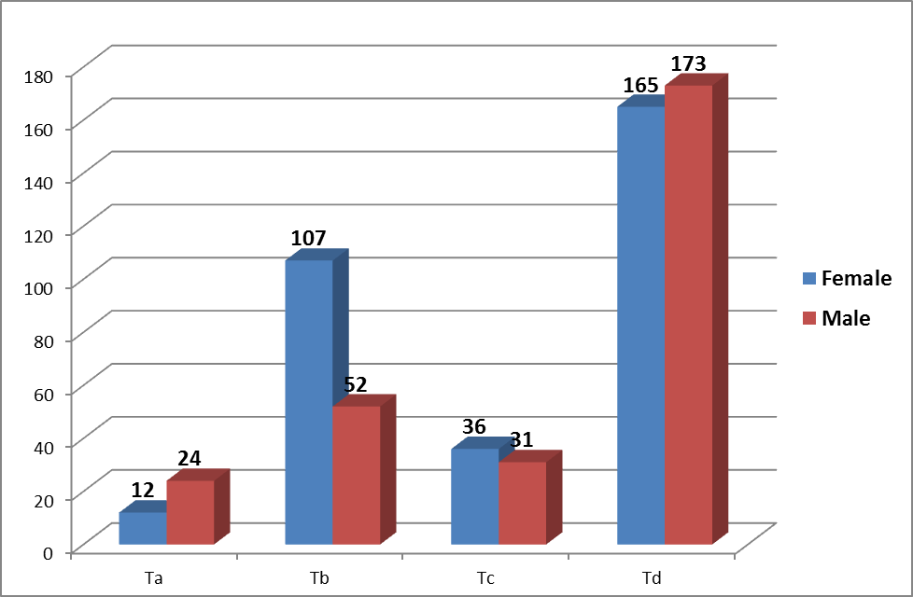

Figure (1): Number of stages of third molar eruption according to gender

Table (4) Chi-square between male and female by stages

 | P-value | Chi-square
P<0.05 Significant | 0.043 | 8.66 | Stages
R=0.48 p=0.827

Table (5): T-test between male and female by older age (Stages of third-molar eruption)

Sig | P-value
NS | P>0.05 | Stage A
S | 0.04S9 | Stage B
S | 0.048 | Stage C
NS | P>0.05 | Stage D
Table (6): T-test between male and female by younger age (Stages of third-molar eruption)

Sig | P-value
NS | P>0.05 | Stage A
S | 0.042 | Stage B
NS | P>0.05 | Stage C
NS | P>0.05 | Stage D

Table (7) :T-test (one-sample t-test) in female (show statistical significant difference between stages).

 | Test Value =0
 | T | Df | Sig.(2-tailed) | Mean Difference | 95% Confidence Interval of the Difference
 |  |  |  |  | Lower | Upper
Stage (A) | 10.0 | 2 | 0.010 | 6.66667 | 3.7982 | 9.5351
Stage(B) | 31.962 | 27 | 0.000 | 10.96429 | 10.2604 | 11.6681
Stage (C) | 36.366 | 5 | 0.000 | 15.33333 | 14.2495 | 16.4172
Stage(D) | 48.716 | 40 | 0.000 | 21.19512 | 20.3158 | 22.0744

Table (8): T-test (one-sample t- test) in male (show statistical significant difference between stages).

 | Test Value =0
 | T | Df | Sig.(2-tailed) | Mean Difference | 95% Confidence Interval of the Difference
 |  |  |  |  | Lower | Upper
Stage (A) | 22.098 | 6 | 0.000 | 6.57143 | 5.8438 | 7.2991
Stage(B) | 22.552 | 12 | 0.000 | 10.38462 | 9.3813 | 11.3879
Stage (C) | 38.938 | 7 | 0.000 | 14.25000 | 13.3846 | 15.1154
Stage(D) | 42.850 | 40 | 0.000 | 20.97561 | 19.9863 | 21.9649

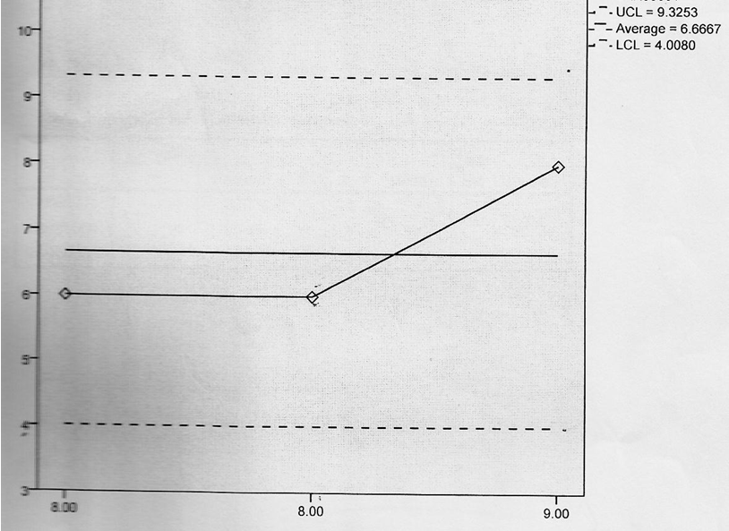

Sigma
level: 3
Figure (2): Control Chart distribution for stage (A) in female (show upper and lower control level)

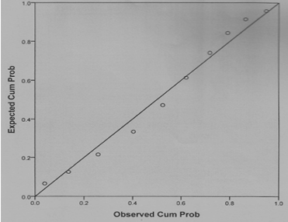
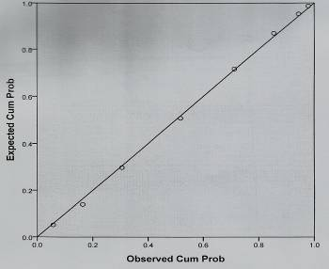
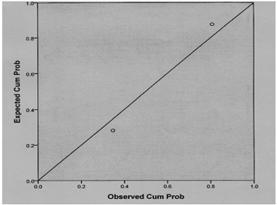
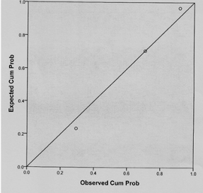
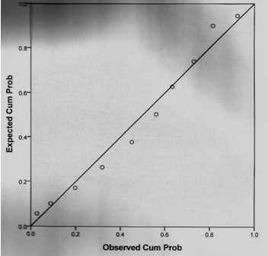
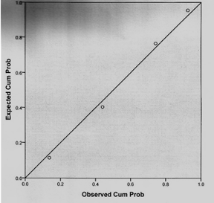

Stage (A) in female
Stage (B) in female
Stage (D) in female

Stage (D) in male
Stage (B) in male
Stage (C) in male
Stage (A) in female

Figure (3): Show correlation between expected and abserved value in female and male for all stages
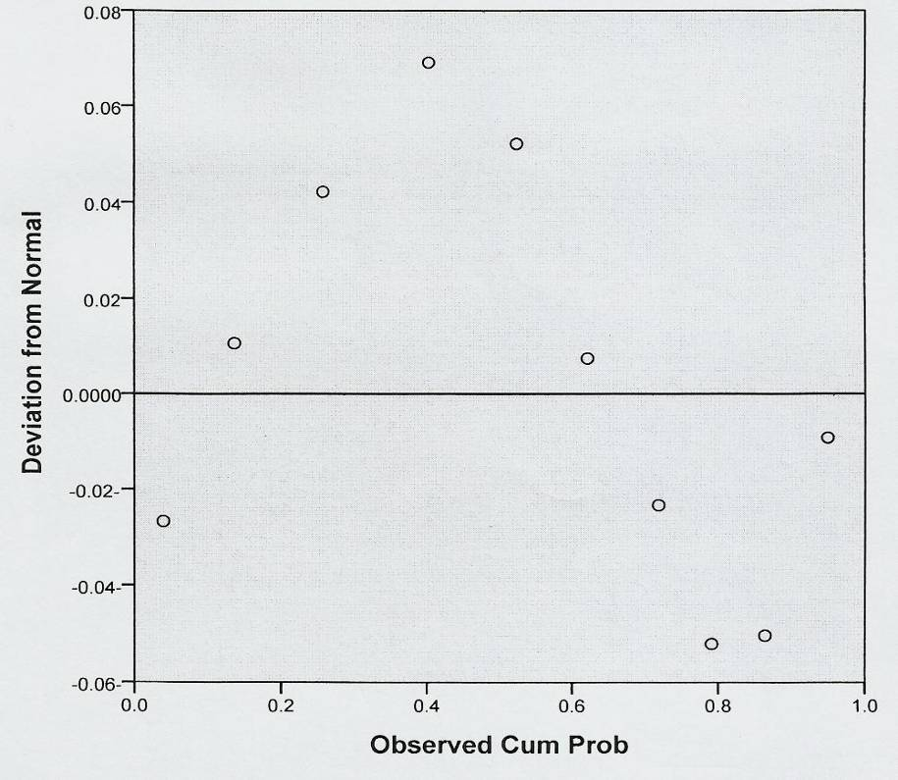

Figure (4a) :Detrended Normal P-P Plot of Stage D in female

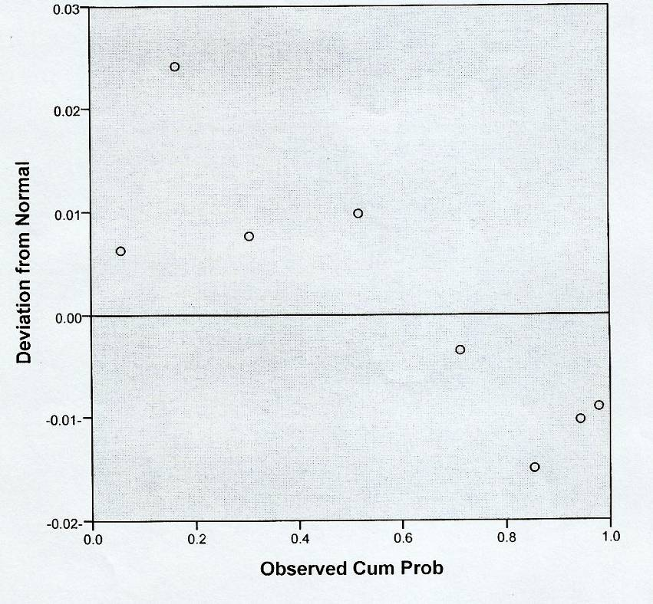

Figure (4b) :Detrended Normal P-P Plot of Stage B in female

