MDJ

Adhesion strength of silicone-based skin adhesive combined with stone-wool fibers

Dr. Arshad F. Jassem Al-Kaabi. *

Abstract

Aim: The aim of this study is to evaluate and improve the adhesion strength of the silicone-based skin adhesive for the appropriate functioning time.
Method: Two groups of samples were prepared, six samples per group, and a human surrogate skin samples were used made from cross-linked polyamide polymer resembling the stratum corneum layer of the human skin. A 180 degree peel test was performed to measure the adhesion strength.
Results and conclusion: The results showed that there was a statistically significant different in the amount of adhesion strength between the two groups which confirmed that the stone-wool fiber addition had increased the adhesion strength of the silicone-based skin adhesive.

Key words: Skin adhesives; Silicone-based adhesives; Stone-wool fibers.

Introduction

Facial prostheses are restorations made from polymeric compounds to simulate missing parts of the face in terms of esthetics and functionality. The biggest challenge presented when using extra-oral prosthesis attached to the facial skin is the capability of the adhesive material to behave as intended for the required period of time. The adhesion longevity, easy to peel off with minimum residue left on skin, and minimizing possible skin irritation are the factors that should be considered carefully when selecting skin adhesives [1]. Silicone adhesives polydimethylsiloxane has been extensively used for maxillofacial prosthesis adhesion to skin. No matter how long the polymer chain is, the material remains in the liquid or the oily state. Certain fillers, mainly silica, are added to this polymer to change it to the gel state when making maxillofacial prosthesis [2].
*Assistant Lecturer, College of Health & Medical Technology / Baghdad
Bab Almuadham / Baghdad / Iraq
High temperature stone wool fibers is a man-made product through spinning molten rocks at a temperature of about 1600 ºC with the presence of air flow. These fibers are characterized by a very high alumina content that unexpectedly gave it the bio-solubility quality as well as low heat conductivity and sound absorption [3].
The goal of this study was to improve the adhesion strength of the medical skin adhesive to retain prosthetic devices on the skin for the required functioning time, and to be peeled off easily without affecting the skin by causing trauma of leaving bulk residue.

Materials and Methods

Medical grade silicone (Factor II-USA) samples were used for this experiment. A skin surrogate material (Spenco-USA) was used that consisted of woven nylon surface at one side to simulates human skin surface properties. Hollister medical skin adhesive was the choice for this experiment based on its popular use for retaining maxillofacial prostheses. The adhesive modification was based on mixing Stone Wool fibers (the average particle dimension was 150 micrometers) with the silicone adhesive within the ratio of 1:6.
Two groups of samples were prepared in this study. The control group consisted of six samples and the modified adhesive group that consisted of six samples as well. The silicone sample dimension was 30X10X2 mm so was the surrogate skin sample.
The adhesive application was done by using a roller made from polystyrene polymer with a surface energy ranging between 28-34 Dyne/cm. the adhesive application was standardized by applying a load of 300g over the roller to allow equal amount of force for fibers distribution and surface wettability. The adhesive was applied to the silicone sample and left for 5 minutes before applying the sample to the substratum according to the adhesive manufacturer instruction (to give enough time for the propellant to evaporate). The peel test was conducted using Mark III chemo-mechanical tester Figures (1 and 2) with a peel speed of about 3 mm/sec. The experiment was conducted under a controlled temperature and humidity (25Cº and 45%).

Results

After conducting a 180 degree peel test for all samples, the adhesion strength measurements were quite different between the two experimental groups. The independent sample test (IBM SPSS Statistics version 20) results showed that there was a statistically significant difference in the adhesion strength between the experimental and the control groups, p-value < 0.05. According to the descriptive statistics, the fiber-modified adhesive group had a higher mean value but also a higher variance among the samples. However, the p-value was also significant whether equal variances was assumed or not.

Discussion

The main goal of this study was to optimize facial prosthesis adhesion to skin to achieve function and esthetics properly. As reported in the literature, the adhesion failure happened cohesively leaving residue on both prosthesis and skin surfaces. In order to overcome the unwanted cohesive failure, adding microfibers to the adhesive may slightly increase the cohesion strength. It was poorly reported in the literature the efficacy of incorporating micro-fibers to the silicone adhesive as an approach to increase the adhesion strength of the adhesive. Fiber-reinforced composite addition to silicone adhesive did not produce significant increase in the adhesion strength values as was expected [4]. This might be due to the poor compatibility between silicone elastomer and the fiber type used. The high temperature stone wool fibers was selected for this experiment since its high silica content is compatible with silica filler exist in the silicone elastomeric prosthesis [5].
Using artificial surrogate for human skin was also challenging. Since the main purpose of this experiment was to mechanically understand the effect of this combination, the artificial surrogate for the human skin was selected based on texture and chemistry to simulate the dead stratum corneum layer of the human skin.
The descriptive values are clearly shown in Figure (3). The mean value for the fiber-modified adhesive group had a superior strength than the control group despite the fact that the fiber-modified group showed greater variance. The statistical analysis confirmed our hypothesis that the suggested combination would significantly raise the adhesion strength value by increasing the cohesion strength of the adhesive itself.

Conclusion

This experiment has mechanically proved that the addition of Stone wool microfibers to the silicone-based skin adhesive would significantly improve its adhesion value mainly by increasing the adhesive cohesion strength which eventually may lead to less residue being left on the skin or the prosthesis after peeling off. However, cohesion failure may be desired for certain cases where prosthesis is to be attached to delicate skin surfaces. Further studies are suggested to examine the adhesive behavior in different temperature and humidity conditions.

References

- Kiat-amnuay S, Gettleman L, Khan Z, Goldsmith LJ. Effect of adhesive retention on maxillofacial prostheses. Part I: skin dressings and solvent removers. J Prosthet Dent. 2000 Sep;84(3):335-40.
- Rudoni C. A service evaluation of the use of silicone-based adhesive remover. Br J Nurs. 2008 Jan 24-Feb 13;17(2):S4, S6, S8-9.
- Guldberg M, Jensen SL, Knudsen T, Steenberg T, Kamstrup O. High-alumina low-silica HT stone wool fibers: a chemical compositional range with high biosolubility. Regul Toxicol Pharmacol. 2002 Apr;35(2 Pt 1):217-26.
- Yerci Kosor B, Artunç C, Şahan H. Adhesive retention of experimental fiber-reinforced composite, orthodontic acrylic resin, and aliphatic urethane acrylate to silicone elastomer for maxillofacial prostheses. J Prosthet Dent. 2015 Apr 7. pii: S0022-3913(15)00045-1. doi: 10.1016/j.prosdent.2014.12.018.
- Andreopoulos AG, Evangelatou M, Tarantili PA. Properties of maxillofacial silicone elastomers reinforced with silica powder. J Biomater Appl. 1998 Jul;13(1):66-73.

Table (1): Peel test results

Sample type | Bond Strength  (Dynes)
As received 1 | 1260
As received 2 | 260
As received 3 | 1120
As received 4 | 1590
As received 5 | 1710
As received 6 | 1830
Fiber-modified 1 | 2870
Fiber-modified 2 | 3000
Fiber-modified 3 | 2750
Fiber-modified 4 | 1837
Fiber-modified 5 | 1470
Fiber-modified 6 | 1347

Table (2): Mean and standard deviation measurements

 | Grouping | N | Mean | Std. Deviation | Std. Error Mean
Peel Test | Control | 6 | 1295.0000 | 574.20380 | 234.41772
Peel Test | Fiber-modified | 6 | 2212.3333 | 746.02484 | 304.56337

Table (3): Independent sample t test for the groups

 |  | Levene's Test for Equality of Variances |  | t-test for Equality of Means
 |  | F | Sig. | t | df | Sig. (2-tailed) | Mean Difference | Std. Error Difference | 95% Confidence Interval of the Difference
 |  |  |  |  |  |  |  |  | Lower | Upper
Peel Test | Equal variances assumed | 2.338 | .157 | -2.387 | 10 | .038 | -917.33333 | 384.33125 | -1773.67673 | -60.98994
Peel Test | Equal variances not assumed |  |  | -2.387 | 9.385 | .040 | -917.33333 | 384.33125 | -1781.34246 | -53.32421

Figures

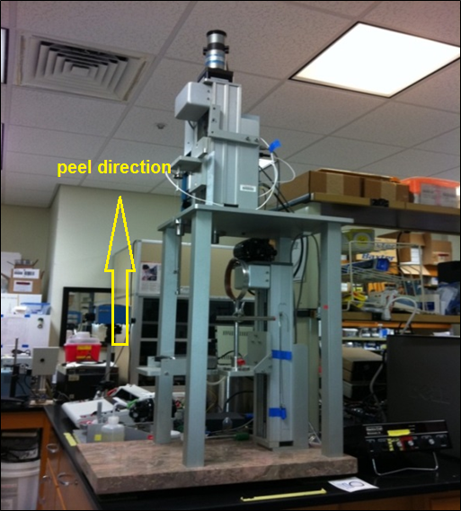
Figure (1): Mark III chemo-mechanical tester

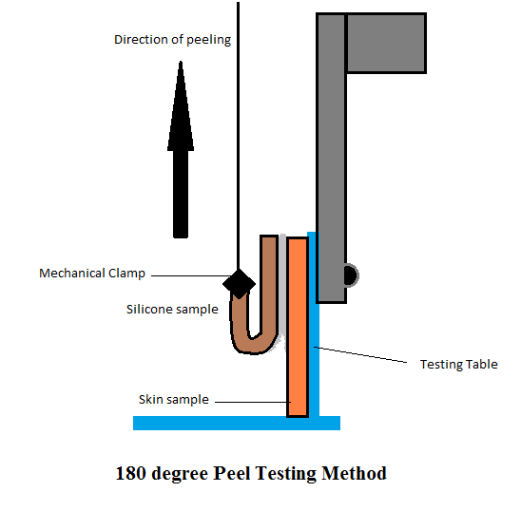
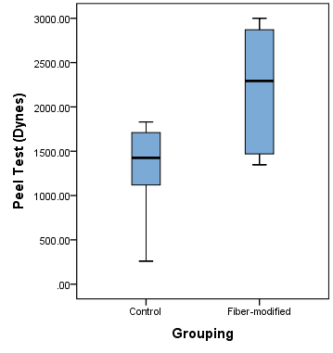

Figure (2): 180 degree peel test
Figure (3): means and standard deviations for the groups

