MDJ

Evaluation of Some Properties of Iraqi Plaster by Using Some Additives and Microwave Drying Technique

Dr. Areej Shehab Ahmad. (Lecturer), M.Sc. in Prosthodontics

Abstract

Aims of this study:1- Evaluation of some properties of Iraqi plaster, compressive strength & surface roughness. 2- Improving the quality of Iraqi plaster by incorporation of some additives. 3- Studying the effect of microwave drying on the compressive strength & surface roughness of Iraqi plaster.
Methods: 56 samples of Iraqi plaster used in this study, divided into two main groups according to the main tests used, 28 samples for compressive strength & 28 samples for surface roughness.
Samples of each test were divided into two groups (each group 14 samples). The first group was without additives, while the second includes the modified gypsum products (Iraqi plaster) with additives, (Gum Arabic 0.5%, calcium oxide 0.75%, and ferric oxide 0.2%).
Samples of each subgroup are subdivided into two subgroups also according to the drying method of Iraqi plaster, Open air drying method & Microwave drying method (7 samples for each)
Measuring of both tests was done in Technology University in Baghdad. Compressive strength measurement by using (unconfined compression machine), while, surface roughness of the samples was measured by Profilometer.
Results: The results showed that incorporation of additives to Iraqi plaster result in changing their evaluated properties & Comparing with open air drying method, microwave drying enhanced the properties tested in this study.
Conclusions: incorporation of additives to Iraqi plasters result in (Improvement of the compressive strength, reduction of the surface roughness and increase smoothness).

Keywords: Iraqi plaster, Microwave drying, open air drying, Gum Arabic.

Introduction

Gypsum materials are used extensively to make models casts and dies in dentistry. ¹ Gypsum products probably serve the dental profession more adequately after slight modification. ²
Products offer a number of advantages as model and die materials; they are accurate, dimensionally stable, easy and convenient to use, compatibility with most impression materials and appropriate setting expansion and familiarity. ³ However, disadvantages of gypsum materials are fracture of the set cast ⁴, technique sensitivity and susceptibility to abrasion. ⁵
The quality requirements of cast materials for good dental casts include: dimensional accuracy, acceptable detail reproduction, abrasive resistance, surface hardness, ease and efficiency of manipulation compatibility with impression materials, lack of toxicity strength. ⁶⁻⁸
Many studies have attempted to introduce an improve system for models and die construction ⁹, experimental attempt to improve the mechanical products where oriented mainly towards requirement. ¹⁰ Several articles have been published since the middle of the last cent additives for this purpose. In the present experimental study and in order to improve gypsum materials many attempts have been made by the use of various additives to gain several modifications related to the chemical, mechanical and physical properties of the gypsum materials. ¹¹⁻¹³ Dentists have often found that it is necessary to work with gypsum casts soon after separating them from the impressions, since wet cast usually has inadequate strength, and dentist normally must wait (24 to 48) hours before the cast is strong enough for manipulation. ^{14, 15}
Microwave energy has been shown to be an efficient source of electromagnetic energy to polymerize acrylic resin dentures, and this was firstly reported by Nishii (1968)¹⁶ ,microwave polymerization was later studied by Kimura et al. (1983)¹⁷ who started base line researches in the use of this energy for polymerization.¹⁸ In the field of microwave technique which has been applied for polymerization of acrylic resin, many studies have been conduct to compare several properties of acrylic resin cured by this technique and conventional water bath technique. These studies showed that acrylic resin processed by microwave technique has higher or similar properties to that cured by water bath technique. ^{19,20} Microwave drying technique has been shown to be an efficient and accurate method of drying many types of gypsum products with different programs. ^{21,22} However, there is little research on the microwave technique as a drying method for the gypsum products, and the ideal time and optimum power of microwave drying have not yet been determined. It is important to know the nature of the gypsum products, particle size, shape and their relation to the properties of the gypsum materials and the effects of adding additives on these properties. The microwave drying technique, additives materials, and particle size of gypsum products are important to evaluate their effects on acrylic denture base. So this study was done to improve the quality of the Iraqi plaster by the incorporation of some additives in a specific ratio (Gum Arabic 0.5%, calcium oxide 0.75%, and ferric oxide 0.2%). And study the effect of microwave drying on some properties of modified Iraqi plaster (Compressive strength & surface roughness) in comparison with open air drying method.

Materials & Methods

56 samples of Iraqi plaster (Al-Ahliya Company for gypsum industries/ Baghdad) used in this study, Figure (3), they are divided into two main groups according to the main tests used, 28 samples for Compressive strength & 28 samples for ssurface roughness.
Samples of each test divided into two groups (each group 14 samples). The first group was without additives, while the second group includes the modified gypsum products (Iraqi plaster) with additives, Gum Arabic 0.5% (manufactured by B.D.H Acacia), Calcium oxide 0.75%, (manufactured by B.D.H. Chemicals; U.K), and Ferric oxide 0.2% (manufactured by Aldrich Chem. Inc. Ltd. / U.K)^{. 23}
Samples of each group are subdivided into two subgroups according to the drying method of Iraqi plaster, (Open air drying method & Microwave drying method), 7 samples for each.
1. Open Air: The samples were prepared and left for 24 hours from the start of mixing, and then measured.
2. Microwave Drying: The samples were prepared and left for 2 hours from the start of mixing, and then dried by microwave according to the drying cycle (800 watts for 10 minutes) ,then measured^{23 .}
The concentration of each additive (gum Arabic 0.5%, calcium oxide 0.75%, and ferric oxide 0.2%) in experimental measurements used in this study,showed the best results as used in previous study by (Mohammed A.A., 2006).²⁴

Main methods

Preparation of all the tests samples and mixing procedure:
A special split moulds were used to prepare 5 cylindrical specimens each time used, 20 mm in diameter and 40 mm in length, Figure (4-A). Mixing procedure employed in the preparation of all the test specimens according to the ADA specification No. 25 for gypsum products (1975)²⁵. Distilled water was used as mixing water for preparation of all tests mixing water temperature was maintained at 23 ± 2 °C. The test powder was added to the correct amount of water and allowed to soak for 30 sec. then it was mechanically mixed for 60 sec. using mechanical vacuum mixer. One hundred gm. of Iraqi plaster mixed with distilled water according to determined water/ powder ratio. The mould coated with a thin layer of separating medium before pouring the mixture to facilitate the removal of the sample after being set.
The prepared mix was poured down the side of the mould retained on a glass plate. The mould then vibrated gently while being filled. The over- filled mould then covered with a second glass plate which rocked into place and pressed firmly into contact with the top surface of the mould to ensure parallel ends. The specimens were removed from the split moulds after 30 minutes from the starting point of mixing; Figure (4-B).

Preparation of samples with additives:
100 gm of dried Iraqi plaster was weighed using an accurate electronic digital balance, and then the dried material was sieved for 20 minutes. All the materials were collected in a special pan to gain the total amount of the Iraqi plaster that would pass through the sieve mesh until no more gypsum product will pass through the sieve. The prepared Iraqi plaster mixed with combined additives (Gum Arabic 0.5%, Calcium oxide 0.75%, and Ferric oxide 0.2%), Figure (5).

Preparation of the Additives:
A-Gum Arabic:
The natural form of this material is obtained (B.D.H Acacia) as crystals with different shape, size and color. Before adding the material to the powdered gypsum, gum Arabic was ground to a fine powder. Then sieved by using a sieve of 100 pm to be homogenous with the gypsum material and free from any debris.
B- Calcium Oxide (CaO):
This material was prepared by converting the calcium carbonate (CaCCb) to calcium oxide (CaO) by heating the sample in a digital muffle furnace at a temperature of 900 °C for three hours at the college of medical & health technologies, using special porcelain crucible according to the following equation:
CaC0₃ CaO + C0₂
Calcium carbonate Temp. 900°C Calciumoxide
The resultant product was sieved using a sieve size of 100 pm, and then placed in a closed container to prevent the contamination of the product from humidity.
C- Ferric Oxide (Fe₂0₃):
Also known as Iron III oxide usually comes in two colors (blue and red) as a ready material (pigments) obtained from Aldrich Chem. Inc. Ltd. U.K.

Measuring of Compressive strength:
Then the sample was crushed after two hours from the start point of mixing by using (unconfined compression machine, Inc. model CN472, EVANSTON, 111) USA), Figure (6), at a loading rate of 980 ± 200 N/min (100 ± 20 Kg/ min).Total number of samples was (28) as previously mentioned.
The compressive strength was determined from the value of the maximum load at the point of specimen fracture, Figure (7), according to the following formula: ²⁶
Compressive Strength = Load (Kg)
Area (Cm²)*
* Surface area= Area of the circle = 3.14 Cm²

Measuring of the surface roughness:
The surface roughness of the samples was measured with Profilometer, (Taylor Hobson Profilometer, Talysuf type 10, Leicester, England,U.K.), Figure (8),where three measurements were made on each sample. The parameter roughness average (Ra) 1 was selected to describe the surface roughness of the sample at a distance of 1.5 mm for each measurement.
Total number of samples is (28 samples) as previously mentioned.
Ra = the average roughness: is the arithmetic mean of all values of the roughness profile within the measuring length.

Statistical Analysis :
In this study, there are two independent variables:
- Iraq plaster type [Conventional and modified (with additives)]
- Drying methods [Air and microwave technique]
So the statistical analysis of the data:
1- Descriptive analysis including mean and standard deviation.
2- Two way ANOVA test was applied to study the effect on the dependent variable (Compressive strength and surface roughness).
3- Student's t-test to evaluate the trend of different beverages within the group.
Highly significant difference at level (p<0.01), no significant difference at level (p>0.05), and significant difference at level (p<0.05)

Results

The effect of drying methods on Iraqi plaster (with and without additives):
Effect on the compressive strength:
Means & standard deviations of the tested samples of Iraqi plaster (without additives and with additives) dried by both, open air and microwave technique, for compressive strength test are listed in table (1) & the associated figure (1) appears that the Iraqi plaster with additives significantly has the higher mean value (2200 Kg/cm²),while the Iraqi plaster without additives significantly the lowest mean value (1285 Kg/cm²), this for samples dried by open air. This is true also for samples drying by microwave technique, that Iraqi plaster with additives significantly has the higher mean value (2914 Kg/cm²) than samples without additives which are significantly the lowest mean value (1485 Kg/cm²).
Two ways ANOVA test is used to compares among groups of compressive strength test as it shows in table (2) and associated LSD in table (3). There is a highly significance difference (p<0.01) between all groups of this study, except between group 1 (without add.) & group 3 (with add.), there is a significant difference (p= 0.049).as shows in table (3).

Effect on the surface roughness:
Means & standard deviations for the tested samples of Iraqi plaster (without additives and with additives) dried by both, open air and microwave technique, for surface roughness test are listed in table (4) & the means charts in figure (2) appears that Iraqi plaster without additives significantly has the higher mean value (1, 54 µm), while the Iraqi plaster with additives significantly the lowest mean value (0, 5 µm), this for samples dried by open air.
For samples drying by microwave technique, also the Iraqi plaster without additives also significantly has the higher mean value (2, 01 µm), while the Iraqi plaster with additives significantly the lowest mean value (0, 79 µm).
Two ways ANOVA test is used to compares among groups of surface roughness test as it shows in table (5) and associated LSD in table (6). There is a highly significance difference (p<0.01) between all groups of this study, except between group 1 (without add.) & group 3 (with add.), there is a significant difference (p= 0.049).as shows in table (6).
When t- test was employed in statistical analysis of this study, the results showed in table (7), (8), and (9) as follow:
Table (7) regard with compressive strength shows that there is a highly significant difference (HS) between two drying methods used in this study (open air & microwave technique). P<0.01
The result in table (8) that associated with surface roughness appears that there is also a highly significant difference (HS) between two drying methods (open air & microwave technique). P<0.01
For both tests, compressive strength & surface roughness, there is significant difference (S) between groups (without additives) and (with additives). This shows in table (9)

Discussion

Effect on Compressive Strength:

Effect of additives on the Iraqi plasters compressive strength:
Results obtained for the compressive strength in table (1), showed that compressive strength of the Iraqi plaster tested samples without additives has lower mean value than those with additives when tested under the same condition for both drying methods (open air & microwave technique).This is due to the lowered water/ powder ratio of the material when mixed with additives. This is related to the conditions of preparing of the gypsum products (a- hemihydrate is more dense, more regular, and less porous particle). ^{2, 8, 27}
After incorporation of additives, table (1) shows that there is an increase in the compressive strength for both dried by open air & microwave technique, this can be explained by the reduction in the water/powder ratio for the Iraqi plaster due to the emulsifying effect of combined additives, act of calcium oxide as a hardener modifier, and improved the adhesive forces between particles. This explanation is supported by (Al-Sadi et al., 1996)²⁸, (Thornton, 1998)²⁹ and agreed with (Sanad et al, 1982)³ .But had disagreement with (Seniour, 1992)³⁰ and (Abdelaziz et al., 2004)³¹.
For the Iraqi Plaster, the addition of a mixture of gum Arabic o.5% and calcium oxide o.75% also produces an increase in the compressive strength compared with material without additives(alone).This could be due to the effect of calcium oxide (quick lime) when mixed with water then called slaked lime and produce calcium hydroxide Ca(OH)2 or lime putty causing gypsum crystals to harden by the evaporation of water and gradual subsequent re-conversion to calcium carbonate CaC03 with time and this agrees with (Thornton, 1998)²⁹.

Effect of a microwave oven (as a drying method) on the Iraqi plasters compressive strength (with or without additives):
The compressive strength increased by time during the tested period is related to multiple factors: First, during the early stages, the gypsum product sample contains a lot of uncombined water which is used for workability. Second, the progressive crystal growth, accordingly the interlocking of the resulted crystals increased by time. So by the use of a microwave oven as a drying method for the Iraqi plaster with or without additives, tables (1) showed that the microwave drying method significantly increased the compressive strength of both compared with the compressive strength of these gypsum materials when dried in open air. Good results are obtained when gypsum products tested with a mixture of additives (gum Arabic 0.5%, calcium oxide 0.75%, and ferric oxide 0.2%).
An increase in the compressive strength by using the microwave drying technique could be explained by the presence of free water (excess water other than water required for the chemical reaction to convert the calcium sulfate hemihydrates to calcium sulfate dihydrate) in the gypsum sample resulting in weakening the structure., while during microwave drying process as a result of heat production within the gypsum samples, excess water begins to evaporate, fine crystals of gypsum precipitate after the last traces of water disappear. ³² The heat production may also improve the crystal form of gypsum product which results in the increase of its compressive strength. The high power level (800 Watt) with ten minutes used in this drying cycle.
The examined water/powder ratio varies according to the type of gypsum materials being used, type and concentration of the additives as a mixture being incorporated within the gypsum products. The actual amount of model plaster has the highest water/powder ratio. This is related to the physical nature of the powdered particles including size, shape, porosity, and density of the particles.
Porous, irregularly shaped hemihydrates crystals require more water to facilitate wetting and mixing; this can be seen in the Iraqi plaster, while for the less porous, dense, more regularly shaped crystals like Elite and dental stone require less water/ powder ratio. ^{1,8,33}
Adhesion between the particles of the hemihydrates is an important factor in determining the amount of water required to produce a product that can be poured. The water/powder ratio of the Iraqi plaster with a mixture of additives (gum Arabic 0.55, calcium oxide 0.75%, ferric oxide 0.2%) is significantly reduced. These additives collectively when mixed with gypsum powders act as " surface active agents " by changing the condition of the surface of grains and the forces between them to be more easily wetted by water and these results are supported by Ridge and Boell in (1962)³⁴. Also this may be due to the saponification effect of the formed calcium hydroxide Ca (OH) 2/ Gum Arabic mixture, which increases the pH of the mixture (increase alkalinity of the mixture).The emulsifying effect and the change in grain arrangements both result from Gum Arabic addition. ^{28, 30}
Generally, the amount of water required for the proper consistency is recommended by the manufacturer and differs for each product; any deviation from these recommendations will change the consistency of the material and the properties of the set mass. However, any modification in the consistency of the gypsum products should be within the range of the water/powder ratio recommended by American Dental Association (ADA) ²⁵ specification for gypsum products.
SB

Effect on the Surface Roughness of the Gypsum Products:
The surface topography of gypsum cast used as a replica with an important consideration when materials used intraoral and constructed against these gypsum cast should have a smooth surface to minimize tissue trauma.
The results obtained in table (4), showed that the Iraqi plaster samples without additives significantly has the higher mean value than the Iraqi plaster samples with additives which has the lowest mean value, this for samples dried by open air. This is true also for the samples drying by microwave technique.

Effect of additives on the Iraqi Plasters Surface Roughness:
There is a significant difference in the surface roughness between samples used in this study with & without additives. Samples without additives had the highest degree of surface roughness than those with additives which had the smoothest surface. This could be attributed to the difference in the rate of the water/ powder ratio for gypsum product. The gypsum product which has the highest surface roughness has the highest water/ powder ratio, while the gypsum material which has the lowest surface roughness has the lowest water/ powder ratio. The water /powder ratio is critical where improper use of gypsum products causing the excess water considered as free water (residual unreacted water) in the setting mass, and contributes to subsequent voids in the final set mass occurred between clumps of gypsum crystals. These voids are roughly spherical and these porosities cause the surface to be rough. The same observation was noticed by (Scrabecke/ al, 1986)³⁵ and (O'Brien, 2002). ³⁶
The gypsum particle size, shape, and compaction between them are the main factors in determining the amount of the water/ powder ratio; the lower surface area permits the use of lower water/ powder ratio to gain a workable mass resulting in less porous and denser for the final set mass. ³⁷
After incorporation of the combined additives for the Iraqi plaster, this showed that there is a significant reduction in the degree of the surface roughness of the plaster. This can be explained due to reduction in the water/ powder ratio (effects of additives), because of the difference in size, shape of the crystals, and the interference. Dispersion of small crystals among large crystals affect the quantity of water necessary for mixing leading to an increase in the density, less porosity, and reduction of roughness of the set sample. This agrees with Prombonas and Vlissidis (1994). ³⁸

Effect of Microwave technique on the Iraqi Plasters Surface Roughness:
By the use of the microwave oven as a drying method for both of Iraqi plaster (with or without additives), tables (4), an increase in the degree of the surface roughness when samples were microwave dried for drying. This could be explained by the rapid escape (expulsion) of the steam water from the tested samples after exposure to radiations within the microwave that might create micro porosity on the outer surface of the dried sample when tested by photomicrography.
Practically, this was noticed when the excess water covered the outer surface of the microwave wet gypsum sample, it looks like sponge when water squeezed from it, so that it is not recommended to use the microwave oven for drying extremely wet casts, otherwise cracks or holes would be obtained, and this agrees with Luebke and Chan (1985)¹⁴ & Luebke and Schneider (1985)³⁹.

Conclusions

The conclusions gained from this study include:
- There was no effect of additives on the chemical properties of Iraqi plaster due to low concentrations of additives used.
- The incorporation of additives (Gum Arabic 0.5%, calcium oxide 0.75%, and ferric oxide 0.2%) to Iraqi plasters result in changing their evaluated properties (Improvement of the compressive strength, reduction of the surface roughness and increase smoothness).
- Comparing with open air drying method, microwave drying enhanced the properties tested in this study (Highly significant differences P<0.01).

References

- Craig RG, O'Brien WJ, and Power JM. Dental Materials Properties and Manipulation. 6 ed., Mosby Co.; 1996. P. 242-265.
- Craig RG. Restorative Dental Materials. 10th ed. Mosby Co.; 1997. chap. 11, 12. p. l27-136, 500-540.
- Sanad ME, Combe EC, and Grant AA. The use of additives to improve the mechanical properties of gypsum products. J Dent Res. 1982; 61: P. 808-810.
- Schwedhelm ER and Lepe X (1997). Fracture strength of type IV and type V die stone as a function of time. J Prosthet Dent. 1997; 78(6):554- 559.
- Fan PL, Power JM, and Reid BC. Surface mechanical properties of stone, resin, metal and dies. J Amer Dent Assoc. 1981; 103(3):408-411.
- Aiach D, Malone WF, and Sandrick J. Dimensional accuracy of epoxy resin and their compatibility with impression material. J Prosthet Dent. 1984; 52(4):500-504.
- Zakaria MR, Johnston MW, Reisbick MH, and Campagni WV. The effects of a liquid dispersing agent and microcrystalline additives on the physical properties of type IV gypsum. J Prosthet Dent. 1988; 60(5):630-637.
- Craig RG and Power JM. Restorative Dental Materials. 11th ed. Mosby Co.; 2002. P. 635-670,392-404.
- Toreskog S, Phillips RW, and Schnell RJ. (1966): Properties of die materials a comparative study. J Prosthet Dent. 1996; 16(5): 119-131.
- Sanad ME, Combe EC, and Grant AA. Hardening of model and die materials by an epoxy resin. J Dent. 1980; 8(2): 158-162.
- Kotsiomiti E,Pissiotis A, kalotannides A and Diakoyianni MI.Effects of the addition of ammonium salts on improved dental stones surface hardness. Hellenic Dent J. 1995; 5: 45-50.
- Singh R,Ringh K, Agrawal KK, A comparative study of physical properties of gypsums manufactured in India .J Indian prosthethhodont Soc. 2013 Dec. 13 (4) ; 531-5.
- Mohammed NZ. The effect of adding some chemical materials on the physical and chemical properties of dental stone.[Master's thesis]. University of Mosul ; 2005. 85p.
- Luebke RJ and Chan KC. Effect of microwave oven drying on surface hardness of dental gypsum products. J Prosthet Dent. 1985; 54(3):431-435.
- Tuncer N, Tutekcioglu HB, and Calikkocaoglu S. Investigation on the compressive strength of several gypsum products dried by microwave oven with different programs. J Prosthet Dent. 1993; 69(3):333- 339.
- Nishii M. Studies on the curing of denture base resins with microwave irradiation with particular reference to heat curing resins. J Osaka Dent Unive. 1986; 2: 23-40.
- Kimura H, Teraoka F, Ohvishi H, Saito T, and Yato M. Application of microwave for dental techniques Part I Dough forming and curing of acrylic resin. J Osaka Dent Sch. 1983; 23: 42-49.
- Curry AA Rached RN, and Ganzarolli SM (2001): Microwave cured acrylic resins and silicon gypsum molding technique. J of Oral Rehabil. 2001; 28; 433-438.
- Truong UT and Thomasz FG. Comparison of denture acrylic resins cured by boiling water and microwave energy. Aust Dent J. 1988; 33:201-204.
- Sanders JL, Levin B, and Reitz PV. Comparison of the adaptation of acrylic resin cured by microwave energy and conventional water bath. Quintessence Int. 1991; 22(3): 181-186.
- Kazanoglu Aand Moon PC. Microwave heating of die stone. J Dent Res.1982; 61:304.
- Al- Hadad NS, Al-Mandilawi LR, and Al-Doori DI. Compressive strength of several gypsum products dried by microwave oven with different programs. Iraqi Dent J. 2001; 28:219-231.
- Mohammed SA. The effect of processing variable on the surface hardness, flow and setting time of gypsum materials. [Master's thesis].University of Alabama; 1983. 63p.
- Mohammed A.A. Evaluation of some properties of gypsum products of acrylic resin by the use of some additives and microwave technique. [Master thesis].University of Mosul; 2006. p.50.
- American dental Association specification (ADA). (Guide to dental materials and devices .7th ed. Chicago ADA. 1975; pp 203-208.
- Salem SA, Al- Hadithi KK, and Al-Shakhily GA. The effect of disinfectant solutions On some properties of dental stone cast. Iraqi Dent J. 1997; 19: 51-70.
- Aljubouri ZA and Alrawas AM. The petrography and Menirology of Technical plaster and local Juss . Iraqi Journal for earth Science. 2006; 34.
- Al- Sadi S, Combe EC, and Cheng YS. Properties of gypsum with addition of gum Arabic and calcium hydroxide. J Prosthet Dent. 1996; 76(5):530-534.
- Thornton J. A brief history and review of the early practice and materials of gap- filling in the west. J Amer Inst Conser. 1998; 37 (1): 3- 22.
- Seniour SS (1992): A study on dental hemihydrates produced from Egyptian gypsum raw materials. Doctor of philosophy (PhD) Thesis, University of Cairo.
- Abdelaziz KM, Attia A, and Combe EC. Evaluation of disinfectant casts poured in gypsum with gum Arabic and calcium hydroxide additives. J Prosthet Dent. 2004; 92(1): 27-34.
- Hersek N, Canay S, Akca K, and Ciftci Y. Tensile strength of type IV dental stones dried in a microwave oven. J Prosthet Dent. 2002; 87(5):499-502.
- Combe EC. Notes on dental materials .4 ed. Huntsmen offset printing PT Ltd; 1991. p. 97 -140,241-253.
- Ridge MJ and Boell GR. Effects of some additives on the water requirement of calcined gypsum. J Appl. Chem. 1992; 12:521-526.
- Scrabeck JG, Fames WB, and Hicks MJ. Spatulation methods and porosities in investments and impression materials. J Prosthet Dent. 1986; 55(3): 332-335.
- O'Brien WJ. Dental materials and their selection. 2nd ed. Quintessence book; 2002. p. 56-60.
- Aniisavice KJ. Phillips science of dental materials. 10 ed. WB Saunder Com;1996. P. 185-208.
- Prombonas A and Vlissidis D. Compressive strength and setting temperatures of mixes with various proportion of plaster to stone. J Prosthet Dent. 1994; 72(1): 95-100.
- Luebke RJ and Schneider RL. Microwave oven drying of artificial stone. J Prosthet Dent. 1985; 53(2): 261-265.

Table (1): Means & standard deviations of the compressive strength (Kg/cm²), for the tested samples of Iraqi plaster without additives and with additives dried by open air and microwave technique

Microwave Drying Method |  | Open Air Drying Method
With additives  (group4) | Without additives (group2) | With additives (group3) | Without additives (group1)
2914.286 | 1485.714 | 2200 | 1285.714286 | Mean
296.8084 | 167.6163 | 115.4700538 | 134.5185418 | SD
120.6538 | 68.13672 | 46.93904628 | 54.68233408 | SE
2500 | 1300 | 2100 | 1100 | Min
3400 | 1800 | 2400 | 1500 | Max

Table (2): ANOVA test between groups for the compressive strength

Sig | P-value | F-test
HS | P<0.01 | 104.155 | Between groups

Table (3): LSD

Sig | P-value | Mean Difference
HS | P<0.01 | 914.28 | (group1) &(group2)
S | 0.049 | -200.00 | (group1) &(group3)
HS | P<0.01 | -1628.57 | (group1) &(group4)
HS | P<0.01 | 714.28 | (group2) &(group3)
HS | P<0.01 | -714.28 | (group2) &(group4)
HS | P<0.01 | 1428.57 | (group3) &(group4)

Table (4): Means & standard deviations of the surface roughness (µm), while for tested samples of Iraqi plaster without additives and with additives dried by open air and microwave technique

Microwave Drying Method |  | Open Air Drying Method
With additives (group4) | Without additives (group2) | With additives (group3) | Without additives (group1)
0.798429 | 2.014571429 | 0.509571 | 1.542571 | Mean
0.080075 | 0.435135939 | 0.048076 | 0.236907 | SD
0.032551 | 0.176884528 | 0.019543 | 0.096304 | SE
0.713 | 1.466 | 0.447 | 1.201 | Min
0.891 | 2.67 | 0.601 | 1.811 | Max

Table (5): ANOVA test between groups for the surface roughness

Sig | P-value | F-test
HS | P<0.01 | 52.057 | Between groups

Table (6): LSD

Sig | P-value | Mean Difference
HS | P<0.01 | 1.033 | (group1) &(group2)
S | 0.049 | -.47200 | (group1) &(group3)
HS | P<0.01 | .74414 | (group1) &(group4)
HS | P<0.01 | -1.50500 | (group2) &(group3)
HS | P<0.01 | -.28886 | (group2) &(group4)
HS | P<0.01 | 1.21614 | (group3) &(group4)
Table (7): t-test between drying methods of the compressive strength samples

Microwave Drying Method | Open Air Drying Method
13.736 | 17.982 | t
P<0.01 | P<0.01 | p
HS | HS | sig

Table (8): t-test between drying methods of the surface roughness samples

Microwave Drying Method | Open Air Drying Method
8.571 | 10.841 | t
P<0.01 | P<0.01 | p
HS | HS | sig

Table (9): t-test between samples with additives and without additives for two tests (Compressive strength & surface roughness)

(surface roughness) |  | (Compressive strength)
With additives | Without additives | With additives | Without additives
6.541 | 3.033 | 5.213 | 2.01 | t
0.001 | 0.023 | 0.02 | 0.049 | p
S | S | S | S | sig

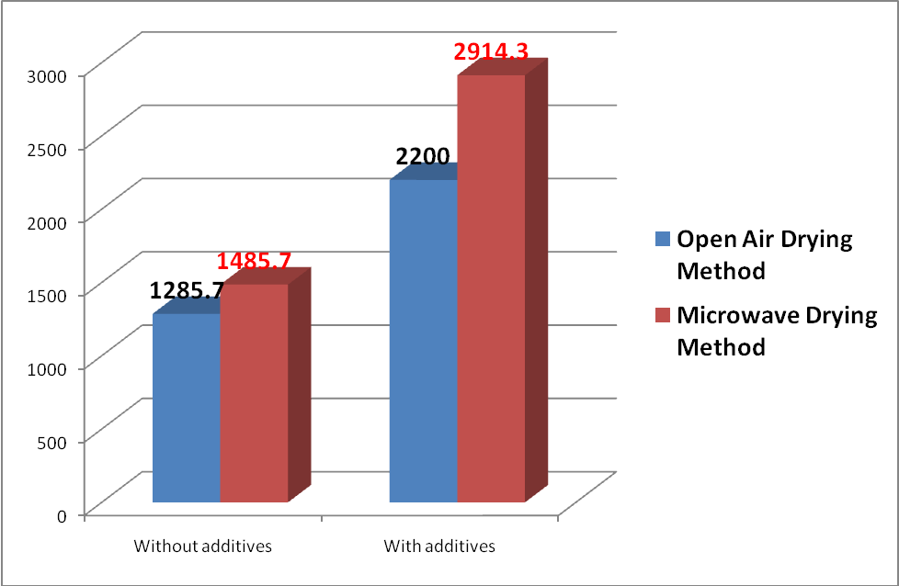

Figure (1): Means of the compressive strength (Kg/cm²), for tested samples of Iraqi plaster without additives and with additives dried by open air and microwave technique.

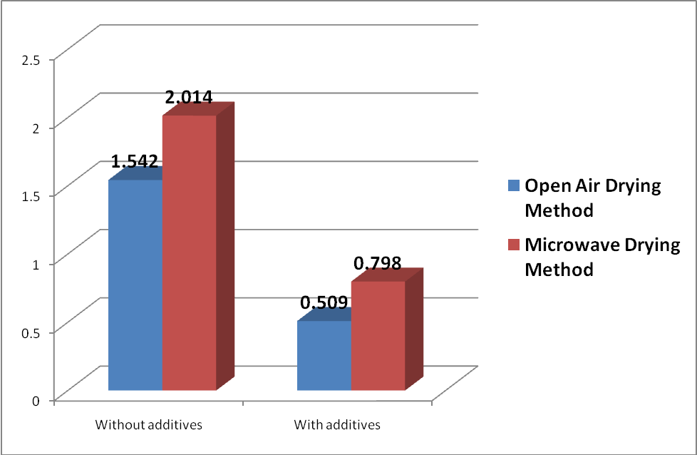
Figure (2): Means of the surface roughness (µm), for tested samples of Iraqi plaster without additives and with additives dried by open air and microwave technique.

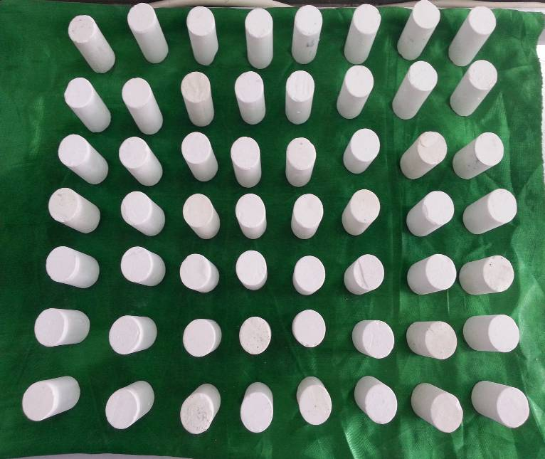

Figure (3): 56 samples of Iraqi plaster used in this study.

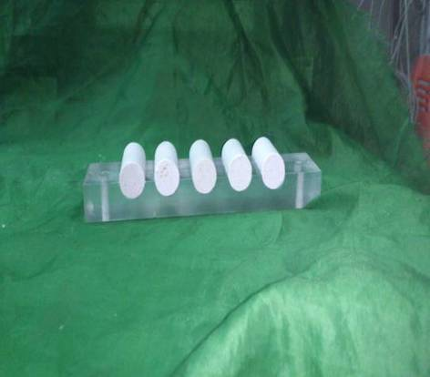
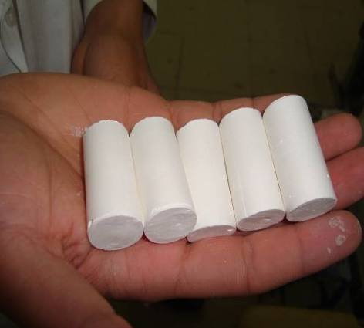

A
B

Figure (4):
A- A special split mould used to prepare 5 cylindrical specimens 20 mm in diameter and 40 mm in length.
B- The specimens were removed from the split moulds after 30 minutes from the starting point of mixing.

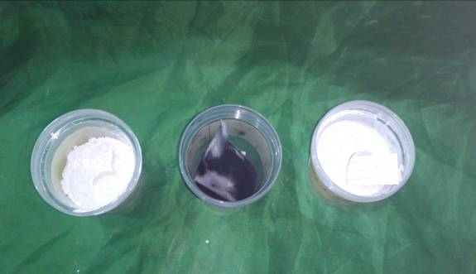
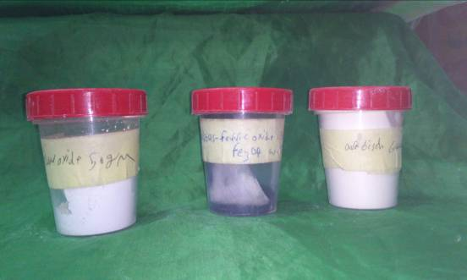

A
B

Figure (5):Additives used in this study(Gum Arabic 0.5%, calcium oxide 0.75% , and ferric oxide 0.2%).
A- Front view. B- From above.

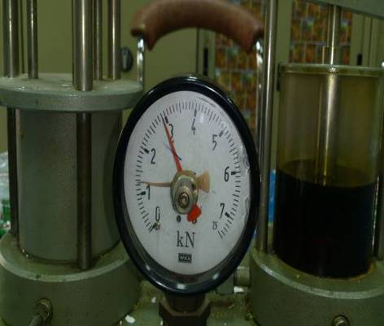
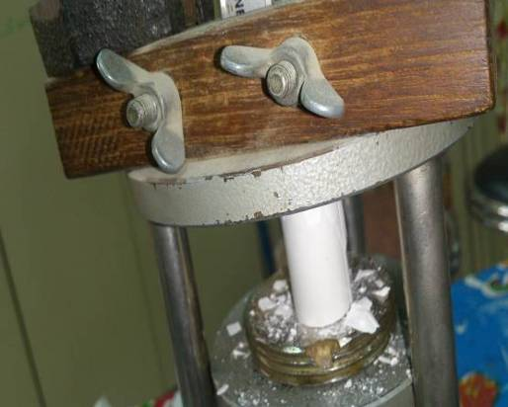

A
B

Figure (6): (A, B) Unconfined compressive machine.

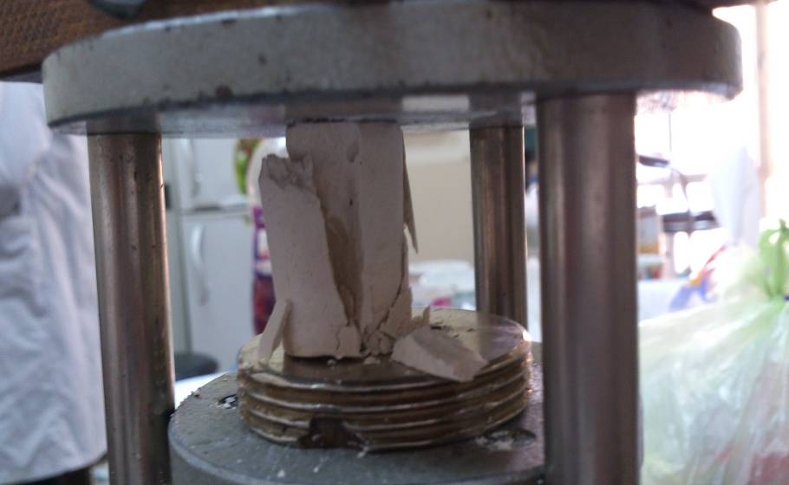

Figure (7): Specimen's fracture.

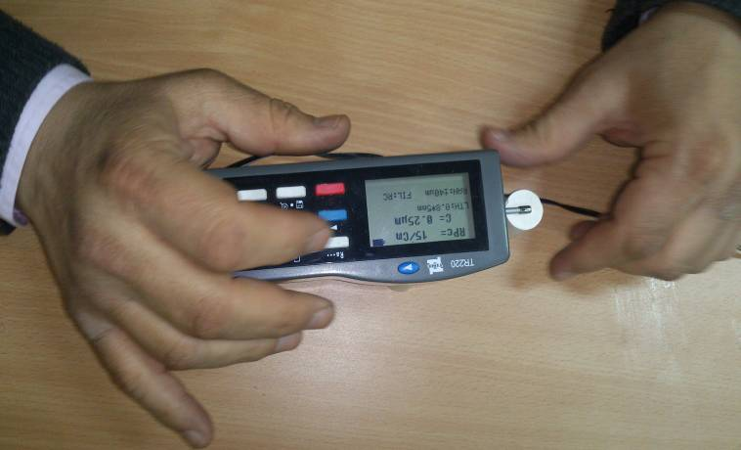

Figure (8): The surface roughness of the samples was
measured with Profilometer.

