MDJ

Evaluation The Effect of Three Types of Light Curing Systems On Temperature Rise intrapulpally and at the tooth surface during resin-based composite polymerization

Ass. Prof. Dr. Shatha A. Salih B.D.S., M. SC.
Prof. Dr. Raad Al- Nakeeb B.D.S., M. SC.

Abstract

Fifteen human premolar teeth freshly extracted were used. Standardized class V was prepared on the buccal and palatal surfaces of each tooth, the teeth randomly divided into three groups according to the curing mode of composite resin: group I cured with quart-tungsten halogen, group II cured with Soft Start While group III cured with Plasma Arc. The increase in temperature internally (inside the pulp chamber) and externally (at the outer surfaces of the tooth) for each sample of the three groups was measured by using two K type thermocouple connected with electrical thermometer. Results: revealed a very high significant differences (P= 0.0001) among the three groups . Conclusion: Plasma Arc light curing unit showed significantly the highest increase in temperature, while the Soft Start gave lower value and Quartz Tungsten Halogen unit with lowest temperature rise internally and externally.

Introduction

The increased use of bonded composite resins in dentistry has stimulated the development of advanced technology designed to improve the resin polymerization process¹. This is clear with the research into dental material photocuring which has corroborated the effectiveness of the curing units in polymerization².
Nevertheless It is quite clear that various dental procedures produce temperature increases of pulp and supporting tissue from both in vitro and in vivo studies; whereas, the amount of heat produced varies from case to case³. Its documented that Light curing units used for polymerizing restorative resins produce heat during operation. The emitted radiation at the light curing tip is mainly visible light and infrared energy; certain curing lights can impart a significant thermal rise⁴.
A temperature rise during curing of light activated restoratives relates to the exothermic reaction of the material during polymerization as well as to the heat output from the dental light curing unit^{5,6}. Temperature rise induced by curing units may
permanently damage the pulpal tissues⁷. Zach and Cohen5 used a Macaca Rhesus monkey model to conclude a temperature rise of 5.5°C within the pulp chamber could lead to irreversible pulp damage⁸. In another experiment 15% of the pulps of ‘small teeth’ became necrotic following such a temperature rise, while 60% of the pulps
failed to recover from an intrapulpal temperature rise of 11°C. Hussey et al. have reported the dental pulp may be endangered by the temperature rise that occurs during light curing⁹. Until recently, light emitted from a conventional quart-tungsten halogen light bulb (QTH) was used to cure composite resins and bonding agents. QTHs generate light when electrical energy heats a small tungsten filament to extremely high temperatures. This type of light source is usually operated at light intensities between 400 and 800 mw/cm² and polymerizes resin composite filling
material to a depth of 2 mm within 40 seconds^{10,11}. Most of the energy put into the halogen system is changed into heat but a small portion is emitted as light. Selective filters control the emission of as light¹². Selective filters control the emission of other wavelengths so only blue light is emitted^{13,14}. Wavelengths of 400-500 nm (blue light) emitted from these curing units activate camphorquinoneamine photoinitiation systems contained in most current composite resins. When these photoinitiator molecules are activated, they create free radicals that initiate the polymerization process^{13,15}. Another companies have marketed different halogen light curing units¹⁶ which were designed to automatically start irradiation with low power followed by high power to reduce the initial contraction stress of the light cure resin composites , often called Soft Start polymerization lights¹⁷ . While other developments have lead to reduce clinical chair time required for curing, alternate light sources such as Plasma Arc (PAC) lights with intensities in excess of 2000 mw/cm² have been developed¹⁰. The PAC lamp has been introduced in restorative dentistry in order to reduce the needed time to cure composite resin filling materials^{18,19}. Curing lights emit continuous frequency bands which are much narrower than those emitted by QTH lights. In general, the spectral radiometric output is limited to the range between 440 and 490 nm and is suitable for activating the camphorquinone, photoinitiator (maximum absorption at 468 nm) found in most light-cured adhesives. Since PAC lights emit at higher intensities, they are supposed to reduce curing times^{20,21}.
Since most dentists are familiar with the conventional visible light curing technique, comparing the effectiveness of the different light curing systems , would provide dentists with much clinical information. So the aim of the present study is to evaluate the influence of three light curing systems: Plasma Arc, Soft Start and conventional Quart-Tungsten Halogen light curing units on heat generation within the pulp chamber and at the outer surfaces of the tooth .

Materials and methods

Fifteen human sound upper second premolar teeth freshly extracted for orthodontic purpose were collected and stored in distilled water. the teeth were scaled, polished and checked for cracks by a magnifying eye lens (x 10). on the buccal and palatal surfaces of each tooth class V was prepared cervically. The dimensions were standardized with mesiodistal width and occlusogingival height of (3mm and 2mm) respectively and depth was 2mm by using tungesten carbide bur no.330 (Komet, Germany) in high speed handpiece (W & H, Dentalwerk, Austria) with proper water cooling. To create access to the pulp chamber, 2mm of the apices of the roots were removed with a carbide bur and the access through the apex was confirmed by pre-opening the canal with a root canal reamers of size 20-40 (Dentsply, Switzerland ), Fig. (1), root canal and pulp chamber were excavated. the teeth were randomly divided into three groups, each of five teeth, according to the cure mode. Fig.(2), each cavity was filled with Hericulite (micro-hybrid resin composite), of A2 shade according to its manufacturer instruction and cured according to grouping:- group I cured with Astralis 5 (QTH, conventional)(Ivoclar vivadent, Liechtenstein) curing unit (450mw/cm²for 40 second), group II cured with Degulux Soft Start curing unit (Degussa-HulsAG, Germany) (650mw/cm²for 10 + 30 second) while group III cured with Plasma arc (Flipo, Lokki, France) (1200mw/cm²for 12 second).Temperature Measurement:-a manikin was used as a base for each tooth. The teeth were placed into a water bath 37 ºC, leaving the crown and restorations exposed to ambient air, temperature was measured before and after light curing of the composite resin by using two K type thermocouple (Japan) Fig.(3) , one was inserted into the pulp chamber through the apex of the root, a second thermocouple was attached on the outer surface of the tooth adjacent to the composite restoration. The other end of each thermocouple was connected with electrical thermometer (RKC, PRECISION,K-Type Range 0-1200 ºC, Japan) which record the temperature after the tooth temperature stabilized. Initial temperatures were recorded at the two thermocouple locations. Another readings were recorded immediately after curing. The difference between final and initial temperature was recorded, which was considered as the increase in temperature, for all teeth of the three groups.
Results

The mean of the increase in temperature internally (inside the pulp chamber) and externally (at the outer surfaces of the tooth) for each sample of the three groups is shown in table (1), in which the highest mean of increasing temperature were recorded externally and internally with group III (38.87 ºC, 8.47 ºC), while the mean of increasing temperature externally and internally with group II (18.8 ºC, 4.12 ºC) which was near to the mean of increasing temperature for group I which was the lowest mean I (17.7 ºC, 4.7 ºC) respectively. ANOVA revealed that there was a very high significant differences (P= 0.0001) among the three groups internally and externally, where P < 0.05, within favor of the conventional group (Quartz Tungsten Halogen) over Soft Start and Plasma Arc group, table (2).and the results of T test between group III and group II, also revealed a very high significant differences (P= 0.0001) , within favor of Soft Start over Plasma Arc group. The comparison between the mean increase of temperature internally and externally for all groups is shown in figure (4), while figure (5) revealed that there is a linear relationship between temperature measurement internally and externally for the three groups.

Discussion

Light curing units used for polymerizing restorative resins produce heat during operation. Heat will be generated by the absorbed light as well as by chemical reaction of the polymerization process⁴ . Unfiltered infrared (IR) can result in heat generation at the target site (pulp)²². Therefore to reduce the passage of IR energy from the source to the tooth, a thin heat absorbing filter is an essential component, then further filtered by a band pass filter⁴. IR energy is absorbed by materials and resulting in increased molecular vibration, the result is the increased probability of molecular collision and the generation of heat. However, increased temperature also can arise from application of very intense visible light energy to a substrate as with the use of Plasma Arc unit. The massive numbers of photons interact with the molecules of substrate . which must absorb some of this energy, this absorbed energy result in increased molecular vibration and the generation of heat²³. As intensity of light activation unit and irradiation time, which are considered as variables governing heat generation²⁴ , and the maximum pulp chamber temperature rise during resin-based composite polymerization show a linear increase with increasing light intensity¹² , therefore, newer curing units with concentrating light guides or different light sources may require shorter curing times²⁵. The result in this study is in corporation with the previous literatures mentioned above, and also with studies were done by Haning and bott, 1999²⁶ , and Bagis et al, 2008¹in which they found that the higher rise in temperature was recorded with Plasma Arc .While less rise in temperature was recorded with Soft Start in which they documented two-step curing or ramp curing are recommended for complete polymerization and less heat generation³. this study documented that the least rise in temperature was recorded with Quartz Tungsten Halogen this is might be related to low light intensity with the presence of selective filters control the emission of as light¹². Selective filters control the emission of other wavelengths so only blue light is emitted^{13,14}.Therefore with the significant different results of the present study, temperature increase during polymerization has to be taken into account.

Conclusion

Under the circumstances of this in vitro study the following conclusions were drawn:
1-Plasma Arc, Soft Start and Quartz Tungsten Halogen units caused an increase in temperature inside the pulp chamber and at the outer surface of the tooth during curing of composite resin restorations.
2 -Plasma Arc light curing unit showed significantly the highest temperature rise, while the Soft Start gave lower value and Quartz Tungsten Halogen unit with lowest temperature rise internally and externally.

References

- Bagis B, Bagis Y, Entras E and Ustaomer S (2008). Comparison of the Heat Generation of Light Curing Units. J .Cont Dent Pract, Volume 9, No. 2.
- Melara Munguía, M. Arregui Gambús,F. Guinot Jimeno, L. J.(2011).Temperature changes caused by light curing units on dentine of primary teeth. Eur J Paed Dent. Vol. 12/1.
- KwonSu, Park Y Jun S, Ahn J and Lee In.(2013).Thermal irritation of teeth during dental treatment procedures.ISSN 2234-7658 (print) / ISSN 2234-7666 (online) http://dx.doi.org/10.5395/J, RDE. 38.3.105.
- Ghareeb NH, Dayem RN, Kamel JH, Al–Qaisi SD (2014). Evaluation of the Influence of Three Types of Light Curing Systems On Temperature Rise, Depth of Cure and Degree of Conversion of Three Resin Based Composites (An In vitro study). J Interdiscipl Med Dent Sci 2: 110. doi: 10.4172/jimds.1000110.
- Hannig M, Bott B (1999). In vitro pulp chamber temperature rise during composite resin polymerization with various light-curing sources. Dent Mater. 15:275-281.
- Lohbauer U, Rahiotis C, Krämer N, Petschelt A, Eliades A (2005). The effect of different light-curing units on fatigue behavior and degree of conversion of a resin composite. Dent Mater. 21:608-615.
- Bouillaguet S, Caillot C, Forchelet J, Cattani-Lorente M, Wataha JC, Krejc I. (2005). Thermal risks from LED- and high-intensity QTH-curing units during polymerization of dental resins. Biomed Res. 72:260-267.
- Stewardson DA, Shortal AC, Lumley PJ (2005). Thermal changes and cure depths associated with a high intensity light activation unit. J Dent. 32;643-651.
- Hussey DL, Biagioni PA, Lamey PJ(1995). Thermographic measurement of temperature change during resin composite polymerization in vivo. J Dent. 23:267-271.
- Wataha JC, Lockwood E, Lewis J, Wesser LM (2004). Biological effects of blue light from dental curing units. Dent Mater. 20:150-157.
- Usumez A, Nilgün O(2004). Temporary increase during resin cement polymerization under ceramic restoration: Effect type of curing unit. Int J Prosthodont. 17;200-204.
- Althoff O, Hartung M (2000). Advances in light curing. J Dent. 13:77–81.
- Turkkahramanan H, Kucukesmen HC (2005). Orthodontic Bracket Shear Bond Strengths Produced by Two High-power Light-emitting Diode Modes and Halogen Light. Angle Orthodont.; 75:854–857.
- Stahl F, Ashworth SH, Jandt KD, Mills RW (2000). Light emitting diode (LED) polymerization of dental composites: flexural properties and polymerisation potential. Biomater. 21:1379–85.
- William J, Anneke C, Bush A (2002). Comparison of polymerization by light-emitting diode and halogenbased light-curing units. Am J Dent Assoc. 133:335-341.
- Charlton CD. (2003). Resin composites http.//www. Broks. Af.Mil/dis/dimnotes/composites pdf 5.9.2003.
- Hasegawa T, Itoh K, Yukitani W, Wakumoto S. and Hismitsu H(2001).Effect of soft start irradiation on the depth of cure and marginal adaptation of dentin . Operat.Dent.26:389-395.
- Perimedde AP, Sheriffiss M, Irelands AJ (2004). An in vivo study to compare a light and a conventional quartz halogen curing light in ortodontiv bonding. Eur J Orthod. 26:573-577.
- Klocke A, Korbmacher HM, Lothar G. Huck, Kahl-Nieke B (2002). Curing lights for orthodontic bonding.Am J Orthod Dentofacial Orthop. 122:643-8.
- Sfondrini MF, Cacciafesta V, Pistorio A, Sfondrini G (2000). Effects of conventional and high-intensity lightcuring on enamel shear bond strength of composite resin and resin-modified glass-ionomer.Am J Orthod Dentofacial Orthop.; 119:30-5.
- Peutzfeld A, Sahafi A, Asmussen F (2000). Characterization of resin composites polymerized with curing units. Dent Mater. 16:330–336.
- Guiraldo RD, Consani S, Lympius T, Schneider LF, Sinhoreti MA, et al. (2008). Influence of the light curing unit and thickness of residual dentin on generation
- Rueggeberg F. (1999). Contemporary issues in photocuring . Copend Contin. Educ. Dent. Suppl. 20:4-15.
- Shortall AC & Harrington E.(1998).Temperature rise during polymerization of light activated resin composites. J., Oral Rehabil. 25(12):908-13
- Loney RW, Price RB (2001). Temperature transmission of high-output lightcuring units through dentin. Oper Dent 26: 516-520.
- Hanning M & Bott B. (1999). In- vitro pulp chamber temperature rise during composite resin polymerization with various light curing source. Dent. Mater. 15(4):278-281.

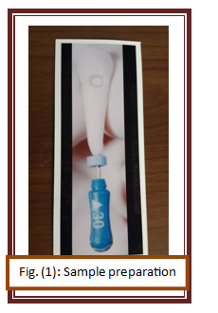
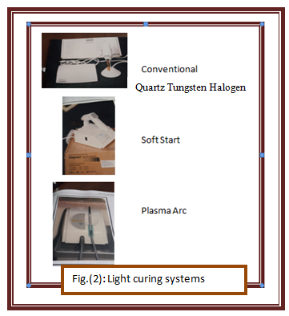

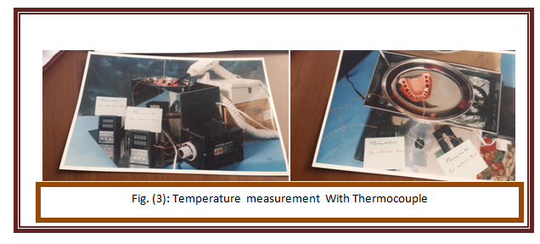

Table(4) T test for temperature measurements internally and externally for group III & II

P | DF | T | Std.  Deviations | Mean | N. | Group
0.0001  V.H.S. | 18 | 6.827 | 1.92 | 8.47 | 10 | III | Int.
0.0001  V.H.S. | 18 | 6.827 | 9.62 | 4.12 | 10 | II | Int.
0.0001  V.H.S. | 18 | 17.056 | 2.50 | 38.87 | 10 | III | Ext.
0.0001  V.H.S. | 18 | 17.056 | 2.75 | 18.8 | 10 | II | Ext.

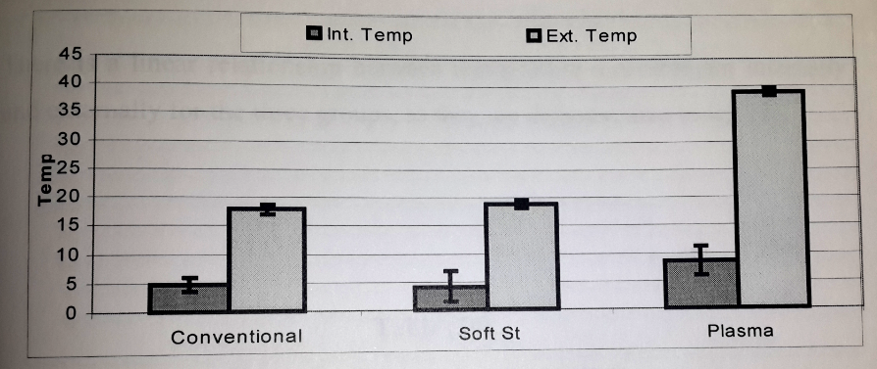

figure(4)Bar chart Peak temperature increase for the three groups internally and externally

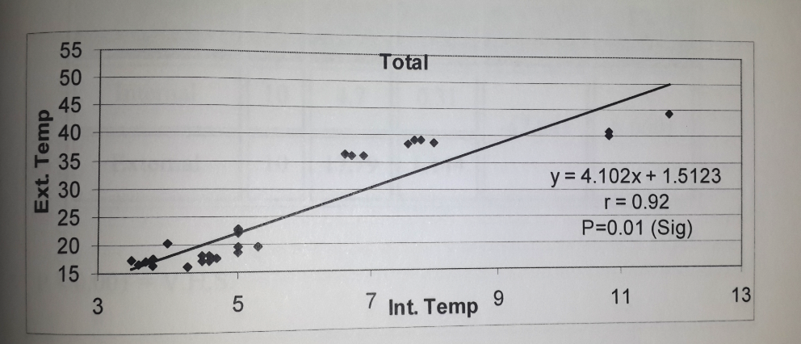

Figure(5)Scatter diagram The relation between external and internal increase in temperature for all groups

