MDJ

The Incidence of dentinal root defects caused by different Nickel Titanium instruments

Dr. Noor Aldiin A. Saieed B.D.S
Dr. Iman M. Al-Zaka, B.D.S., M.Sc

Abstract

The aim of this in vitro study was to compare the effect of different Nickel Titanium instruments on the root dentin in term of dentinal defects. Seventy-five palatal roots of maxillary first molars teeth were selected for the study. Fifteen roots were left unprepared to serve as a negative control group; the remaining 60 roots were divided into four tested groups. Group (I) prepared using ProTaper Universal, group (II) prepared by EndoSequence, Group (III) prepared by ProTaper Next and finally group (IV) prepared by RECIPROC systems. After preparation the roots were embedded in clear acrylic and then sectioned at different levels (apical, middle and coronally) and examined under Stereomicroscope. Results: No cracks were observed in the negative control group, while dentinal defects were observed in roots prepared with ProTaper Universal, EndoSequence, ProTaper Next and RECIPROC systems (28.88%, 8.89%, 11.11% and 33.33% respectively). The results showed a non-significant difference between EndoSequence and Protaper Next groups and between ProTpaer Universal and RECIPROC groups (p > 0.05), ProTaper had a significant difference with EndoSequence and ProTaper Next groups (P < 0.05) While The RECIPROC group had a highly significant difference with EndoSequence and ProTaper Next groups (P < 0.01). Conclusion, all instrumentation systems used in this study created cracks in the root dentin. The EndoSequence and ProTaper Next instruments tended to cause least dentinal cracks compared with the ProTaper Universal and RECIPROC instruments.

Keywords: Dentinal defects, Cracks, NiTi instruments, Reciproc, Vertical root fracture

Introduction

Root canal shaping is one of the most important steps in endodontic treatment. It is essential in determining the efficacy of all subsequent procedures, including chemical disinfection and root canal obturation ⁽¹⁾. Complication usually result from root canal treatment are zipping, elbow, ledge formation, perforation, transportation, craze lines, cracks and fractures. The most frustrating complication to root canal therapy is vertical root fracture in an endodontically treated tooth. Prognosis most often is hopeless and differential diagnosis from other pathosis may be difficult at times ⁽²⁾.
Endodontic procedures have been blamed as a frequent cause of vertical root fracture. Numerous experimental studies have challenged this conclusion. Dentin of endodontically treated teeth does not exhibit mechanical properties that are significantly different from those of vital teeth; that is, dentin does not appear to become more brittle ^{(3, 4)}. It has been shown that access cavity preparation has non-significant effects on tooth stiffness ⁽⁵⁾. The load generated during lateral condensation is generally far lower than the load required to fracture the roots. Thus, obturation should not be regarded as a major cause of vertical root fracture except in very weak roots ⁽⁶⁾. So canal preparation involves dentin removal may compromise the fracture resistance of the roots ⁽⁷⁾.
ProTaper Universal is a multivariable tapered system. Each instrument has a changing taper over the length of its cutting blade. Working from the tip to the end of the cutting flutes, taper increases on the shaping files, and decreases on the finishing files ⁽⁸⁾.
The EndoSequence system is another full rotary nickel-titanium(NiTi) system, it has an alternating contact points along the instrument’s cutting length, with triangular cross section that are further enhanced by electropolishing treatment ⁽⁹⁾.
Recently, reciprocating systems were introduced, RECIPROC file is able to completely prepare root canals with only one instruments. The files have an S shaped cross-section and they were made of a special nickel titanium alloy called Memory shape wire that offers greater flexibility and resistance to cyclic fatigue than traditional nickel titanium alloy ⁽¹⁰⁾.
ProTaper Next instruments have been introduced that have an off-centered rectangular design and progressive and regressive percentage tapers on a single file, which is made from Memory shape wire ⁽¹¹⁾. The aim of this in vitro study was to compare the effect of different Nickel Titanium instruments on the root dentin in term of dentinal defects.

Materials and methods

Seventy-five straight palatal roots of freshly extracted human maxillary first molars teeth were used in this study, the palatal roots were sectioned perpendicular to the long axis of the root at 11 mm from the apex ⁽¹²⁾. The criteria for roots selection included ⁽¹³⁾ straight palatal root, initial size would be # 20 which inserted passively to working length, no fractures, cracks or external resorption on examination with 10x magnifying eye lens and light cure device. Each root was wrapped with 2 layers of aluminum foil to provide space for moisten gauze during instrumentation, the mold was obtained using silicon impression material in plastic test tube. The root was placed in the center of putty material and then allowing the material to set. Then the roots were removed from the plastic tube and the aluminum foil was remove. The roots were kept moist at all times by wrapping them in saline-socked gauze ⁽¹²⁾. Fifteen roots were left unprepared to serve as a negative control group. The remaining tested roots were prepared to MAF # 40, after each file size of the (rotary files) or after three pecking motion of the (reciprocating files), the file was removed from the canal and the canal was irrigated with 1 ml of 2% of sodium hypochlorite. All files were cleaned periodically to prevent clogging of flutes during instrumentation.

Instrumentation

The tested roots were divided into 4 groups, each group contained 15 roots:
Group I was prepared by rotary ProTaper Universal system (Dentsply Maillefer, Switzerland) to MAF # F4/.06. The instrumentation sequence was started as following:
- S1 (shaping file # 1) and SX (auxiliary file) were used sequentially to 3/4 of WL.
- S1 was used to full WL.
- S2 (shaping file # 2) was used to full WL.
- Finishing files (F1, F2, F3, and F4) were used sequentially to full WL.
Group II was prepared by rotary EndoSequence system (Real World Endo, Brasseler USA) with Crown-Down technique to master apical file #40/0.06. The instrumentation sequence was started as following:
• The expeditor file was inserted until dentin engagement.
• File size 40/.06 was inserted until dentin engagement.
• File size 35/.06 was inserted until dentin engagement.
- File size 30/.06 was inserted until dentin engagement.
- File size 25/.06 was inserted to full working length.
- File size 30/.06 was inserted to full working length.
- File size 35/.06 was inserted to full working length.
- File size 40/.06 was inserted to full working length
Group III was prepared by rotary ProTaper Next system (Dentsply Maillefer, Switzerland) to MAF # X4. The instrumentation sequence was started as following:
- X1 was used in one or more passes, until working length is reached.
- X2 was used to full WL.
- X3 was used to full WL.
- X4 was used to full WL.
Group IV was prepared by reciprocating RECIPROC system (VDW GmbH, Germany) using R40/.06 RECIPROC file. The silicon stopper was set on the RECIPROC file at 2/3 of WL. Then, the file was introduced in the canal with a slow in-and-out pecking motion without pulling the instrument completely out of canal. After three in-and-out movements, the RECIPROC file was pulled out of the canal to clean the flutes. The RECIPROC file was used until it had reached 2/3 of the WL, then the file was reused in the same manner until the WL had been reached.

Sectioning and Microscopic Examination:
When the instrumentation was completed, the roots were then embedded in a clear acrylic resin blocks and each root was sectioned into three levels: apical, middle and coronal at (2) mm, (4.5) mm and (7) mm respectively from the anatomical apex using diamond cut-off saw under continuous flow of water ⁽¹³⁾. Samples were examined under Stereomicroscope (magnification 20X) from the coronal direction. The number and the type of dentinal defects were recorded and classified using (Milani et al., 2012) classification with some modification ⁽¹⁴⁾:
1.No defect: the slice has no defect at all.
2.Cracks: are defects that doesn’t extend the whole way through dentine from canal lumen to the external surface of the root.
3.Fracture: the slice has a complete crack that extend from the canal lumen to the external surface of the root.
Collected data was tabulated and subjected to statistical analysis using chi-square test. The results were expressed as the number and percentage of defect root in each group. The chi-square test was performed to compare the appearance of root defects between the experimental groups. The level of significance was set at 0.05.

Results

No dentinal defects were observed in the negative control group while all experimental groups showed the incidence of dentinal defects. The number and percentages of roots with dentinal defects in each group are shown in table (1). The RECIPROC group had the highest number of defected roots (10/15), followed by ProTaper Universal group (9/15), while the lowest number of defected roots were shown in ProTaper Next group and EndoSequence group (3/15) for both (Fig: 1). The highest percentage of dentinal defects were found in the apical sections of RECIPROC and ProTaper groups (46.66%), while the lowest percentage of dentinal defects were found in the middle and coronal sections of ProTaper Next and EndoSequance groups (6.66%) Table (2), (Fig: 2).
The results showed a non-significant difference between EndoSequence and Protaper Next groups and between ProTpaer Universal and RECIPROC groups (p > 0.05), ProTaper had a significant difference with EndoSequence and ProTaper Next groups (P < 0.05) While The RECIPROC group had a highly significant difference with EndoSequence and ProTaper Next groups (P < 0.01) table (3). No significant difference was found between the different levels (apical, middle, and coronal) in EndoSequance, Protaper Next and RECIPROC groups (P ≥ 0.05), a significant difference was found between the apical and coronal sections in The ProTaper group (P < 0.05) table(4).

Discussion

When NiTi rotary instruments are used, a rotation force is applied to root canal walls and the canal is shaped by the contact between instrument and dentin walls. These contacts create many momentary stress concentrations in dentin. Such stress concentrations may leave dentinal defects in which VRF can initiate. Contact stress levels are determined by the mechanical behavior of files, which is determined by their cross-sectional and longitudinal design ^{(15, 16)}. The objective of the present study was to compare the extent to which different NiTi instruments (ProTaper Universal, EndoSequence, ProTaper Next and RECIPROC) can cause dentinal defects in the root dentine.
EndoSequence group showed the lowest number of dentinal defects with a highly significant difference with RECIPROC group and a significant difference with ProTaper Universal group and a non-significant difference with ProTaper Next group and this in agreement with Al-Zaka, 2012 who showed that EndoSequence file produce the lowest incidence of dentinal defects ⁽¹⁷⁾.
The basic design of EndoSequence file is that of a reamer, not a file, and designed in such a way that there are alternate contact points (ACPs) along the shank of the instrument. These designs decrease the contact area with the canal wall as compared to other NiTi rotary instruments used in the study ⁽¹⁸⁾. In 2014 Peters et al.⁽¹⁹⁾, stated that increased rotational speed was associated with increased cutting efficiency, the recommended speed of the EndoSequence instrument (500 rpm) is higher than that of the other instruments tested in the study. Consequently, the smaller number of cracks in the EndoSequence group might be related to their relatively higher cutting efficacy that associated with the higher rotational speed ⁽¹⁹⁾.
The ProTaper Next also showed the lowest number of dentinal defects after EndoSequence with a highly significant difference with RECIPROC group and a significant difference with ProTaper Universal group and this result may be related to the off-centered rectangular cross section of ProTaper Next file. This design minimize the contact between the file and the dentin and generates a swaggering motion, which decreases the screw effect, dangerous taper lock and torque on any given file. Another factor that reduced stress on dentine is the increased cross-sectional space that enhanced cutting, loading, and augering debris out of a canal compared to a file with a centered mass and axis of rotation, since the excessive intra-blade debris packed between the cutting flutes increase the stress on the dentin ⁽¹¹⁾. This significant difference comes in line with Capar et al.⁽²⁰⁾, who found a significant difference between ProTaper Universal group and ProTaper Next group ⁽²⁰⁾.
RECIPROC group showed the highest number of dentinal defects followed by ProTaper universal group with no statistically significant difference between them, This findings comes in line with Bürklein et al.^{(21,22)}, and disagree with Liu et al.⁽¹³⁾, who found that ProTaper Universal system cause more defects than RECIPROC system, this disagreement could be contributed to the fact that Liu et al., use R25 RECIPROC file in his study, in addition to that, they use GG for preflaring the canal ⁽¹³⁾. The reciprocating movement is claimed to relieve stress on the instrument by special counterclockwise (cutting action) and clockwise (release of the instrument) movements, and it is assumed that this movement reduces the risk of cyclic fatigue caused by tension and compression.
The transition from the initial size (20/02) to final size (40/06) was done using single instrument in RECIPROC system, this mean high stress was generated to shape the canal using single instrument. In addition, the cross section of RECIPROC file (S – shaped) tend to remove more dentin than other instruments which show the high amount of stress on dentin ^{(23, 24)}. Another factor may be related to debris transportation, many studies found that the reciprocal motion seems to enhance debris transportation to the apex which may increase torsional forces on dentine. ^{(25, 26)}.
The high incidence of dentinal defect was also found in ProTaper universal group and this may be contributed to the large tapering of ProTaper universal system ^{(27, 28)}. In the apical portion, the ProTaper Universal finishing files (F1, F2, F3 and F4) have more taper (0.07, 0.08, 0.09 and 0.06, respectively) than the ProTaper Next (X1, X2, X3 and X4; 0.04, 0.06, 0.07 and 0.06, respectively) and EndoSequence instruments that has constant taper configuration (0.06), The large apical taper of finishing files in this system (up to 0.09 mm) generates more stress on dentinal walls and remove more dentin as compared to other systems, which may increase the incidence of dentinal cracks and explain the higher incidence of cracks observed in the ProTaper Universal group ^{(20, 29)}.
A significant difference was found between the apical and coronal section of the ProTaper Universal group and a non-significant difference was found between the different levels of sections for the other groups, the highest incidence of dentinal defects was found in the apical section. This may be contributed to; first: the high level of stress generated at the tip of instrument ^{(30, 31)}. Second: the narrow thickness of dentinal wall was in the apical area which make it more vulnerable to crack because it has less ability to withstand the generated force of instrumentation ⁽³²⁾.

References

- Hülsmann M, Peters OA, Dummer PM. Mechanical preparation of root canals: shaping goals, techniques and means. Endod Top. 2005; 10 (1): 30-76.
- Tamse A. Vertical root fractures in endodontically treated teeth: diagnostic signs and clinical management. Endod Top. 2006; 13 (1): 84-94.
- Huang T-JG, Schilder H, Nathanson D. Effects of moisture content and endodontic treatment on some mechanical properties of human dentin. J Endod. 1992; 18 (5): 209-215.
- Sedgley CM, Messer HH. Are endodontically treated teeth more brittle? J Endod. 1992; 18 (7): 332-335.
- Reeh ES, Messer HH, Douglas WH. Reduction in tooth stiffness as a result of endodontic and restorative procedures. J Endod. 1989; 15 (11): 512-516.
- Lertchirakarn V, Palamara JE, Messer HH. Load and strain during lateral condensation and vertical root fracture. J Endod. 1999; 25 (2): 99-104.
- Sathorn C, Palamara JE, Messer HH. A comparison of the effects of two canal preparation techniques on root fracture susceptibility and fracture pattern. J Endod. 2005; 31 (4): 283-287.
- Simon S, Lumley P, Tomson P, Pertot W, Machtou P. ProTaper®-Hybrid Technique. Dent update -London-. 2008; 35 (2): 110-120.
- Kurtzman GM. Simplifying endodontics with endosequence rotary instrumentation. CDA. 2007; 35 (9): 625-632.
- Yared G. Canal preparation with only one reciprocating in-strument without prior hand filing: A new concept. International dentistry - African edition. 2012; 2 (2): 78-87.
- Ruddle CJ, Machtou P, West JD. The shaping movement: fifth-generation technology. Dent Today. 2013; 32 (4): 94, 96-99.
- Soares CJ, Pizi ECG, Fonseca RB, Martins LRM. Influence of root embedment material and periodontal ligament simulation on fracture resistance tests. Braz oral res. 2005; 19 (1): 11-16.
- Liu R, Hou BX, Wesselink PR, Wu MK, Shemesh H. The incidence of root microcracks caused by 3 different single-file systems versus the ProTaper system. J Endod. 2013; 39 (8): 1054-1056.
- Milani AS, Froughreyhani M, Rahimi S, Jafarabadi MA, Paksefat S. The effect of root canal preparation on the development of dentin cracks. Iran Endod J. 2012; 7 (4): 177-182.
- Lam PP, Palamara JE, Messer HH. Fracture strength of tooth roots following canal preparation by hand and rotary instrumentation. J Endod. 2005; 31 (7): 529-532.
- Kim HC, Kim HJ, Lee C, Kim B, Park J, Versluis A. Mechanical response of nickel–titanium instruments with different cross‐sectional designs during shaping of simulated curved canals. Int Endod J. 2009; 42 (7): 593-602.
- Al-Zaka IM. The effects of canal preparation by different NiTi rotary instruments and reciprocating WaveOne file on the incidence of dentinal defects. MDJ. 2012; 9 (2): 137-142.
- Williamson AE, Sandor AJ, Justman BC. A comparison of three nickel titanium rotary systems, EndoSequence, ProTaper universal, and profile GT, for canal-cleaning ability. J Endod. 2009; 35 (1): 107-109.
- Peters O, Morgental R, Schulze K, Paqué F, Kopper P, Vier‐Pelisser F. Determining cutting efficiency of nickel‐titanium coronal flaring instruments used in lateral action. Int Endod J. 2014; 47 (6): 505-513.
- Capar ID, Arslan H, Akcay M, Uysal B. Effects of ProTaper Universal, ProTaper Next, and HyFlex Instruments on Crack Formation in Dentin. J Endod. 2014; 40 (9): 1482-1484.
- Bürklein S, Hinschitza K, Dammaschke T, Schäfer E. Shaping ability and cleaning effectiveness of two single‐file systems in severely curved root canals of extracted teeth: RECIPROC and WaveOne versus Mtwo and ProTaper. Int Endod J. 2012; 45 (5): 449-461.
- Bürklein S, Tsotsis P, Schafer E. Incidence of dentinal defects after root canal preparation: reciprocating versus rotary instrumentation. J Endod. 2013; 39 (4): 501-504.
- Capar ID, Ertas H, Ok E, Arslan H, Ertas ET. Comparative Study of Different Novel Nickel-Titanium Rotary Systems for Root Canal Preparation in Severely Curved Root Canals. J Endod. 2014; 40 (6): 852-856.
- Gergi R, Osta N, Bourbouze G, Zgheib C, Arbab-Chirani R, Naaman A. Effects of three nickel titanium instrument systems on root canal geometry assessed by micro-computed tomography. Int Endod J. 2014; In press, available online in: http://onlinelibrary.wiley.com/doi/10.1111/iej.12296/full.
- Bürklein S, Schäfer E. Apically extruded debris with reciprocating single-file and full-sequence rotary instrumentation systems. J Endod. 2012; 38 (6): 850-852.
- De-Deus G, Brandão MC, Barino B, Di Giorgi K, Fidel RAS, Luna AS. Assessment of apically extruded debris produced by the single-file ProTaper F2 technique under reciprocating movement. Oral Surg Oral Med Oral Pathol. 2010; 110 (3): 390-394.
- Kim HC, Lee MH, Yum J, Versluis A, Lee CJ, Kim BM. Potential relationship between design of nickel-titanium rotary instruments and vertical root fracture. J Endod. 2010; 36 (7): 1195-1199.
- Bier CA, Shemesh H, Tanomaru-Filho M, Wesselink PR, Wu MK. The ability of different nickel-titanium rotary instruments to induce dentinal damage during canal preparation. J Endod. 2009; 35 (2): 236-238.
- Kishen A. Mechanisms and risk factors for fracture predilection in endodontically treated teeth. Endod Top. 2006; 13 (1): 57-83.
- Sathorn C, Palamara JE, Palamara D, Messer HH. Effect of root canal size and external root surface morphology on fracture susceptibility and pattern: a finite element analysis. J Endod. 2005; 31 (4): 288-292.
- Medha A, Patil S, Hoshing U, Bandekar S. Evaluation of Forces Generated on Three Different Rotary File Systems in Apical Third of Root Canal using Finite Element Analysis. JCDR. 2014; 8 (1): 243-246.
- Bernardes RA, Rocha EA, Duarte MAH, Vivan RR, Gomes de Moraes I, Bramante AS, de Azevedo JR. Root canal area increase promoted by the EndoSequence and ProTaper systems: comparison by computed tomography. J Endod. 2010; 36 (7): 1179-1182.

Table (1): Number and percentage of roots with dentinal defects in each group

 | Group I  ProTaper Universal |  | Group II  EndoSequence |  | Group III  ProTaper Next |  | Group IV RECIPROC
 | No. | % | No. | % | No. | % | No. | %
Defects | 9 | 60 | 3 | 20 | 3 | 20 | 10 | 66.67
No Defects | 6 | 40 | 12 | 80 | 12 | 80 | 5 | 33.33
Total | 15 | 100 | 15 | 100 | 15 | 100 | 15 | 100

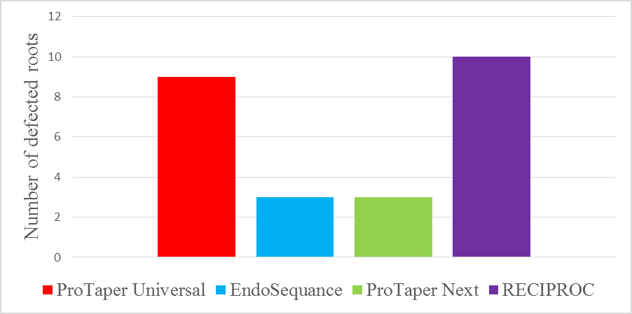
Fig. (1): Bar chart represent the number of defected roots for all groups

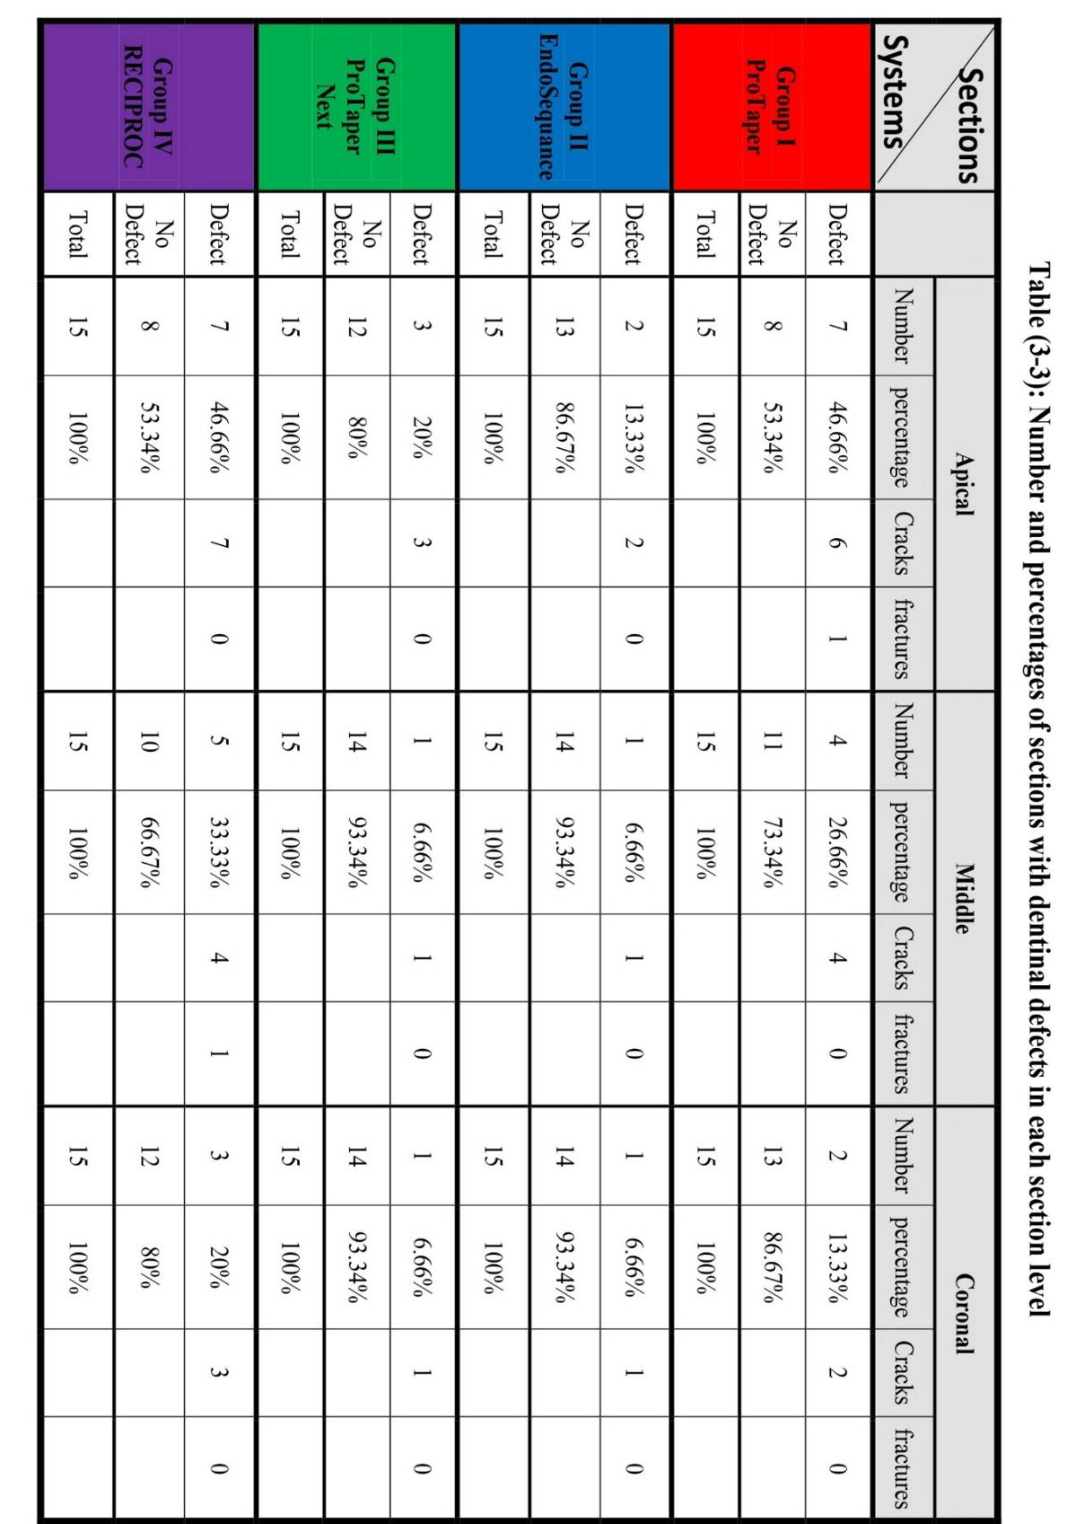
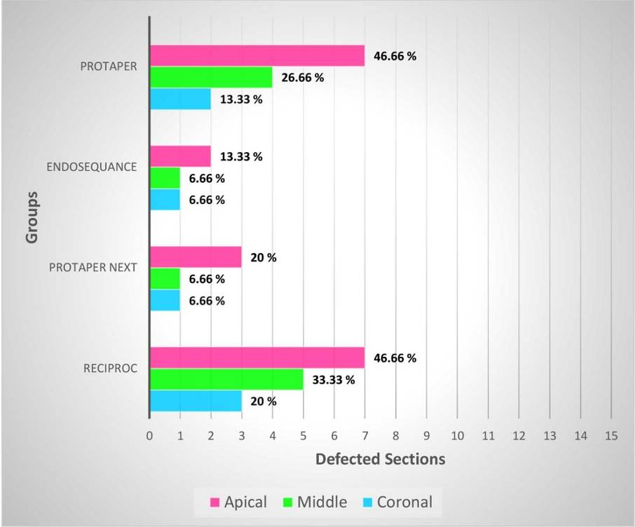
Fig.(2) Bar chart represent the percentage of dentinal defects at each level for all

Table (3): Chi-square test between groups.

Groups |  | X² | P-value | Sig.
Group I  ProTaper Universal | EndoSequence | 5 | 0.025 | S
Group I  ProTaper Universal | ProTaper Next | 5 | 0.025 | S
Group I  ProTaper Universal | RECIPROC | 0.14 | 0.7 | NS
Group II EndoSequence | ProTaper Next | 0 | 1 | NS
Group II EndoSequence | RECIPROC | 6.65 | 0.009 | HS
Group III  ProTaper Next | RECIPROC | 6.65 | 0.009 | HS
NS: Non-significant P ≥ 0.05, S: Significant P < 0.05, HS: Highly Significant P ≤ 0.01

Table (4): Chi-square test for different level of sections in each group.

Groups | Sections |  | X² | P-value | Sig.
ProTaper | Apical | Middle | 1.292 | 0.255 | NS
ProTaper | Apical | Coronal | 3.968 | 0.046 | *
ProTaper | Middle | Coronal | 0.833 | 0.361 | NS
EndoSequance | Apical | Middle | 0.3704 | 0.542 | NS
EndoSequance | Apical | Coronal | 0.3704 | 0.542 | NS
EndoSequance | Middle | Coronal | 0 | 1 | NS
ProTaper Next | Apical | Middle | 1.1538 | 0.282 | NS
ProTaper Next | Apical | Coronal | 1.1538 | 0.282 | NS
ProTaper Next | Middle | Coronal | 0 | 1 | NS
RECIPROC | Apical | Middle | 0.555 | 0.456 | NS
RECIPROC | Apical | Coronal | 2.4 | 0.121 | NS
RECIPROC | Middle | Coronal | 0.681 | 0.409 | NS

