MDJ

Estimation of Salivary Levels of Pro Inflammatory Cytokines (Interleukin-1α and Interleukin-8) in Iraqi Lichen Planus patients, the association of these parameters with dental plaques, gingivitis and smoking status

Dr. Esra Hassan Abd Ali, B.SC., M.SC, Ph.
Dr. Maha Jamal Abbas, B.D.S.,M.SC
Dr. Hussain Owid Muhammed, B.D.S, M.SC
Dr.Ghada Moosa Mustafa, B.D.S., M.SC.

Abstract

Background: Oral lichen planus (OLP) is chronic inflammatory disease of the oral mucosa whose etiology is still unknown but mounting evidence points to the immunologic basis of this disorder.
The aim of the present study was to assess the level of salivary IL-1α, IL- 8, salivary flow rate (SFR), the plaque and gingival indices in lichen planus patients, and to assess their level pre and post treatment with topical steroid in study group, in addition to the assessment of relation of smoking to these parameters in oral lichen planus patients.
Materials and methods: Whole saliva from fifteen (15) patients with oral lichen planus, eighteen (18) healthy persons, were investigated for the presence of IL-1 α, IL-8 by enzyme linked immunosorbent assay ( ELISA). In addition, the flow rate of saliva (SFR) measured in both groups, plaque and gingival indices also assessed pre and post treatment.
Results: The results showed a significant elevation of pro-inflammatory cytokines IL-1α , IL- 8, plaque and gingival indices in study group in comparison to control group except the SFR where it was higher in control group than study group also showed that some of these parameters significantly related to smoking statues.
The studies parameters also showed significant variation after using of topical steroid in which the salivary level of cytokines IL-1 α , IL-8, plaque &Gingival indices were significantly decreased after treatment except SFR was significantly increase after treatment.
Conclusion: Patients with oral lichen planus have had high levels of inflammatory cytokines in their saliva. The results also showed wide variations in levels among patients in pre and post treatment with steroid, in addition the level of pro inflammatory cytokines significantly related to smoking status. The results suggest links between the proinflammatory cytokines ( IL-1 α , IL-8 ) from one side and oral lichen planus disease, medication used for treatment and smoking status of the patients from another side.

Key wards: Oral Lichen Planus (OLP), Gingivitis, Cytokines (IL-1α, IL-8)
Introduction

Lichen planus is a chronic systemic disease of established immune-mediated pathogenesis. It most commonly, protractedly and persistently, involves the mucosa of the oral cavity, but it can involve other sites, namely the skin, the scalp (with inflammation around and affecting the hair follicles) resulting in alopecia, the nails as well as the genital area ⁽¹⁾. Oral lichen planus (OLP) is chronic inflammatory disease
of the oral mucosa whose etiology is still unknown but mounting evidence points to the immunologic basis of this disorder ^{(2),} however other study (Scully, and his coworkers) ⁽³⁾ reported that the etiopathogenesis of OLP has now been better clarified based on the mechanisms involved and appears to be complex, with interactions related to genetic, environmental and lifestyle factors.
The oral lichen planus disease has many different forms; however, reticular type is the most frequent one. Oral lichen planus disease is thought to be precancerous lesion with different percentages of malignant transformation reported in the literature. It is well known that erosive/atrophic type most commonly evolve into oral cancer. So far, many salivary cytokines have been investigated in patients with OLP in order to obtain better diagnostic and/or prognostic evaluations ⁽⁴⁾.
The oral lichen planus disease is a common condition, with a prevalence between 0.5-2.2 percent of the population ⁽⁵⁾, However, a recent review of epidemiological studies specific to OLP, found only one study as being the most useful, and the free of error and bias. So, is regarded as the most reliable estimation of population prevalence of OLP, at least in European populations with a reported prevalence of 1.27% . Oral Lichen Planus patients most frequently presents in women aged 40 years and above, by a ratio of approximately 3:1 to 3:2 compared with men, of the same age ^{(6).}
Many mediators are involved in the pathogenesis of OLP such as matrix metalloproteinase, chymase, tryptase and proinflammatory cytokines ^{(7).} An alteration in the basal keratinocytes by certain stimuli that induce humoral and cell mediated immune response has been postulated as a mechanism, the antigen that serves as the trigger and / or driver of the immune responses seen in OLP is unknown. It is likely, in the majority of cases to be an endogenous peptide, a protein sequence innate to the basal keratinocyte; therefore, Oral lichen planus disease can be characterized as an auto-immune condition. It is also likely that supposed exogenous triggers for OLP, such as dental materials, certain drugs, viruses and even trauma serve to expose such self-antigens, or, alter the normal innate peptide sequences so that they are perceived by the immune-surveillance cells and system as being “non-self, that is “foreign ^{(8).} Different studies have confirmed that keratinocytes are not only the main targets of immune attack in OLP, but may play a critical role through production of cytokines; the Tissue-Infiltrating Mononuclear Cells (TIMC) are stimulated to differentiate to produce a range cytokines characteristic, and the inflammation is modulated by the local cytokine network ^{(9).}
Interleukin-1 alpha (IL-1α) is a polypeptide cytokines produced primarily by cells of the mononuclear phagocytic lineage. Target cell type includes osteoblasts ⁽¹⁰⁾. In general, IL-1 is responsible for the production of inflammation, as well as plays one of the central roles in the regulation of the immune responses. Interleukin -8 (IL-8) is a potent proinflammatory cytokine that has a key role in the recruitment and activation of neutrophils during inflammation ^{(11).} It is secreted mainly by monocytes and is important in regulating alveolar bone resorption during tooth movement by acting early in the inflammatory response ^{(12).}
Topical corticosteroids are widely used in the treatment of vesicular-erosive diseases of the oral mucosa including OLP to reduce pain and inflammation ⁽¹³⁾.
Cigarette smoking is related to many pathological conditions; however, chemical substances affect the oral cavity first, so it is important to consider its influence on oral mucosa and oral potentially pre-malignant lesions ^{(14).}

The present study was conduct to explore the potential of detecting the level of pro-inflammatory cytokines, interleukin-1- α and IL-8 in whole unstimulated saliva (WUS), monitoring the therapeutic effects of topical dexamethasone on these salivary cytokines, plaque, gingival indices and SFR in subjects with erosive oral lichen planus disease in pre and post using treatment and correlation of smoking to these parameters.

Material and Methods

a-Study groups: -
Thirty-three subjects enrolled to this study, their age ranged from 18-60 years, 15 subject with OLP was considered as study group and 18 health subjects (free of the disease) served as control group. The subjects were chosen from patients attending to the clinic of dermatology in Al-karama Teaching Hospital, private clinic and from patients visited the Hospital of Dentistry College of AL-Mustansiriya University. The saliva samples were obtained from the patients diagnosed with OLP (none of the them were get treatment with topical steroid at last six months, and they did not have any other systemic immune disease or tumor). The diagnoses were confirmed clinically and pathologically. The informed consent was obtained from the patients, then the plaque, gingival indices, SFR and cytokines were measured pre and post medication include topical steroid in addition to other classic medication such as using of antibiotics and oral washing solution in study group. The same parameters were measured in control group.
b-Dental examination: -
For each patient, plaque Index (Sinless &Loe, 1994) ⁽¹⁵⁾ and gingival index (Loe.H 1976) ⁽¹⁶⁾ were recorded at all surfaces per tooth (buccal, lingual, mesial and distal). The flow rate of saliva( ml/min ) was estimated by dividing the total collected saliva volume (ml) by collecting time (min) that was measured by sample collection:
SFR ml/min = saliva sample volume (ml)/ collection time (min).
c-Cytokines assay (salivary IL-1 - α and IL-8): -
Two ml of whole unstimulated saliva was collected using plastic tube pre and post medication, then saliva centrifuged at 1000 rpm for 10 minutes, the supernatants were aspirated immediately and kept at -20 C⁰ until used for assay. The level of IL 1- α,IL- 8 had been estimated by using method of enzyme linked immunosorbent assay (ELISA) from information’s kits of Immunotic (France Company).

d-Statistical analysis: -
Statistical Package for Social Science (SPSS 20.0) software was used to analyze the data. Results were expressed as mean standard deviation. Two-sample (Student’s) t-tests was used for comparison of study and control group and paired sample t test was used for comparison of tested parameters pre and post treatment with steroid. Additionally, correlation of the parameters was assessed by Pearson’s correlation. P<0.05 was considered statistically significant (S) and p < 0.01 was consider as highly significant (HS).

Results

Table-1-demonstrate the descriptive criteria of studied groups regarding the gender, smoking status and the age, the result revealed that the female represents 80% of patients group and 61% of control group, male subject represent only 20% of patient group, this finding showed that the female represents the higher percentage in both groups but it is much higher in patient group , no statistical significance difference was reported. For the smoking status the result demonstrate the non-smoker subjects were higher in both groups but it is slightly higher in control group with no statistical difference. The mean age of study group was 40 years higher than that of control group 36 year but no statistical significance was reported also.
The result in Table -2- reported that the mean value of interleukine-1 α (49.9 pg/ml), IL-8 (439 pg /ml), gingival index (2.39), plaque index (2.12) of patient group were higher than that of control group (18.8 pg/ml ,138.9 pg/ml ,1.15 ,1.178) respectively with high statistical significant difference but the mean value of SFR of control group (1.4 ml / min was higher than that of patient group 0.58 ml / min with high statistical significant difference.
Table-3-revealed that the mean value of interleukin-1 α , IL-8 and the gingival ,plaque indices of patient group were higher in pretreatment status (49.9 pg/ml , 439.3 pg/ml , 2.4 and 2.1) respectively than that of post-treatment with topical steroid (45.5pg/ml, 341.0 pg/ml , 1.1 and 1.1 ) respectively with statistical significant difference for all but the mean value of SFR of post –treatment status (1.0 ml/min ) was higher than that of pre-treatment (0.6 ml/min), significant statistical difference also reported for this parameter. The results also showed there are strong positive correlation between studied parameters with high statistical difference as shown in Table-4-.and figures (1-7).
Table-5- showed that there was a positive correlation between all tested variable except salivary flow rate (pre and post) has had a negative correlation with all tested variables
Regarding the statistical analysis of the correlation between the salivary level of IL-1 α and the mean of gingivitis index, the correlation was positive in pre and post medication as shown in Figure 1 and 2. Figure -3 and 4, revealed a positive correlation between salivary level of IL-8 and gingivitis index in pre and post treatment ( r = 0.258, r = 0.178) respectively. The statistical analysis of the correlation between the salivary cytokines level of both IL-1 α and IL-8 with the value of plaques indices in pre and post treatment reported a positive correlation as showed in Figure 5,6,7,and8.
The results in Table-6- revealed that the mean value of salivary interleukin-1 α (62.8pg/ml), IL-8 (41.3pg/ml) were higher in smokers than non-smokers (425.6 , 460 pg/ml), but significant difference reported for interleukin- 1 α only. The mean value of salivary flow rate was higher in no-smoker patients; no significant difference was reported. The gingival and plaque indices were higher in smoker patients with significance differences.

Discussion

The present study was undertaken to test the hypothesis of the elevation of salivary pro-inflammatory cytokines: IL-1 α , IL-8, plaque, gingival index and salivary flow rate in OLP patients, correlation of these parameters to smoking and topical steroid treatment. We set out to identify whether cytokines IL-1 α and IL-8 could be measured in the saliva of patient with lichen planus and these cytokines could be potentially being useful as biomarkers for this disease or not.
The results of current study indicate that altered cytokine production and responsiveness in saliva of oral lichen planus patients and the level of these cytokines are significantly higher than that of control group and then we supposed that these interleukins are good marker for the disease, however other study of Vanja, 2014⁽⁴⁾ reported that many salivary cytokines have been investigated in patients with OLP in order to obtain better diagnostic and/or prognostic evaluations, Still, due to the conflicting results, none of the investigated cytokines have been proposed as the most useful marker of the disease . One could argue that higher concentrations of salivary cytokines consolidate the immunological mechanism of the disease and the role of proinflammatory cytokines in initiating this immunological mechanism.
A study conducted by Lai Yet al ,2011⁽¹⁷⁾ stated that cytokines like Tumor necrosis factor –alpha ( TNF- α) and IL-1 α are strong inducers of IL-8. Another researcher has speculated that dysfunction of the triangle oral mucosa, immune cells and saliva leads to the onset of oral mucosa diseases and inflammation, such as oral lichen planus, oral cancer, periodontitis and leukoplakia ^{(18).} Gornowicz. and his workers ⁽¹⁹⁾ reported that the positive correlation between TNFa and IL-8. Tumor necrosis factor –alpha is an effectors cytokine and its production leads to oral diseases. It is probable that the higher level of IL-8 induces TNF-a. , these two cytokines play an important role in immunity of the oral cavity. Taken together, these data suggest links between the production of inflammatory and immunoregulatory cytokines and chemokines, such as the tumor necrosis factor a , interleukin-6, interleukin-8 , and dental caries disease.
The findings of this study also reported a significant difference with regards to mean level of interleukin-1 α and 8 in smoker patients than non-smoker and this may be explained by irritant mechanism of content of cigarette and it is role in enhancement the release of proinflammatory factors. Pryor, et al,1993 ⁽²⁰⁾ reported that cigarette smoke , a complex mixture of more than 4700 chemical compounds and oxidants and of course such number of chemical compounds will induce sever irritation to the mucosa of oral cavity.
Kłosek SK,2011 ⁽¹⁴⁾, reported: we observed increased Micro -Vessel Density (MVD) in patients of OLP with smoking habit in comparison to those of OLP in non-smokers. The Micro -Vessel Density was by almost one third higher when OLP patients smoked. The increased MVD in samples obtained from smoking patients might be the result of compensatory angiogenesis due to lower oxygen concentration in tissue, and the smaller diameter of blood vessels was the effect of vasoconstriction evoked by tobacco smoke. Interestingly, there are no other reports showing such correlation.
Kode et al, 2006 ⁽²¹⁾ stated that the IL-8 and IL-6 are important in the recruitment and activation of inflammatory cells, the induction of these proinflammatory mediators is regulated by the activation of redox sensitive transcription factor NF-κB, this transcription factor has been shown to be activated by a wide variety of agents including stress, cigarette smoke, viruses, bacteria, inflammatory stimuli, cytokines and free radicals .other researchers reported that the OLP is a pre-malignant lesion, others reported that, smoking is also associated with potentially malignant disorders of the oral and oropharyngeal mucosa , especially with leukoplakia and erythro -plakia , with risk increasing in a dose dependent manner and declining with the duration of smoking cessation, however, little is known about the influence of cigarette smoke content on the course of oral lichen planus and its potential of malignant transformation ^{(22,23 and 24) .}Moreover, tobacco could support tissue destruction in OLP through irritation and other well-established mechanisms, such as functional alterations in chemotaxis and phagocytosis of neutrophils, elevating levels of Tumor Necrosis Factor, Prostaglandin E2 (PGE2) neutrophil elastase and Matrix Metalloproteinases ( MMPs), as well as vasoconstrictor effect with lower oxygen concentration in tissue ^{( 25,26).}
Various treatment regimens have been attempted to improve the refractory lesions, but a complete cure of OLP has not yet been accomplished because of its recalcitrant nature ⁽²⁷⁾. Another interesting finding in the present study was the significant difference regarding the level of interleukin1 α , 8 pre and post treatment with topical steroid and this finding agree with other researchers whom reported, the levels of cytokines such as TNF-alpha, IL-1 α , IL-6 , and IL-8 were decreased significantly, these preliminary results indicate that dexamethasone can reduce some cytokines involved in the pathogenesis of OLP ⁽²⁸⁾, and this may suggest the immunological bases of the disease and it is response to immunosuppressive medication as topical steroids.
In this study, gingival and plaque indices was significantly increased in OLP patient than control and this finding is close to the results of study conducted by Fluixa and his coworkers ⁽²⁹⁾ where they reported that significant increase of plaque and calculus deposits are significantly associated to incidence of a trophic erosive gingival lesions in patients with OLP. Also , study of Ling et al. (2005) ⁽³⁰⁾, reported that OLP is a very common form of lichen planus disease, considering high frequency of gingival involvement and it influence on oral health and recommended to management OLP . In this study , the gingival and plaque indices decreased significantly in OLP patients after using treatment and this finding are similar to what was reported by Ali et al. 2011 ⁽³¹⁾ ,where they reported that , after the OLP patients received oral hygiene treatment resulting decreasing in the mean of plaque score and concluded that OLP cases improvement of gingivitis lesions after using treatment .
Conclusions

The results of this study indicate that salivary analysis of cytokines may be applied to monitoring the therapeutic response of OLP to topical steroid. Effect of smoking and presence of other oral lesions on the level of proinflammatory cytokines in OLP were significantly increase in patients than control, while the mean level of the studied parameters were significantly decreased post treatment than pretreatment, except for the level of SFR which was higher in control than patients , but this mean of SFR was also increased after treatment .

References

- Al-Hashimi I, Schifter M, Lockhart PB, Wray D, Brennan M, Migliorati CA. Oral lichen planus and oral lichenoid lesions: diagnostic and therapeutic considerations. Radiol Endod 2007, 103, S25:1-12.
- Pezelj-Ribaric S, Prso IB, Abram M, Glazar I, Brumini G, et al. Salivary levels of tumor necrosis factor-alpha in oral lichen planus. Mediators Inflamm., 2004, 13: 131-133.
- Scully C, Eisen D, Carrozzo M. Management of oral lichen planus. Is J Clin Dermatol 2000, 1: 287-306.
- Vanja J. A. The Role of salivary cytokines in patients with oral lichen planus. Journal of Autacoids and Hormones, 2014, 3, 1:.2-6.
- Bouquot JE and Gundlach KK. Oral exophytic lesions in 23,616 white Americans over 35 years of age. Oral Surg Oral Med 1986: 62: 284–291.
- McCartan BE, Healy CM. The reported prevalence of oral lichen planus: a review and critique. J Oral Pathol Med 2008; 37:447–53.
- Lodi G, Scully C, Carrozzo M, Griffiths M, Sugerman PB, Thongprasom K. Current controversies in oral lichen planus: report of an international consensus meeting – Part 1. Viral infections and aetiopathogenesis. Oral Surg Oral Med, 2005,100, 40-51.
- Sugerman PB, Savage NW L.J. Walsh LJ, Zhao ZZ, Zhou XJ, Khan A, Seymour GJ and Bigby M. The Pathogenesis of oral lichen planus. Crit Rev Oral Biol Med 2002, 13:350-365.
- Erdem MT, Gulec AI, Kiziltunc A, Yildirim A, Atasoy M. Increased serum levels of tumor necrosis factor alpha in lichen planus. Dermatology 2003; 207: 367-70.
- Nicklin MJ, Weith A, Duff GW. A physical map of the region encompassing the human interleukin-1 alpha, interleukin-1 beta, and interleukin-1 receptor antagonist genes. Genomics. 1994; 19 (2): 382–4.
- Bankers-Fulbright JL, Kalli KR, McKean DJ. Interleukin-1 signal transduction. Life Sci. 1996; 59 ,2: 61–83.
- Al-Ghurabi BH, Mohammed-Salih HS, Ghazi A, Saloom HF. Evaluation of salivary levels of proinflammatory cytokines (IL-1α, IL-8 and GM-CSF) in Adult orthodontic patients, IOSR-JDMS, 2014, 13, 3: 75-78.
- Gonzalez-Moles MA and Scully C. Vesiculoerosive oral mucosal disease – management with topical corticosteroids. fundamental principles and specific agents available. J Dent Res, 2005, 84, 294-301.
- Kłosek SK, Sporny S, Kanicka O.S, Kurnatowska A.J. Cigarette smoking induces overexpression of c-Met receptor in micro vessels of oral lichen planus. Arch Med Sci, 2011, 7, 4: 706-712.
- Silness J. and Loe H.: Correlation between oral hygiene and periodontal condition . Acta . Odont.Sc.1994,22:121-139 .
- Loe H: The gingival index, plaque index and retention index systems. J. periodontal, 1976 ,83:610 supplement.
- Lai Y, Shen Y, Liu XH, Zhang, Zeng Y, Liu YF. Interleukin-8 Induces the endothelial cell migration through the activation of phosphoinositide3-kinase-Rac1/RhoA pathway. Int J Biol Sci. 2011; 7: 782-791
- Sugawara S. Host defense of oral mucosa and the molecular mechanism of oral mucosal signal transduction diseases. J Oral Biosci. 2005, 47:115-125.
- Gornowicz A, Anna Byelaws 1, Zyta Grabowska SA, Wójcicka A. Zalewska.M, Maciorkowska.E, Pro-inflammatory cytokines in saliva of adolescents with dental caries disease, 2012; 19(4): 711-716.
- Pryor WA, Stone K: Oxidants in cigarette smokeRadicals,hydrogen peroxide, peroxynitrate, and peroxynitrite. Ann NYAcad Sci 1993, 686:12-27.
- Kode A, Yang S and Rahman I. Differential effects of cigarette smoke on oxidative stress and proinflammatory cytokine release in primary human airway epithelial cells and in a variety of transformed alveolar epithelial cells. 2006, 7:1:32.
- Gandolfo S, Richiardi L, Carrozo M. Risk of squamous cell carcinoma in 402 patients with oral lichen planus: a follow-up in an Italian population. Oral Oncol 2004, 40:77-83.
- Dietrich T, Reichart PA, Scheifele C. Clinical risk factors of oral leukoplakia in a representative sample of the US population. Oral Oncol 2004, 40: 158-63.
- Banoczy J, Gintner Z, Dombi C. Tobacco use and oral leukoplakia. J Dent Educ 2001, 65: 322-7.
- Newman MG, Takei HH, Klokkevold PR, Carranza FA. Carranza’s F. Clinical Periodontology. 10th ed. Saunders Elsevier: Missouri 2007; 254-5
- Kedah S, Rashed L, Obaia E, Sabry D. A preliminary study: matrix metalloproteinase expression as an indicator of the hazards of shisha (nargila) smoking. Arch Med Sci 2009; 5: 570-6.
- Lodi G, Scully C, Carrozzo M, Griffiths M,Sugerman PB, Thongprasom K . Current controversies in oral lichen planus; report of an international consensus meeting. Part 2. Clinical management and malignant transformation. Oral Surg Oral Med Oral Pathol Oral Radiol Endod ,2005,100,164-178.
- Thompson K and Dhanuthai K. Steriods in the treatment of lichen planus: a review. Journal of Oral Science,2008, Vol. 50, No. 4, 377-385.
- Fluixa CRl, StatSebastain JB,Masanet MM. and Scally C Peridontal status in patients with oral lichen planus : a study of 90 cases .Oral Disease2008,5,4:303-306.
- Ling J,Fan M W,Wang SZ,Chen X M .A clinical study of 674 patients with oral lichen planus in chine .Journal of Oral Pathology and Medicine ,2005,34, 8: 467-472
- Ali AM , Elgendy E A , Elden A. A comparative Study between Intralesional low molecular weight chitosan and triamcinolone acetonide for treatment of erosive –atrophic oral lichen planus. J. of American Science ,2011,7,10 :338-345.

Table (1): Descriptive criteria of the studied groups according to gender and smoking statues.

study variables |  | Studied groups (patients and control)
 |  | Control group |  | Patients group
 |  | No. | % | No. | %
Gender | Female | 11 | 61.1% | 12 | 80.0%
Gender | Male | 7 | 38.9% | 3 | 20.0%
Smoking statues | Non-smoker | 11 | 61.1% | 9 | 60.0%
Smoking statues | Smoker | 7 | 38.9% | 6 | 40.0%
 |  | Mean | ST. D | Mean | ST. D
Age(year) |  | 36 | 14 | 40 | 13

Table (2): The mean level of studied parameters of patients and control group.

study parameters | Groups | N | Mean | Std. Deviation | Std. Error | p-value
Salivary IL-1 α (pre) pg/ml | Patients | 15 | 49.9 | 19.0 | 4.9 | HS
Salivary IL-1 α (pre) pg/ml | Controls | 18 | 18.8 | 5.3 | 1.2 | HS
Salivary IL8 (pre) pg/ml | Patients | 15 | 439.3 | 59.1 | 15.2 | HS
Salivary IL8 (pre) pg/ml | Controls | 18 | 138.9 | 17.2 | 4.0 | HS
SFR ml/min | Patients | 15 | 0.58 | 0.12 | 0.0 | HS
SFR ml/min | Controls | 18 | 1.4 | 0.35 | 0.08 | HS
Gingival index(pre) | Patients | 15 | 2.39 | 0.43 | 0.11 | HS
Gingival index(pre) | Controls | 18 | 1.15 | 0.20 | 0.04 | HS
Plaque index(pre) | Patients | 15 | 2.12 | 0.34 | 0.08 | HS
Plaque index(pre) | Controls | 18 | 1.178 | .2016 | .0475 | HS
HS=highly significant differences

Table (3): The mean of studied parameters of patients group (pre and post) treatment.

study variables | Mean | N | Std. Deviation | p-value (paired sample t-test)
salivary IL-1 α (pre) pg/ml | 49.9 | 15 | 19.0 | HS
salivary IL-1 α (post) pg/ml | 45.5 | 15 | 18.5 | HS
salivary IL-8(pre) Pg/ml | 439.3 | 15 | 59.1 | HS
Salivary IL-8(post) Pg/ml | 341.0 | 15 | 69.0 | HS
Salivary flow rate ml/min(pre) | 0.6 | 15 | 0.1 | HS
Salivary flow rate ml/min(post) | 1.0 | 15 | 0.1 | HS
Gingivitis index(pre) | 2.4 | 15 | 0.4 | HS
Gingivitis index(post) | 1.1 | 15 | 0.5 | HS
Plaque index(pre) | 2.1 | 15 | 0.3 | HS
Plaque index(post) | 1.1 | 15 | 0.3 | HS

Table (4): Correlation of studied parameters pre and post treatment.

Paired Samples Correlations
study variables | N | Correlation | p value. | Significant
salivary IL-1 α (pre) & salivary IL-1 (post) pg/ml | 15 | 0.9 | 0.001 | HS
salivary IL-8(pre) & Salivary IL-8(post) pg/ml | 15 | 0.8 | 0.001 | HS
Salivary flow rate ml/min & SFRPost | 15 | 0.8 | 0.001 | HS
Gingivitis index(pre) & Gingivitis index(post) | 15 | 0.8 | 0.001 | HS
Plaque index(pre) & Plaque index(post) | 15 | 0.9 | 0.001 | HS

Table (5): Correlation between studied parameters.

study parameters |  | sal.IL-1-pre | Sal. IL-1 -post | Sal. IL-8-pre | Sal.IL-8-post | S.F.R(pre)ml/min | S.F.R-post  Ml/m | G.I -pre | G.I -post | P.I-pre | P.I -post
Sal.IL- α 1(pre) Pg/ml | Pearson Correlation | 1 | .991** | .910** | 0.761** | -.810** | -0.706** | 0.696** | 0.817** | 0.892** | 0.892**
Sal.IL- α 1(pre) Pg/ml | Sig. |  | 0.000 | .000 | 0.001 | .000 | 0.003 | 0.004 | 0.000 | 0.000 | 0.000
Sal. IL-1 α (post) Pg/ml | Pearson Correlation | 0.991** | 1 | .882** | 0.740** | -.802** | -0.684** | 0.696** | 0.817** | 0.910** | 0.881**
Sal. IL-1 α (post) Pg/ml | Sig. | 0.000 |  | .000 | 0.002 | .0000 | 0.005 | 0.004 | 0.000 | 0.000 | 0.000
Sal. IL-8(pre) Pg/ml | Pearson Correlation | 0.910** | 0.882** | 1 | 0.864** | -.872** | -0.822** | 0.508 | 0.627* | .700** | 0.760**
Sal. IL-8(pre) Pg/ml | Sig. | 0.000 | 0.000 |  | 0.000 | 0.000 | 0.000 | 0.053 | 0.012 | 0.004 | 0.001
Sal. IL-8(post) Pg/ml | Pearson Correlation | 0.761** | 0.740** | 0.864** | 1 | -0.825** | -.766** | 0.280 | 0.422 | 0.529* | 0.580*
Sal. IL-8(post) Pg/ml | Sig. | 0.001 | 0.002 | 0.000 |  | 0.000 | 0.001 | 0.312 | 0.117 | 0.043 | 0.023
S.F.R (pre)ml/min | Pearson Correlation | -.810** | -.802** | -.872** | -.825** | 1 | 0.861** | -.379 | -.0479 | -0.637* | -.645**
S.F.R (pre)ml/min | Sig | 0.000 | 0.000 | 0.000 | 0.000 |  | 0.000 | 0.163 | 0.071 | 0.011 | 0.009
S.F.R (post)ml/min | Pearson Correlation | -.706** | -.684** | -0.822** | -.766** | 0.861** | 1 | -.271 | -0.381 | -0.423 | -.458
S.F.R (post)ml/min | Sig. | 0.003 | 0.005 | 0.000 | 0.001 | 0.000 |  | 0.329 | 0.161 | 0.116 | 0.086
G.I(pre) | Pearson Correlation | 0.696** | 0.696** | 0.508 | 0.280 | -0.379 | -.0271 | 1 | .824** | 0.650** | 0.639*
G.I(pre) | Sig. | 0.004 | 0.004 | 0.053 | 0.312 | 0.163 | 0.329 |  | 0.000 | 0.009 | 0.010
G.I(post) | Pearson Correlation | 0.817** | 0.817** | 0.627* | 0.422 | -0.479 | -0.381 | 0.824** | 1 | 0.793** | 0.855**
G.I(post) | Sig. | 0.000 | .000 | .012 | 0.117 | 0.071 | 0.161 | .000 |  | 0.000 | 0.000
P.I(pre) | Pearson Correlation | 0.892** | 0.910** | 0.700** | 0.529* | -0.637* | -0.423 | 0.650** | 0.793** | 1 | 0.939**
P.I(pre) | Sig. | 0.000 | 0.000 | 0.004 | 0.043 | 0.011 | 0.116 | 0.009 | 0.000 |  | 0.000
P.I(post) | Pearson Correlation | 0.0892** | 0.881** | 0.760** | 0.580* | -0.645** | -.0458 | 0.639* | 0.855** | 0.939** | 1
P.I(post) | Value | 0.000 | 0.000 | 0.001 | 0.023 | 0.009 | 0.086 | 0.010 | 0.000 | 0.000
 | Sig. | HS | HS | HS | S | HS | NS | HS | HS | HS

Table-6-The mean value of tested parameters for smoker and non-smoker of study group.

study variables | Smoking statues | N | Mean | Std. Deviation | p-value | Sig.
salivary IL-1 α (pre) pg/ml | Non-smoker | 9 | 41.3 | 15.6 | 0.02 | S
salivary IL-1 α (pre) pg/ml | Smoker | 6 | 62.8 | 16.8 | 0.02 | S
salivary IL-8(pre) pg/ml | Non-smoker | 9 | 425.6 | 62.6 | 0.2 | NS
salivary IL-8(pre) pg/ml | Smoker | 6 | 460.0 | 51.5 | 0.2 | NS
Salivary flow rate ml/min | Non-smoker | 9 | 0.6 | 0.09 | 0.2 | NS
Salivary flow rate ml/min | Smoker | 6 | 0.3 | 0.15 | 0.2 | NS
Gingivitis index(pre) | Non-smoker | 9 | 2.2 | 0.45 | 0.06 | NS
Gingivitis index(pre) | Smoker | 6 | 2.6 | 0.3 | 0.06 | NS
Plaque index(pre) | Non-smoker | 9 | 1.9 | 0.2 | 0.006 | HS
Plaque index(pre) | Smoker | 6 | 2.4 | 0.3 | 0.006 | HS
Figures :-

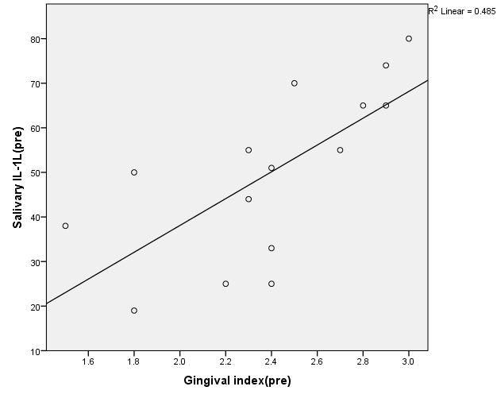
Figure-1- correlation between salivary interleukin1- α (pre) and gingival index (pre)

Figure-2- correlation between salivary interleukin1 α - (post) and gingival index (post).
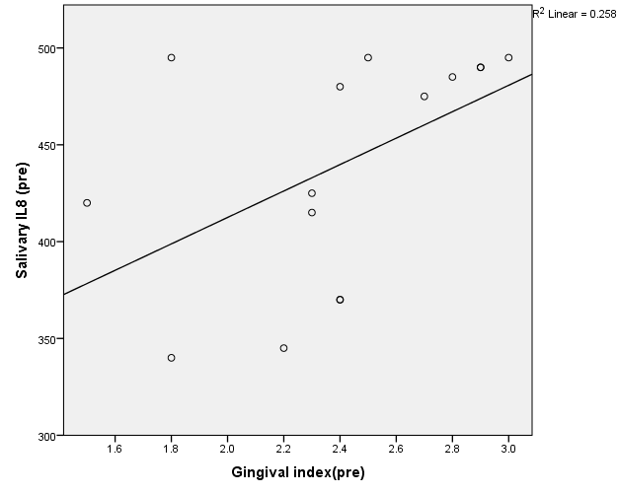
Figure-3- correlation between salivary interleukin-8 (pre) and gingival index (pre)

Figure-4- Correlation between salivary interleukin-8 (post) and gingival index)

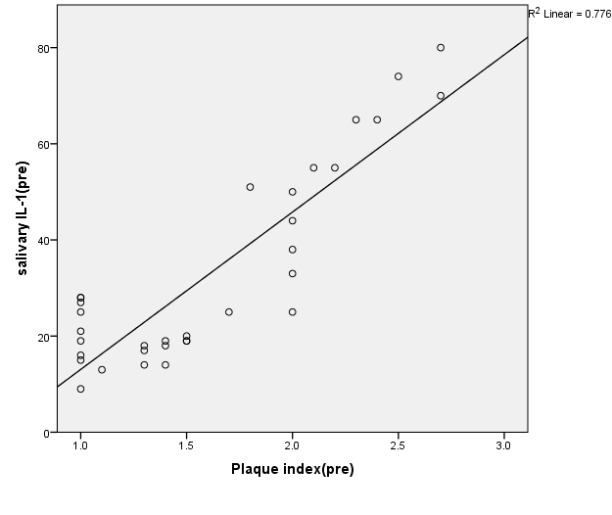
Figure-5- correlation between salivary interleukin-1alpha (pre) and plaque index (pre)

Figure-6- correlation between salivary interleukin-1alpha (post) and plaque index (post)
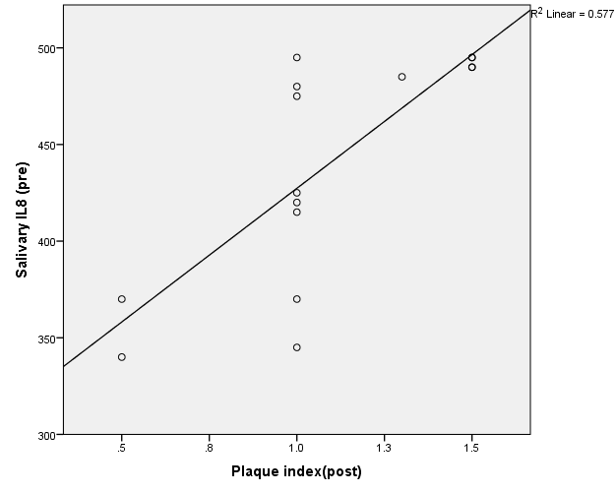
Figure-7- correlation between salivary interleukin-8 (pre) and plaque index (post)

Figure-8- correlation between salivary interleukin-8 (post) and plaque index (post)

