MDJ

Validity of Hounsfield Units in Skyview Cone Beam Computed Tomography to detect bone densities at different jaw sites during implant insertion

Dr. Amal R.S. Mohammed, B.D.S., H.D.D., M.Sc. Rad.

Abstract

Background: The purpose of this study was to evaluate the bone densities by Hounsfield Unit at jaw sites in sky view cone beam computed tomography and to compare these values to the optimal bone densities proposed in the literature.
Materials and Methods: Thirty-six patients, 15 males and 21 females were assessed; CT data for different jaw sections and regions were compared using (t-test).
Results: The means of bone density in all regions are higher in male than female. The mean bone density in the anterior mandible is higher ; the mean bone densities in the four jaw regions decreased in the following order in female or male or general ( anterior mandible > anterior maxilla > posterior mandible > posterior maxilla ) .
Conclusion: The bone densities assessed by HU fell into the range of optimal bone densities proposed in the literature.

Keywords: Hounsfield Unit, jaw, bone density, cone beam computed tomography.

Introduction

The successful treatment of dental implants is considered to be influenced by both the quality and the quantity of available bone for implant placement. Studies have shown higher failure rates for implants placed in bone of poor quality and quantity ^{(1,2)} . Hence, a precise evaluation of bone structure is essential before implant placement. Computerized tomography (CT) has been an established method to evaluate cross-sectional images of jaw bone before implant surgery ^{(3,4,5)} . It can also be used for the objective quantification of bone mineral densities. Quantitative CT (QCT) furnishes direct density measurements expressed in Hounsfield units (HU). The X-ray dose absorbed by the patient during CT scanning may limit the use of this modality for a routine diagnosis or repeated surveys. Therefore, a new type of CT machine for dental and maxillofacial imaging has been introduced ⁽⁶⁾ .This new CT machine uses a cone-shaped X-ray area detector and is termed cone-beam CT (CBCT).
Like a conventional CT, quantitative bone density measurements can be retrieved (quantitative CBCT, QCBCT). The amount of radiation absorbed by the patient for each scan I reportedly 0.62 mGy. ⁽⁷⁾ .Recently, the use of cone-beam (CBCT in dentistry has increased, because CBCT is associated with benefits such as increased patient comfort ,
lower radiation doses, and lower operation costs compared to conventional CT ⁽⁸⁾ .The Hounsfield unit is a standardized and accepted scale for reporting and displaying reconstructed CT values , this unit is based on a linear scale defined only by two points , the attenuation of dry air, set at 1,000 HU, and the attenuation of pure water at 25 ℃ , set at 0 HU. Bone quality can be measured with CBCT as well. However, for the CBCT, the standard unit of displaying bone density (HU) is not used but the term‘ CT number 'should be used ^{(9,10)} . Misch and Kircos in 1999 ⁽¹¹⁾, expressed numerically the subjective bone density obtained mainly from experience and tactile sensation, and classified the bones into 5 categories according to density:
D1>1250 HU
D2, 850-1250 HU
D3, 350-850 HU
D4, 150-350 HU
and D5<150 HU.
In present study used Sky view adopts a new and increasingly successful X-ray technique, known as Cone Beam Computed Tomography (CBCT), ideal for obtaining three- dimensional reconstructions of teeth and the entire maxillofacial area, skeyview has the advantage of acquiring images with just one partial rotation of the source-detector system around the patient. Consequently, less time is need to perform the examination and, above all, the patient is exposed to a considerably lower X-ray dose.
Generally, bone density is higher in the dentulous than edentulous bone and increases with decreasing inter-radicular distance. Furthermore, bone density tends to decrease with increasing depth, particularly in the posterior area ⁽¹²⁾.

Materials and Methods

Bone densities in HU unit evaluated in different jaw sites using Skyview cone beam computed tomography(figure (1)) (My ray: Italy, X-ray beam (conical, variable-field (H.R. Zoom)) , X-ray source (90 kVp, 10 mA (max) , pulsed emission ) , image detector (high resolution intensifier-digital CCD sensor 1000 × 1000- pixel 7.4 μm ) , thickness of axial tomography sections ( starting from 0.05 mm) , class (electro-medical equipment-Class IIb (CCE 93/42, annex IX ) .The bone densities measured in each jaw both anteriorly and posteriorly for thirty-six patients ( 15 males and 21 females ) .

Results

The mean of bone density in anterior mandible is higher than other regions in both male and female (anterior mandible : 841.1; 823.1 respectively ) and the means of bone density in all regions are higher in male than female , as shown in tables (1,2) , figure (2) cleared that .
In both gender, the bone density in anterior mandible > anterior maxilla > posterior mandible > posterior maxilla (bone density: 830.6 ; 699.8 ; 612.5 ; 527.1 respectively) , as shown in table (3) ; figure (3) illustrated that .
T-test between age and bone density showed statistically highly significant difference in four regions with (p-value < 0.01), table (4) cleared that.
T-test cleared statistically highly significant difference between age and bone density in male for four regions with (p-value <0.01), table (5) explained these results.
In table (6), t-test showed highly statistically significant difference between age and bone density in female for four regions with (p-value <0.01).
Pearson's correlation coefficients showed very strong statistically significant correlation with (p-value <0.01) between four regions in both male and female, as shown in tables (7,8) .
Pearson's correlation coefficients showed very strong statistically significant correlation between age and four regions with (p-value <0.01), as shown in table (9).

Discussion

Merheb et al. in 2010 ⁽¹³⁾, showed that a significant linear relationship exists between damping values and HU values at implant insertion and suggested that preoperative evaluation of cortical thickness and trabecular bone HU appears to be the most reliable method for predicting implant stability. In the present study the density in mandible is higher than maxilla in both gender, the anterior mandible have higher bone density in males than females. The bone densities in the present study assessed by HU fell into the range of optimal bone densities proposed in the literature ⁽¹¹⁾. Borges and Mucha in 2010 ⁽¹⁴⁾ , done a study to assess maxillary and mandibular alveolar and basal bone density in Hounsfield units (HU) eleven files with CT ( cone beam ) images of adults obtained from two males and nine females, Brazilians, aged between ( 20 and 30 years ) , and concluded that bone density in the mandible was higher than in the maxilla which is in conformity with the present results . A study done by Hiasa et al. ⁽¹⁵⁾ to evaluate preoperative CT-derived bone densities in Hounsfield units (HU) at implant sites and to compare these values to the optimal bone densities proposed in the literature , fifty-one patients (18 males (37 implant sites) and 33 females (67 implant sites) ) ,the mean bone density in the maxilla was significantly lower than that in the mandible (P < 0.05); the mean bone density in males was significantly higher than that in females, which is similar to findings reported by the present study . The tendency for the mean bone densities of the four jaw regions to decrease, as seen in this study, in the order of anterior mandible, anterior maxilla, posterior mandible, and posterior maxilla is similar to that observed in previous studies ^{(10,16,17)} . Turkyilmaz et al. , 2008 ⁽¹⁸⁾ concluded that anterior mandible has highest bone density during a study group comprised of randomly selected 140 patients with 372 implant sites and the mean bone density values in Hounsfield unit (HU) measured using a CT which is in agreement with present study .Tewfiq and Al- Hashimi ⁽¹⁹⁾ done a study in 2013 , fifty three individuals who were divided into two groups according to their age into: group I (ages 16-20 years) and group II (ages 21-29 years) had subjected to clinical examination, then 64-multislice computed tomography scan data were evaluated and bone density was measured in Hounsfield unit at 102 points (51 in the maxilla and 51 in the mandible), and mean alveolar bone density was calculated at each site in the CT axial plane and they found that the mandible tended to be denser than the maxilla which conformed with the results of present study . Concerning bone density differences between the maxilla and the mandible, it might be associated with the different biomechanical functions: the mandible is a force absorption unit; while the maxilla is a force distribution unit, hence the maxilla has a thin cortical palate and fine trabecular bone ⁽²⁰⁾.

Conclusions

The bone quality is one of the factors that require evaluation before implant surgery and CT using HU is therefore a suitable assessment tool for bone densities prior to dental implantation . The bone densities in the present study assessed by HU fell into the range of optimal bone densities proposed in the literature.

References

- Jaffin RA. and Berman CL. The excessive loss of Brånemark fixtures in type IV bone : A 5 year analysis. J of Periodontology 1991; 62(1): 2-4.
- Herrmann I., Lekholm U., Holm S. & Kultje C. Evaluation of patient and implant characteristics as potential prognostic factors for oral implant failures. The International Journal of Oral & Maxillofacial Implants 2005 ; 20: 220-230.
- Schwartz MS. , Rothman SLG. , Rhodes ML. , Chaftez N. Computed tomography : part I. Preoperative assessment of the mandible for endosseous implant surgery. Int J Oral Maxillofac Implants 1987 a ; 2: 137-141.
- Schwartz MS., Rothman SLG. , Rhodes ML. Computed tomography: part II. Preoperative assessment of the maxilla for endosseous implant surgery. Int J Oral Maxillofac Implants 1987 b ; 2:143-148.
- Smith JP. and Borrow JW. Reformatted CT Imaging for Implant Planning. Oral Maxillofac Surgery Clin of North Am 1991 ; 3: 805-825.
- Ito K. , Yoshinuma N. , Goke E. , Arai Y. , Shinoda K. Clinical Application of a New Compact Computed Tomography System for Evaluating the Outcome of Regenerative Therapy: A Case Report. J Periodontol 2001 ; 72: 696-702.
- Aranyarachkul P. , Caruso J. , Gantes B. , Schulz E. , Riggs M. , Dus I. , Yamada J. , Crigger M. Bone Density Assessment of Dental Implant Sites: Quantitative Cone-Beam Computerized Tomography. Int J Oral Maxillofac Implants 2005 ; 20: 416-424.
- Scarfe WC. , Farman AG. , and Sukovic P. “Clinical applications of cone-beam computed tomography in dental practice,”. Journal of the Canadian Dental Association 2006 ; 72 (1) : 75–80 .
- Shapurian T. , Damoulis P. , Reiser G. , Griffin T. , Rand W. Quantitative evaluation of bone density using the Hounsfield index. Int J Oral Maxillofac Implants 2006 ; 21: 290-297.
- Norton MR. and Gamble C. Bone classification: An objective scale of bone density using the computerized tomography scan. Clin Oral Implants Res 2001 ; 12: 79-84.
- Misch CE. and Kircos LT. Diagnostic imaging and techniques. In Misch CE (Ed.). Contemporary implant dentistry. 2nd ed. St. Louis: Mosby ; 1999. P. 73-87.
- Choi JH. , Park CH. , Yi SW. , Lim HJ. , Hwang HS. Bone density measurement in interdental areas with simulated placement of orthodontics miniscrew implants . Am J Orthod Dentofacial Orthop 2009 ; 136 (6) :766 . el-12. (IVSL) .
- Merheb J.,Van Assche N.,Coucke W., Jacobs R., Naert I., and Quirynen M. “Relationship between cortical bone thickness or computerized tomography-derived bone density values and implant stability,” Clinical Oral Implants Research 2010 ; 21 (6) : 612–617.
- Borges MS. and Mucha JN. Bone density assessment for mini-implants position . Dental Press J Orthod 2010 ; 15(6):58.e1-9.
- Hiasa K. , Abe Y. , Okazaki Y., Nogami K. , Mizumachi W., and Akagawa Y. Preoperative Computed Tomography-Derived Bone Densities in Hounsfield Units at Implant Sites Acquired Primary Stability. ISRN Dentistry 2011 ; P. 5.
- de Oliveira RC. , Leles CR. , Normanha LM. , Lindh C., and Ribeiro-Rotta RF. “Assessments of trabecular bone density at implant sites on CT images,” Oral Surgery, OralMedicine, Oral Pathology, Oral Radiology and Endodontology 2008 ; 105(2) :231-238.
- Fuh LJ. , Huang HL. , Chen CS. et al. “Variations in bone density at dental implant sites in different regions of the jawbone,” Journal of Oral Rehabilitation 2010; 37(5): 346-351.
- Turkyilmaz I. , Ozan O. ,Yilmaz B. , Ersoy AE. Determination of Bone Quality of 372 Implant Recipient Sites Using Hounsfield Unit from Computerized Tomography: A Clinical Study . Clinical Implant Dentistry and Related Research 2008 ; 10 (4) : 238–244.
- Tewfiq SM. and Al- Hashimi HA. Bone density determination for the maxilla and the mandible in different age groups by using computerized tomography (Part I) . J Bagh Coll Dentistry 2013; 25(1):164-170.
- Misch CE, Abbas HA. Contemporary Implant Dentistry. 3rd ed. St. Louis: Mosby; 2008. P. 38-64; 130-44; 645-65.

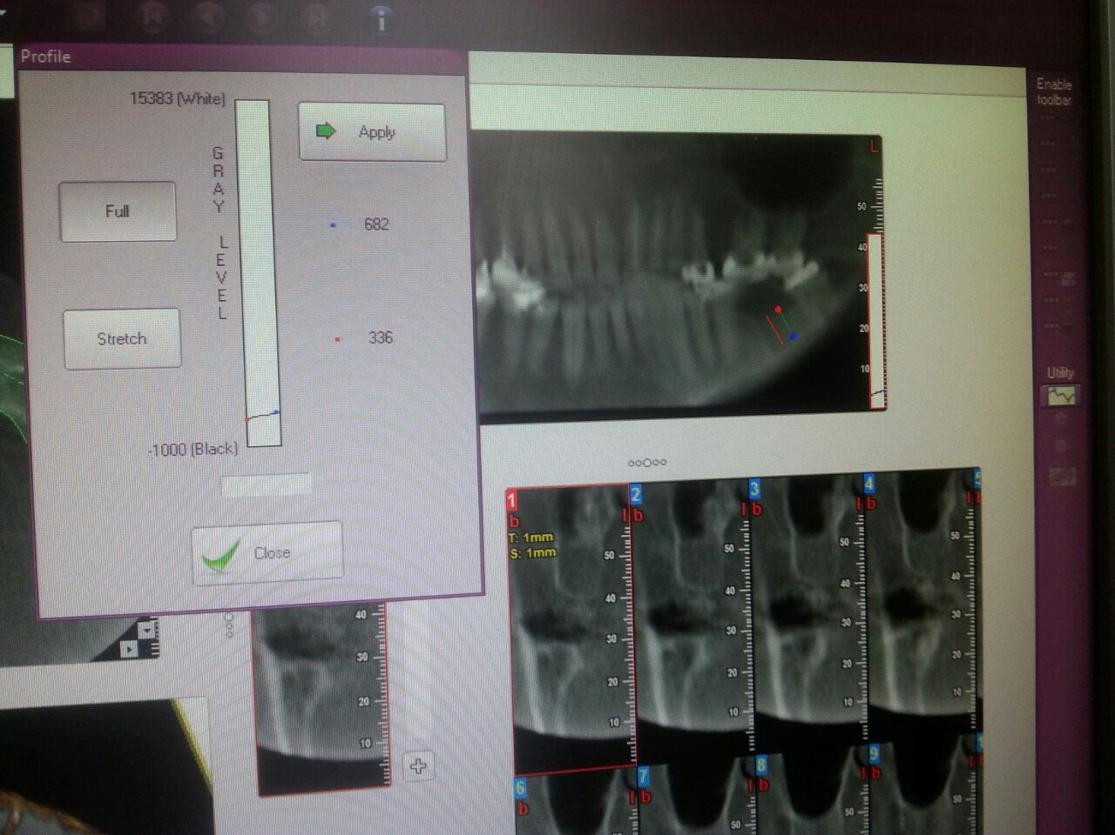

Figure (1): skyview (panoramic image)

Table (1) : The mean , SD , Median for age and bone density in male for four regions .

Posterior maxilla | Posterior mandible | Anterior maxilla | Anterior mandible | Age
543.6 | 617.2 | 728.6 | 841.1 | 33.1 | Mean
124.6927 | 147.0064 | 153.7445 | 147.7231323 | 7.576907 | SD
290 | 370 | 470 | 560 | 20 | Min
750 | 826 | 1010 | 1042 | 47 | Max
550 | 630 | 780 | 880 |  | Median

Table (2) : The mean , SD , Median for age and bone density in female for four regions .

Posterior maxilla | Posterior mandible | Anterior maxilla | Anterior mandible | Age
515.2857 | 609.1429 | 679.2857 | 823.0952 | 32.09 | Mean
113.7792 | 142.5445 | 164.3418 | 161.2333 | 7.36 | SD
286 | 390 | 410 | 520 | 19 | Min
700 | 810 | 990 | 1030 | 43 | Max
510 | 600 | 690 | 870 |  | Median

Table (3) : The mean , SD , Median for age and bone density for four regions .

Posterior maxilla | Posterior mandible | Anterior maxilla | Anterior mandible | Age
527.0833 | 612.5 | 699.8611 | 830.6111 | 32.52 | Mean
117.5469 | 142.3777 | 159.6804 | 153.8348 | 7.362 | SD
286 | 370 | 410 | 520 | 19 | Min
750 | 826 | 1010 | 1042 | 47 | Max
542.5 | 622.5 | 725 | 872.5 |  | Median

Table (4) : T-test between age and bone density

Posterior maxilla | Posterior mandible | Anterior maxilla | Anterior mandible
14.959 | 14.643 | 16.763 | 20.166 | t
P<0.01 | P<0.01 | P<0.01 | P<0.01 | p
HS | HS | HS | HS | sig

Table (5) :T-test between age and bone density of male .

Posterior maxilla | Posterior mandible | Anterior maxilla | Anterior mandible
18.316 | 17.649 | 17.291 | 21.533 | t
P<0.01 | P<0.01 | P<0.01 | P<0.01 | p
HS | HS | HS | HS | sig

Table (6) :T-test between age and bone density of female .

 | Anterior mandible | Anterior maxilla | Posterior mandible | Posterior maxilla
t | 29.759 | 24.032 | 23.257 | 23.816
p | P<0.01 | P<0.01 | P<0.01 | P<0.01
sig | HS | HS | HS | HS

Table (7) : Showed Pearson's correlation coefficients between four regions in male with p- value (p<0.01) .

p | r
P<0.01 | 0.975 | Anterior mandible & Anterior maxilla
P<0.01 | 0.992 | Anterior mandible & Posterior mandible
P<0.01 | 0.984 | Anterior mandible & Posterior maxilla
P<0.01 | 0.955 | Anterior maxilla & Posterior mandible
P<0.01 | 0.96 | Anterior maxilla & Posterior maxilla
P<0.01 | 0.984 | Posterior mandible& Posterior maxilla

Table (8) : Showed Pearson's correlation coefficients between four regions in female with p- value (p<0.01) .

p | r
P<0.01 | 0.968 | Anterior mandible & Anterior maxilla
P<0.01 | 0.973 | Anterior mandible & Posterior mandible
P<0.01 | 0.973 | Anterior mandible & Posterior maxilla
P<0.01 | 0.96 | Anterior maxilla & Posterior mandible
P<0.01 | 0.972 | Anterior maxilla & Posterior maxilla
P<0.01 | 0.963 | Posterior mandible& Posterior maxilla

Table (9) : Showed Pearson's correlation coefficients between age and four regions with p- value (p<0.01) .

p | r
P<0.01 | 0.962 | Age &Anterior mandible
P<0.01 | 0.938 | Age &Anterior maxilla
P<0.01 | 0.983 | Age &Posterior mandible
P<0.01 | 0.955 | Age &Posterior maxilla

Figure (2) : Showed the means of bone density in female and male for four regions

Figure (3) : Showed the means of bone density for four regions .

